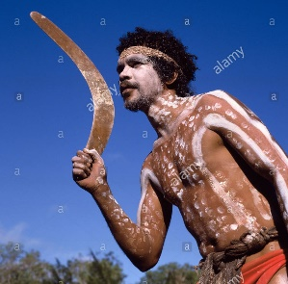
Boomerangs are a traditional Australian Aboriginal tool primarily used to hunt animals. They are often thrown into flocks of birds and it was common that two or more birds would be struck in one throw. If you thought ‘killing two birds with one stone’ was impressive, the boomerang can do better!
The airfoil shape of the boomerang is why it returns to the same location when thrown correctly. A spinning boomerang has a curved flight path because one wing spins faster than the other and generates more lift. This imbalance between the force on the wings is why the boomerang doesn’t fly in a straight line.
If it has been a while since you’ve thrown a boomerang and forgotten how, eventually it will come back to you. (laughing emoji image)
We are confident that once you’ve taken a bite of our premium chocolate boomerang, it won’t be coming back. Don’t worry, because we ship all over the world and you can order more online from www.nakedchocolate.com.au.

[insert some aboriginal art patterns
to fill in the spaces}
Nutritional Information
Servings per pack: 3  Serving size: ?? | Per Serve | Per 100g
Energy |  | 2,273kJ
Protein |  | 5g
Fat – Total |  | 35g
Saturated |  | 21g
Carbohydrates - Total |  | 46g
Sugars |  | 44g
Sodium |  | 10mg


[insert some aboriginal art patterns
to fill in the spaces}
Ingredients: Premium Dark Chocolate (Cocoa mass (44.5%), sugar (44%), cocoa butter (11%), emulsifier: soya lecithin (<1%), natural vanilla flavouring (<1%), natural colours (<1%).
Allergy Advice: Made on the same equipment that processes products containing nuts and milk traces.
Store product in a cool ,dry place below 27º C / 80º F.
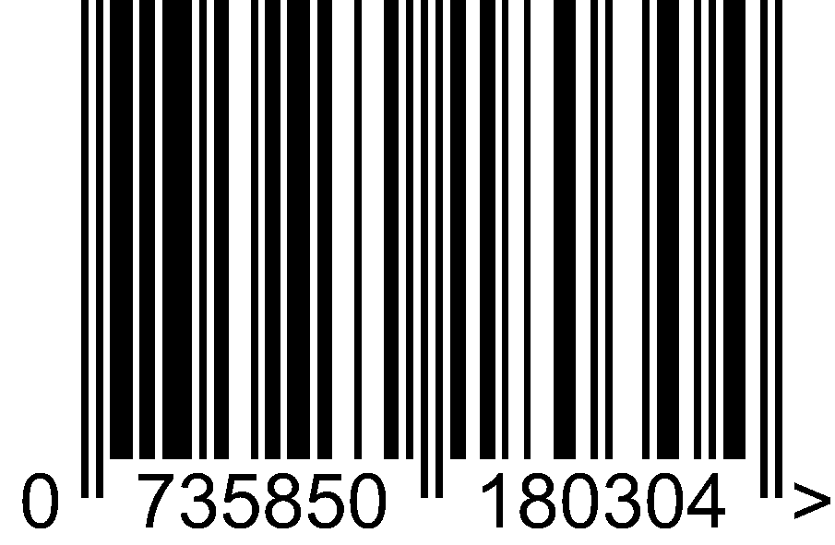
Manufactured by:
Naked Chocolate Co. Pty Ltd
Unit 3, 13 Endeavour Drive
Kunda Park 4556
AUSTRALIA

