POINT OF SALE

FLEXIBLE TAXES
GreenBoxPOS highly customizable tax settings give you complete control over setting your tax rates. Configure multiple tax zones for all your locations, or set taxes by the item.

RESPONSIVE
GreenBoxPOS is at attention and awaiting your command. It works and looks the same on any screen size, in portrait or landscape mode, responding to you in real time.

SALES SCREEN
GreenBoxPOS sales screen is fully customisable, so you can organize it any way you like. Organize items by category, or alphabetically if that's what you're into. Easily navigate through product variants and modifiers, and add customers and discounts.

ACCEPT ORDERS WHILE OFFLINE
With or without internet access, GreenBoxPOS keeps ringing up orders and saving transactions. When your connection comes back, the data is automatically synced back to the cloud.

RECEIPTS
Customise your receipts, with the option to print and/or email them at the end of a sale.
Copyright © 2017 GreenBox LLC — Escapade WordPress theme by GoDaddy

+
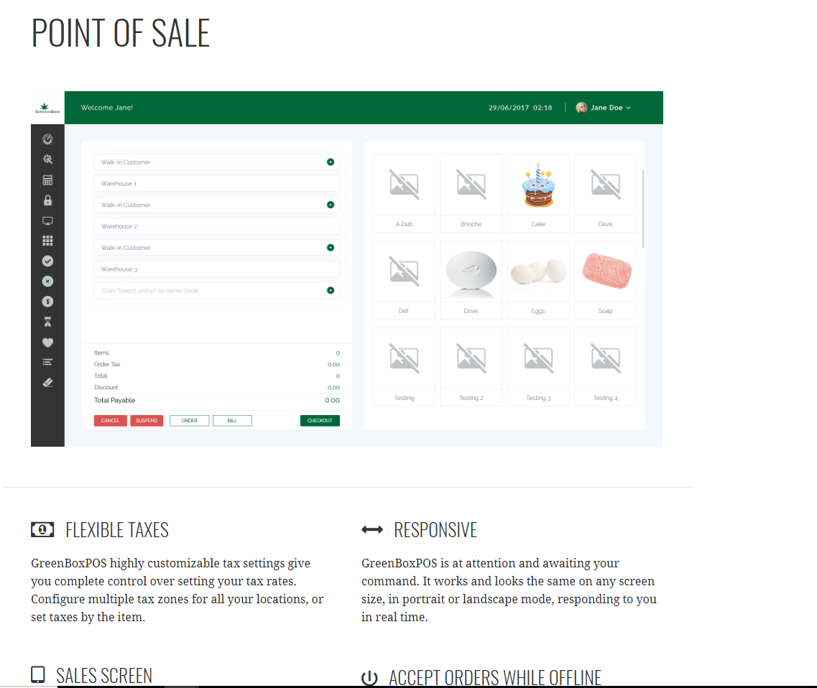

CheckOut

FAST BUTTON – FAST SALES
One action finalizes a sale, pops the cash drawer and prints receipts. Keep the line moving and your customers happy.

DISCOUNTS
Entering a discounts-by percentage or dollar amount, per item or the entire order-is easy, intuitive, and quick.

ORDER NOTES
Attach notes to an item or entire order, making it easy to track item customizations or shipping instructions, or anything else that you need to communicate.

CUSTOM EMAIL OR PRINTED RECEIPTS
You can print or email-or print and email-customised receipts with your store name, URL, phone #, hours, and whatever else you want to put your unique stamp on it.

TAXES
Taxes are automatically calculated based on settings you configure-by location, by item, by a group, or any combination thereof.

CUSTOM PAYMENT TYPES
You're not just limited to cash and credit cards. Set up custom payment types like cheques, gold coins, mobile payments, IOUs, or anything else of value.

SHIPPING
Record a customer's shipping address at the time of sale, and save it for future reference.

TIPPING
Add a Tip line to your receipt, or process tips right from Kounta's screen before, during, or even after processing payments. Customers can select from predefined percentages or add their own custom amounts on-screen. The POS records tips separately and makes it easy to pull out the right amount of cash at the end of a shift.

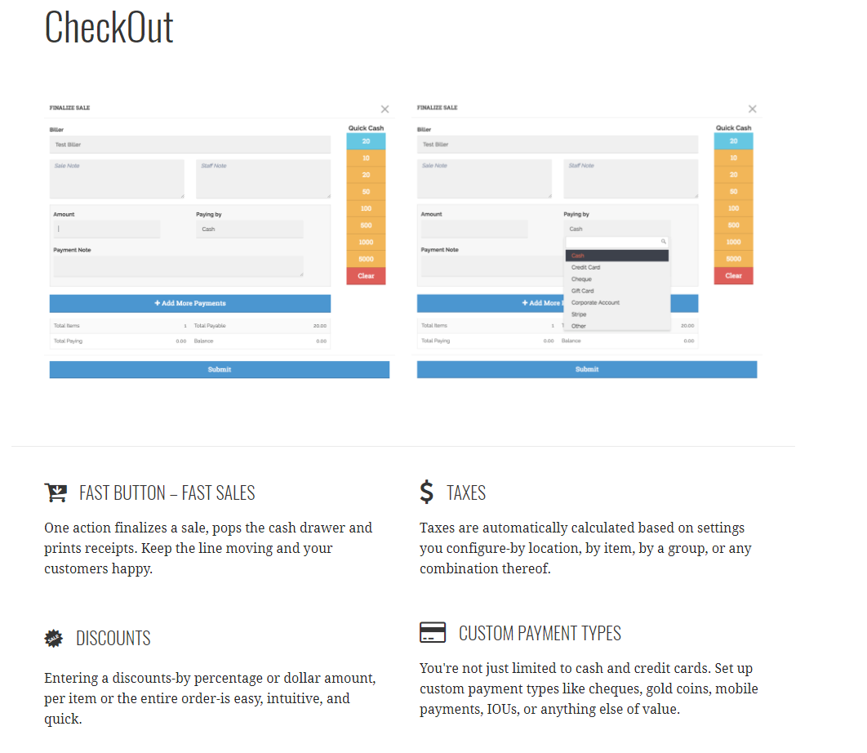

PAYMENTS
Accept cash, card and mobile payments, including split payments, layby and account sales.


FAST CASH, FAST PAYMENTS
Keep your lines moving as GreenBoxPOS guides you through the checkout process. Taking payments, whether cash or credit card or other, couldn’t be easier.

CARD PAYMENTS
GreenBoxPOS integrated credit card payments are fully EMV compliant and have been for years. All transactions are "out of scope," meaning that your customers' sensitive data doesn't pass through GreenBoxPOS. It's strictly between the card terminal and the processing bank, which is safer for everyone.

NON-INTEGRATED PAYMENTS
Got a payment terminal that isn’t yet integrated with GreenBoxPOS? You can still use GreenBoxPOS and simply choose your own custom payment types each time you check-out.

ACCOUNT SALES
Create customer accounts and keep a running balance. And GreenBoxPOS plays real nice with popular account platforms like MYOB, Xero, Quickbooks, and Saasu.

PART PAYMENTS AND LAY-AWAY
Accept as much or as little as you choose as a deposit, set the terms-give it away for free if you really want. No matter which way you go, GreenBoxPOS will help you manage the payments and keep a nice, tidy record.

MOBILE PAYMENTS
A 21st century POS ought to take 21st-century payments. Integrated PayPal payments and Stripe Payment let GreenBoxPOS do just that.
Copyright © 2017 GreenBox LLC — Escapade WordPress theme by GoDaddy

AY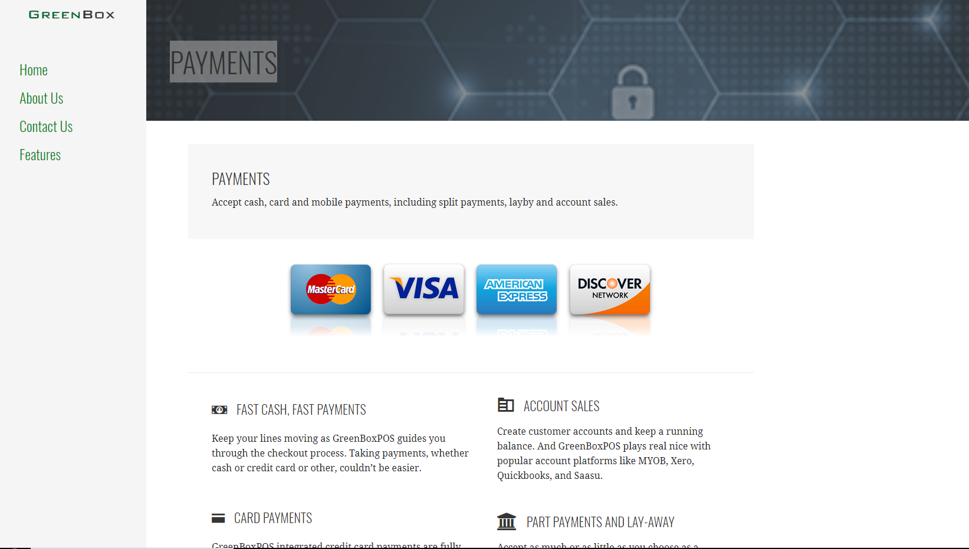MENTS

PAYMENTS

STORE MANAGEMENT
View past, current, and future orders made in any of your stores or online

ORDERS
View past, current, and future orders made in any of your stores or online. Search by customer, date, product, or order number.

CASH IN / CASH OUT
Enter your float and manage cash adjustments throughout the day and stay on top of what’s in your cash drawer.

PRICE LISTS
GreenBoxPOS supports multiple price lists, and each one can be activated automatically using rule-based logic. Happy hour from 4 – 6 PM? Set GreenBoxPOS to knock the price back to $10 at 4 PM, and go back to regular pricing at 6 PM.

REFUNDS
Refund past orders as gift cards, or the customer's original payment method and record the reasons for these refunds to understand better why sales are being reversed.

DAILY TOTALS
Achieve balance by easily tracking your daily totals for every payment type.

STAFF ACCOUNTS
With multiple user accounts, each with a secure PIN, you'll be able to see who's doing what in your store.

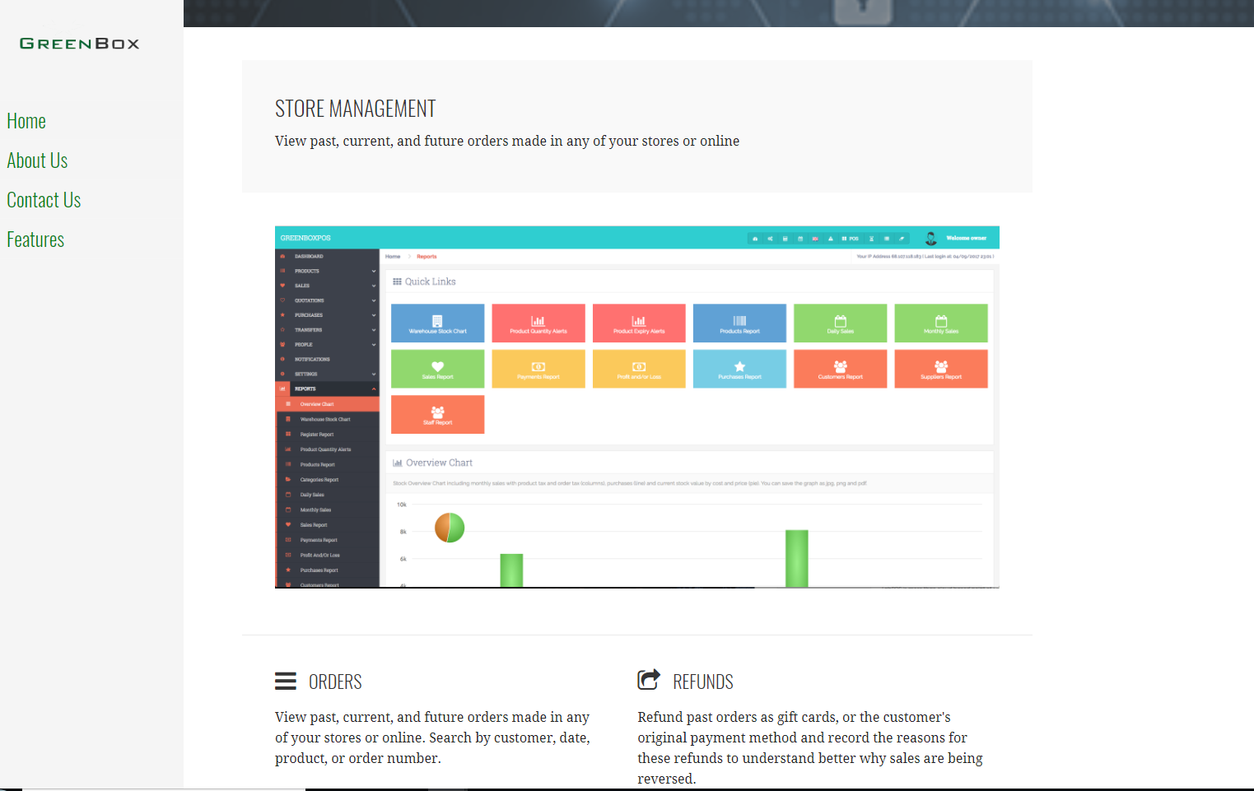

PRODUCTS
Easily add, edit, and remove products. Assign images, colors, and item-specific taxes and stock level.

EASY PRODUCT MANAGEMENT FROM ANYWHERE.
Easily add, edit, and remove products. Assign images, colors, and item-specific taxes and stock level. GreenBoxPOS flexible pricing options make it easy to discount and create promotional campaigns, as well as automatic price adjustments based on store locations or even customers.

BULK IMPORT AND EXPORT
Use our product import template to build your product catalog in one broad stroke. Migrate from your existing point-of-sale, the one that's got you so fed up you're here looking for a change. If you have a Retail Manager, Retail Hospitality, or Retail Basics store, GreenBoxPOS can automatically import your products in a few easy steps.

VARIANTS
Define multiple sizes, colors, or any other variation of your products, with support for unlimited types of variants per product. This is equally useful for hospitality, as well: a bar could set up Small, Medium, and Large drinks, and GreenBoxPOS will automatically deduct the appropriate amount-10, 16, or 20 ounces-from your inventory.

TAGS
Add an unlimited amount of tags to products and customers to create flexible, powerful search and reporting options. This helps to make GreenBoxPOS as much a product of your creation as ours.

OPTION SETS
Option Sets let you group your products in various ways to form new products, like modifiers, upsells, deals and gift packs. Coming soon.

COMPONENTS
Perfect for retail, Components allow you to track items. Make product bundles/gift baskets and track each item individually. Monitor your liquor sales down to the milliliter. GreenBoxPOS fine degree of detail over your inventory gives you all the info you need to stay on top of your

BARCODES
Import existing barcodes or quickly create your own. Support for handheld and Bluetooth scanners simplifies adding products to sales and doing stock-takes.

UNLIMITED PRODUCTS
With GreenBoxPOS, there’s no limit on the number of items in your inventory.
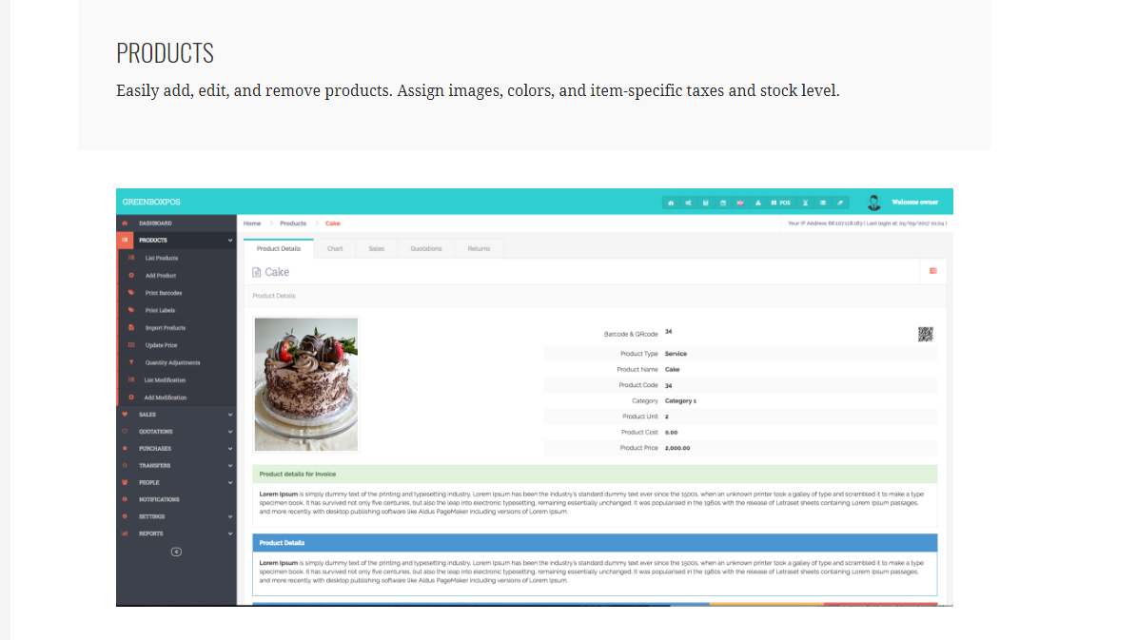

INVENTORY

STOCK MANAGEMENT
Powerful and cloud based inventory management keeps you on top of your stock room where ever you may be. Stay current with stock levels, purchase orders, and wastage.

REAL TIME DATA
Stock on-hand and product level sales reports are fed real-time data. You'll make better informed and more timely decisions to build a better business.

PAINLESS STOCK-TAKES
You can quickly generate full or partial stock-takes and use GreenBoxPOS search tool to find the product you're looking for

WASTAGE/SHRINKAGE
GreenBoxPOS helps you easily understand what items are doing more harm than good. Track what's not being sold, and find the real cost of damaged COGS to your costs and revenue.
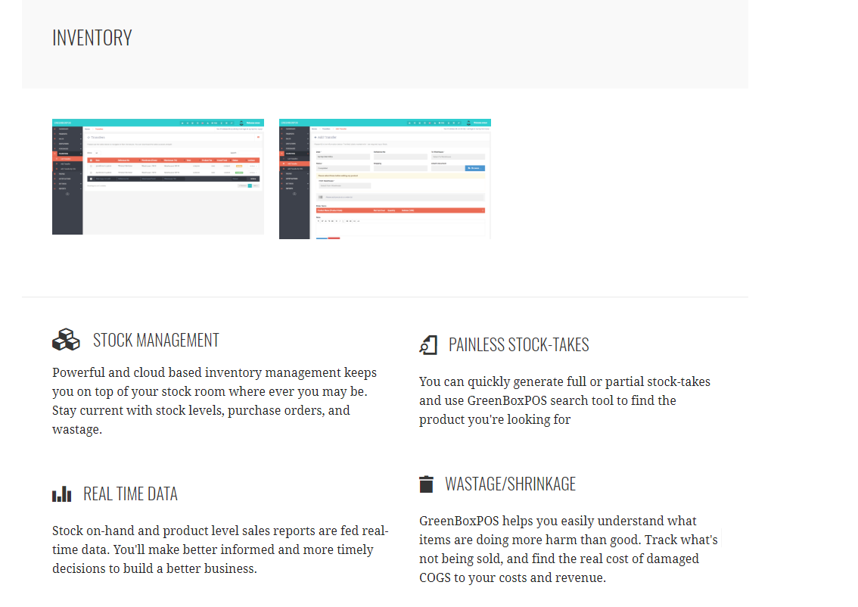

REPORTING

SEE THE BIGGER PICTURE
Get instant snapshots of what's going on in any one of your stores, or see all stores aggregated into a single report. Real time views of your sales history, customers, and popular products, accessible anytime and from anywhere.

ALL THE NUMBERS YOU NEED.
GreenBoxPOS comes preloaded with contextual reports to make sense of all your sales totals, costs, and customers. You can also export your sales history, right down to items and payments types and generate complex reporting Excel, or import into other software.

INSIGHTS
Go beyond simple reporting with our real-time analytics platform, powered by industry specific reports and ad-hoc queries alike. GreenBoxPOS Insights lets you dive deep into your data, help you make more informed business decisions.

EXPORT REPORTS
We included a tool that exports your reports to share with your bookkeeper or accountant. You can also export into spreadsheets and other reporting tools to get the Business Intelligence that’s right for you.
Copyright © 2017 GreenBox LLC — Escapade WordPress theme by GoDaddy

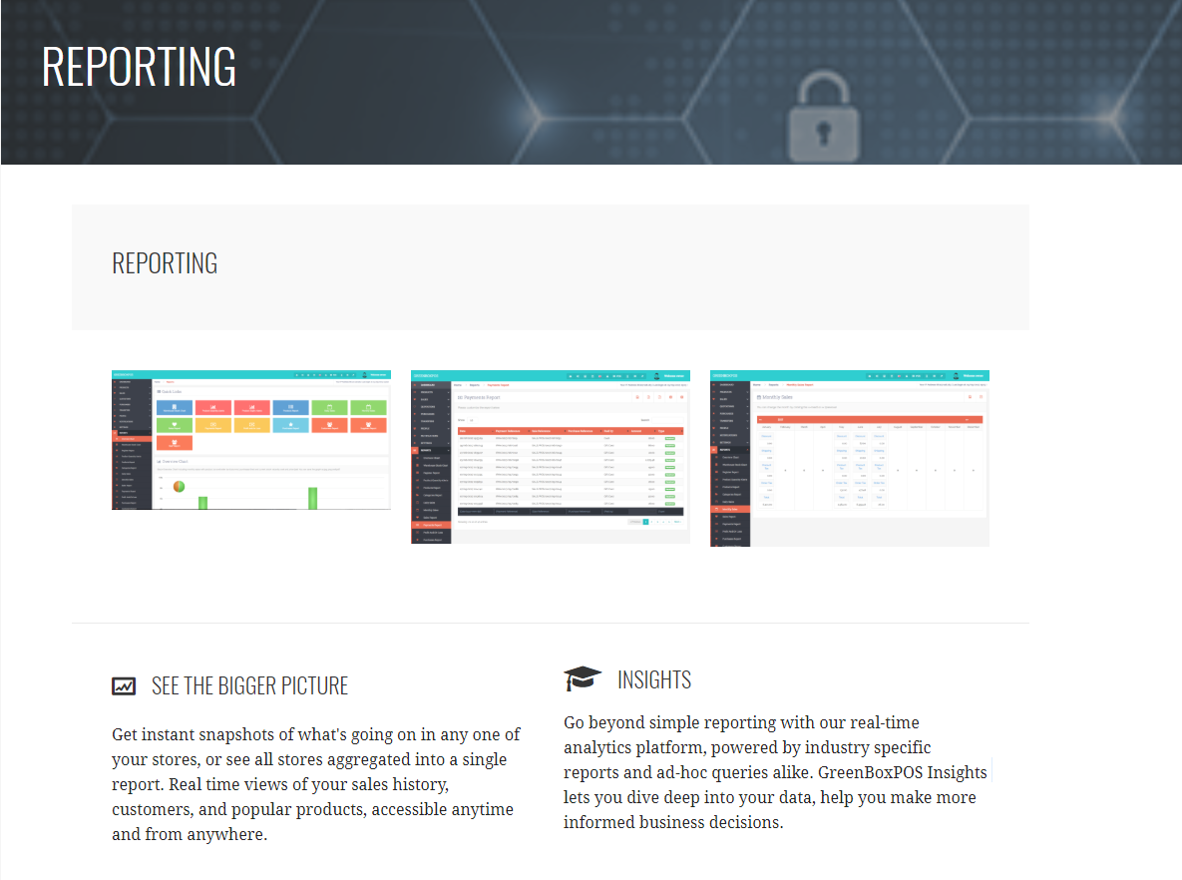

PRINTING
GreenBoxPOS robust printing feature supports an unlimited number of receipt or production printers in a store. You can connect each register to its own cash drawer and printer, or have several shares the same one.
Along with support for an unlimited amount of printers, GreenBoxPOS lets you define at the item-level which station it gets routed to. Send any item to anywhere, automatically and error-free.

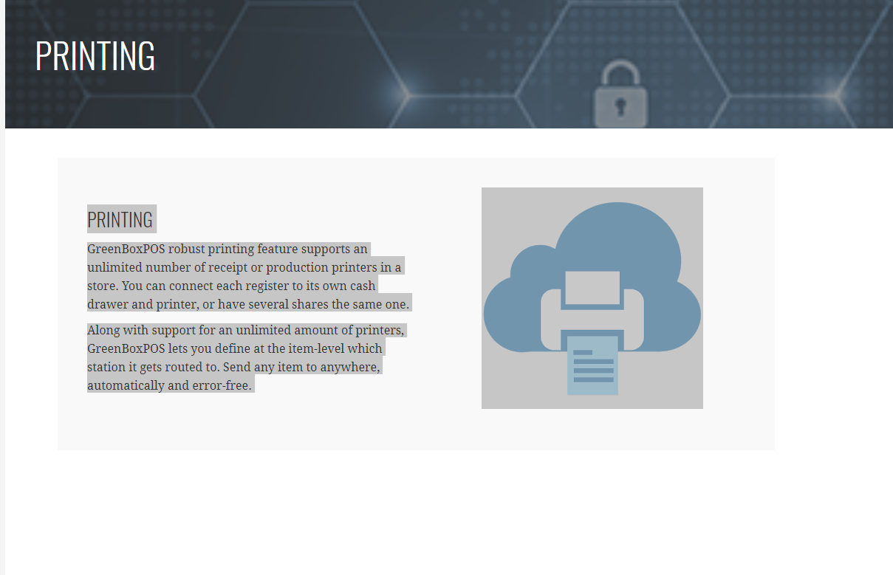

SECURITY

SECURITY
GreenBoxPOS is about providing uninterrupted, reliable service, making information security a major focus. Skilled resources, network redundancies, religious data back-ups, standby power, up-to-date security, and intrusion detection are mandatory components of our security procedures.
All GreenBoxPOS Customers get the benefit of a comprehensive, high-performance solution with a low total cost of ownership while keeping their data safe, their interactions secure, and their businesses protected.

