- How do you describe your company’s services and/or products?

Core Adventures is a South African Adventure Operator focused on providing exhilarating adventure experiences to both local and international customers alike. We are situated in Gauteng, South Africa concentrating on all types of adventure activities and tours within South Africa, Southern-Africa, and Africa. Whether you are alone or in a group, your adventure begins with Core Adventures.

Our slogan: “We live it, you’ll love it” is at the core of everything we do as a truly unique Adventure Operator. Core Adventures has partnered with exceptional people and companies to bring you a multi-location, multi-activity adventure experience specifically designed to enthral you and make you part of an unforgettable adventure that you can share with everyone.

Adding to the spirit of adventure, Core Adventures has incorporated numerous outdoors activity types including outdoor hikes, rock climbing, off road adventuring and many more. Our packages range from a single day excursion with multiple locations and events, to a full-weekend, or multiple-day excursions incorporating fun and adventurous activities that includes amazing overnight stays at various locations.

Whether you would like to stare a lion in the eyes, climb a mountain, or track an elephant on your next African safari, bring your friends along and meet new kindred adventurers that will join you on your next adventure with Core Adventures.

- Which logos do you like?

We did include a logo that we think could be used for the inspiration of a new, fun and exciting logo design. Our activities are predominantly outdoors, and the logo must instil a true African adventure theme that can be easily identified with our adventure theme. An obvious statement that the logo must be unique is stated as; well obvious. Something that shows driving, walking, climbing etc in African nature, and having fun with friends.

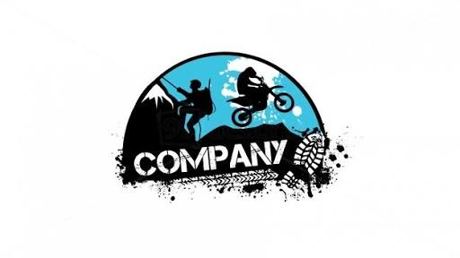
Also, our adventure vehicle of choice is a Jeep Wrangler Unlimited Rubicon. The current vehicle is standard, and we would like to replace the current star badge on the doors with the newly designed logo. Because Jeep Wrangler is synonymous with adventure, and the star badge is used on many Wranglers throughout South Africa (if not worldwide), we would like to keep the star incorporated somehow into the design. The idea is that once a person has seen the logo with a star motive on our “Core Adventures” vehicles, every Jeep Wrangler with a star on the door will be somehow associated with our brand. A logo that we can use on the vehicle that is unique and adds to our brand recognition is key. Also, our slogan “We live it, you’ll love it” must also be incorporated where possible.

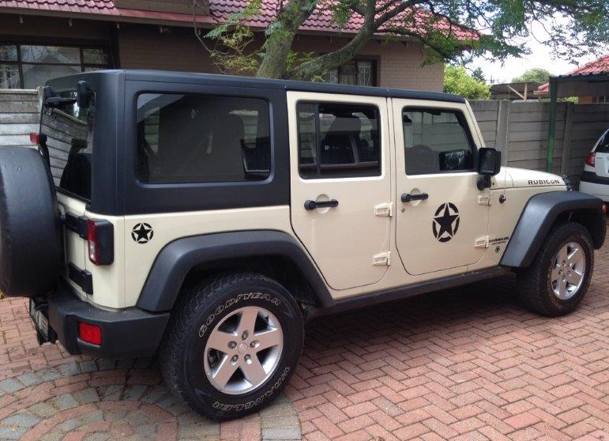

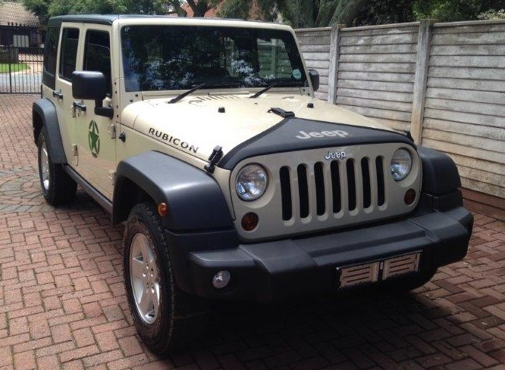

- What do you want your new logo to accomplish?

The new logo must have the feel of adventure and fun. We want a unique logo with the star incorporated that will aid in brand recognition, even from other Jeep Wrangler’s with star motives on its doors. This logo will be added to our vehicles, and the idea is that when you see a Jeep Wrangler with a star on the door, you will immediately associate this with our Core Adventure Brand.

- Who are your main competitors?

Our main competitors are other adventure tour operators. Our research has shown that there is not currently a brand that has the same focus that we have. We incorporate a multi-location, multi-activity package that is currently not on offer by other suppliers as a standard package.

- What’s the main age range of your target customer base?

Locally, our main target audience is adults above 21 in the mid to upper class society group. Younger couples, either married or unmarried without children. Older couples, either unmarried or married with children above 12 years of age is also a target market. Children cannot participate in some or all activities.

Overseas, our target market is couples, either married or unmarried above 40 years of age. Our research indicates that it will mostly be couples with older children over 16 years of age, that is interested in South Africa or Africa as a holiday destination.

- Do you have any colour preferences or existing brand colours?

Not currently.

- Do you have any fonts the designer should consider?

Not currently.

- Do you have a slogan, tagline, or motto? Does it need to be incorporated in the log?

Our Slogan: We live it, you’ll love it” must be incorporated into the logo if possible.

- Which brands inspire you?

Brands like Survivor, Amazing Race etc. was used as inspiration.

- What’s a reasonable time frame to create the best logo?

We are looking for the best logo. We are not too pressed on a delivery date at this point.

