Who We Are
Ace Global Solutions is an Ace Hardware International consulting service that provides strategy, operations, and organization recommendations as well as training based on Ace’s 94-year retail industry expertise. Our services drive significant and sustainable performance improvements so you can accomplish your company’s most important business objectives.
We are uncompromising in our approach to helping AIH Retailers make better decisions, deliver results, and address complex retail and organizational issues that require focus and effort, but have a substantial return on investment.

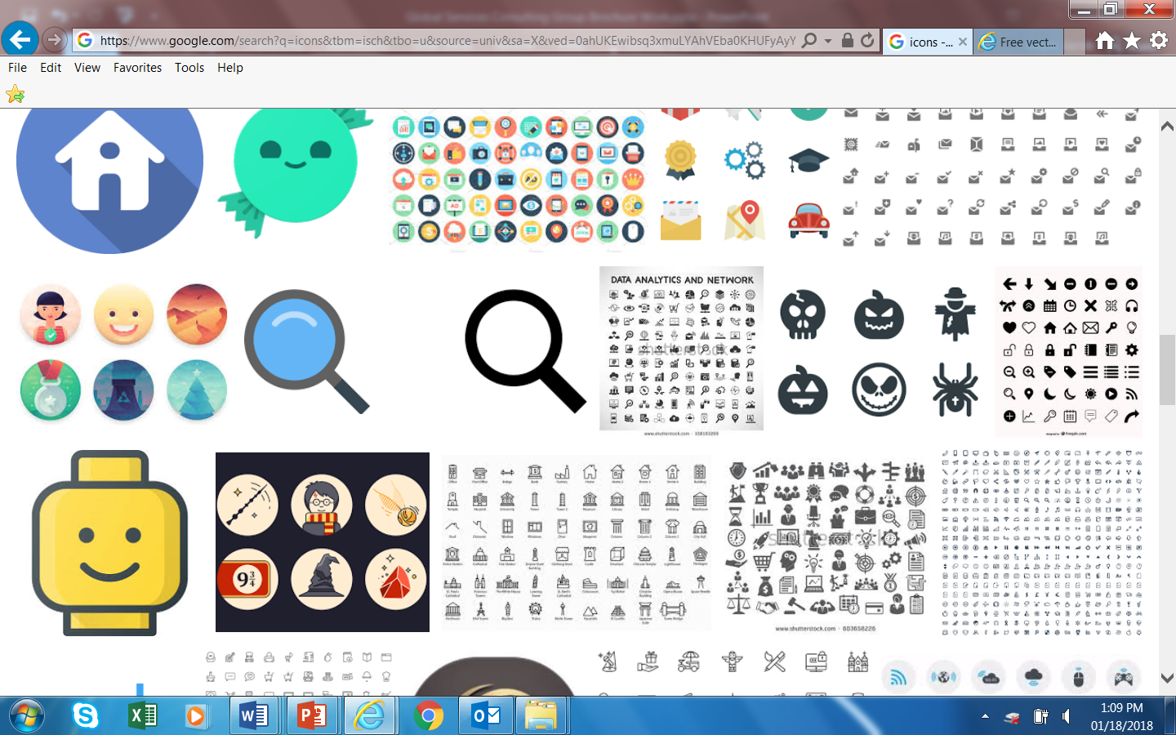Our Solutions
We specialize in the retail industry, offering 94 years of valuable expertise across several areas of your business:
- Business-to-Business
- Category Management / Merchandising
- Customer Experience and Engagement
- Leadership Development
- Loss Prevention

Don’t See Your Development Objectives Listed? We Customize!

- Marketing Solutions
- Organizational Design
- Retail Information Systems’
- Strategy Creation
- Supply Chain Optimization

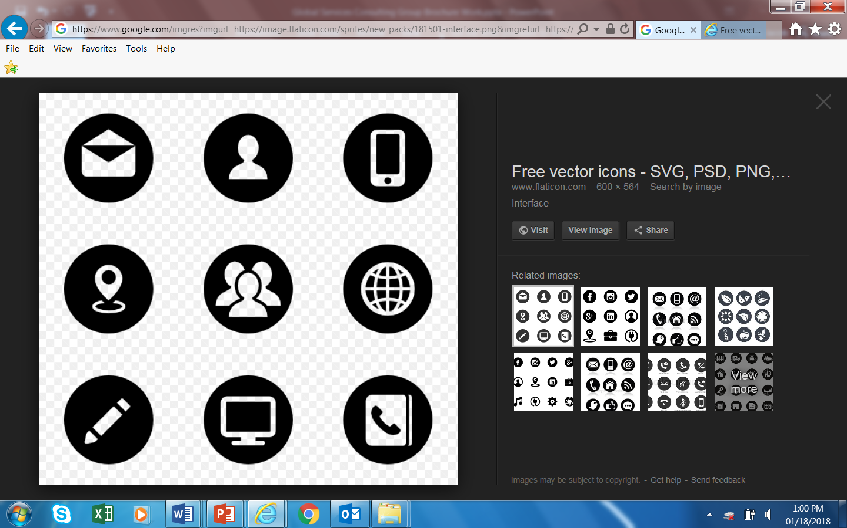Our Methods and Deliverables

Your success is our success. Our main objective is to ensure you become a more profitable retailer and the ultimate Ace brand ambassador.

Deliverable
- Sharpen brand performance
- Streamline processes/ Dissolve wasted costs
- Build high-performance teams
- Customize action plans
- Consistently follow-up and advise

Method
- Understand long-term vision and objectives
- Assess current state of affairs
- Engage Ace experts, & Ace best in-class retailers
- Set achievable KPIs
- Deploy in-market solutions

