- CONCEPT- REAL ESTATE AT THE JERSEY SHORE (THE BEACH). MARKET IS HIGHER END AND LUXURY HOMES ALONG THE COAST. LOGO NEEDS TO BE SOPHISTICATED, CLASSIC AND MEMORABLE.

- PREFERRD COLORS- BLUE, GOLD, TURQUOISE, SOFT ORANGE.

- OPEN TO- SHELLS, WAVES, ETC.

- DO NOT WANT- ROOF TOPS THAT MANY REALTORS USE, NO PALM TREES (WE DON’T HAVE THEM)

BELOW ARE SAMPLES OF LOGOS I LIKE.

#1- LOGO CAPTURES REAL ESTATE (house) AND JERSEY SHORE LIFE (Bird). Blue color is good maybe with gold. Needs more color

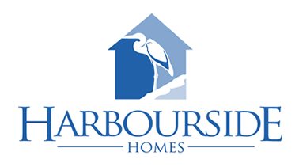

NOTES: LIKE THE BOLD LOOK, BOAT NEEDS TO BE CHANGED TO REAL ESTATE.
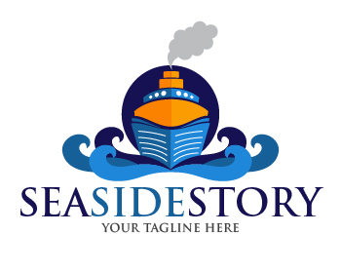
** NOTES- LIKE DEEPER BLUE, LAYOUT, SHELLS . NEEDS MORE “WOW” FACTOR.
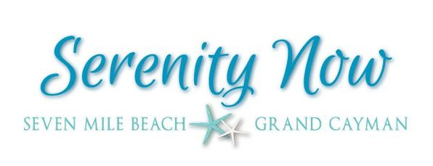

** NOTES- LIKE LAYOUT, SHELLS . NEEDS ADDITIONAL COLORS

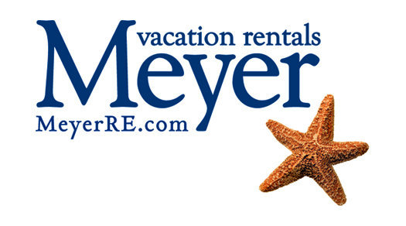
** NOTES- LIKE THE LAYOUT, SEAHORSE NEEDS TIO BE CHANGED, NEEDS ADDITIONAL COLORS

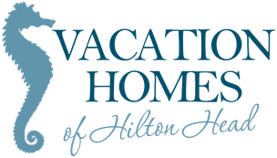
** NOTES- LIKE FUN LOOK AND MULTIPLE COMORS. THE SMALLER TEXT IS TOO THIN FOR SIGNAGE.

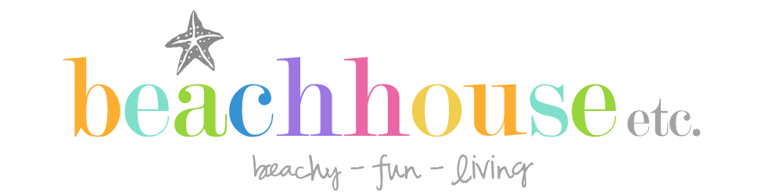

** NOTES- HOUSE LOOKS “BEACHY” …


** NOTES- COLORS I LIKE- TROPICAL BLUES, SOFT GOLD
