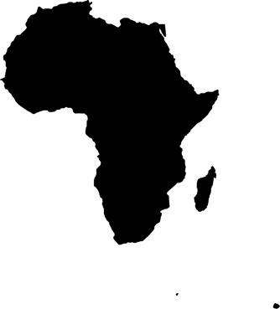
africaMASSIVE
INNOVATE. SHARE. LIVE.

ABOVE: Rough logo I made can be seen above… I had something like this in mind but open to any ideas.

BELOW: Some logos I found online, which I like, can be seen below…



