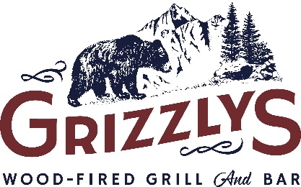
PRIVATE DINING ROOM

Thank you for your interest in reserving Grizzly’s Private Dining Room! We are more than happy to go above and beyond to make the most of your group experience – below are some helpful details about the room that will help you plan your event. See pages 2-4 for menu options.

Food and Beverage Room Minimum (before tax&gratuity):
LUNCH (Eating Prior to 3pm)
- Every day: $200 minimum
DINNER (Eating After 3pm)
- Sun-Thurs: $400 minimum
- Fri-Sat: $600 minimum

*If you do not reach the room minimum, we simply charge you the remaining balance to get your bill up to the room minimum. For example, if you book a Thursday lunch meeting and spend $165 in food and beverage (before tax and gratuity) we will charge $35 to the bill to get to the minimum of $200.
Gratuity: There will be an automatic 18% gratuity added on to the bill
Room Capacity/Layout Options:
Sit down dinner setting – accommodates up to 50 people
Happy Hour setting – up to 60 people (at one time, can hold more if guests are coming and going)
Layout options – U-Shaped (up to 24 ppl) , Large Square (up to 20 ppl), Other (up to 50 ppl)
Open to Patio – have the option to open three double doors from room to patio and block off a section of the patio right outside of the room, only available if weather is permitting
Miscellaneous Services:

Linen Fee (ivory tablecloths on all tables): $25 total
Cake Cutting Fee (for any licensed bakery dessert, cannot bring anything homemade): $10
Corkage Fee (per bottle of wine brought in): $12
Audio Visual: 60” LED Smart TV for presentations, picture slideshows, or watching the big game. Project wirelessly with Google Chromecast or with hookups via VGA, mini display port, or HDMI cables.
Decorations: We are happy to assist in setting up any decorations – let us know what you are thinking prior to the event and we can approve.

PRIVATE DINING ROOM MENU

APPETIZERS (price is by the dozen)

Texas Egg Rolls……….……………………………………………………….……………………………….$25
Chicken Wings (Buffalo, BBQ, OR Blackened)……………….……………………………………$12
Baby Back Ribs……….…………………………………………………….………………………………….$30
Sliders (Pulled Pork or Rotisserie Chicken)……...…………….………………………………….$35
Wood-Roasted Quesadillas……...…………………………………….………………………………….$30
Grizzly Skins…..……….…………………………………………………….………………………………….$25

PLATTERS – SMALL & LARGE (small serves ~10-15 – large serves ~25-30)

Chips, Salsa, and Guacamole.………………………………………………………………sm$25/lg$45
Fresh Fruit Platter….…………………………………...………………………….…….……sm$50/lg$75
Hot Artichoke Dip (comes with bread and tortilla chips)……...………...……sm$30/lg$60
Domestic Cheese and Crackers………...……………………………………………...….sm$45/lg$65
Fresh Veggie Platter……………….…..…...……………………………………………...….sm$40/lg$65

DESSERT OPTIONS (Price is per item)

House Made Cheesecake Slice (turtle, strawberry, or plain)……………………..….$5/slice
Whole House Made Cheesecake (turtle, strawberry, or plain)………………..$60 (15 slices at $4/slice) Assorted Bars and Cookie Platter (25 bars/cookies)….…………..…………………………..$25

BEVERAGE OPTIONS
We offer a full bar with a variety of NA, liquor, beer, and wine options All beverages will be charged per menu price

NA Beverage Host: Soda, Iced Tea, Lemonade, Coffee, and Hot Tea hosted by renter for their guests

Full Host: All NA and Alcoholic beverages to be hosted by the renter for their guests

Partial Host: A set amount or certain types of beverages hosted by the renter for their guests

Cash Bar: Each beverage will be paid for by each individual guest

LUNCH OPTIONS
(an option must be chosen for groups of 15 or more, served before 3pm)

Option A - $10-$12/Person
Pick Two Lunch Menu – Soup/Salad ($10), Soup/Sandwich ($11), or Salad/Sandwich ($12)

- Sandwiches: ½ Turkey Club, ½ BLTA, BBQ Pork Sliders (2), Wood-Roasted Rotisserie Chicken Sliders (2), Walleye Tacos (2), or Chicken Tacos (2)
- Soups: Chicken Wild Rice, White Chicken Chili, or Soup of the Day
- Salads: Wedge, House, or Caesar Salad

Option B - $13/Person
Served with your choice of fries, cheesy hashbrowns, soup, or apple cabbage slaw

- Applewood Bacon & Fajita Chicken Salad
- Rotisserie Chicken Salad
- Brown Sugar Bacon and Smoked Cheddar Burger
- Pepperjack Turkey Melt
- Walleye Fish Tacos

Option C - $13/Person Buffet Option
Food ready upon arrival, or at a set time of your choice

- Sandwich platter – Assorted Rotisserie Turkey Club, Ham and Cheese, and Veggie Wrap
- Rotisserie Chicken Salad Bar
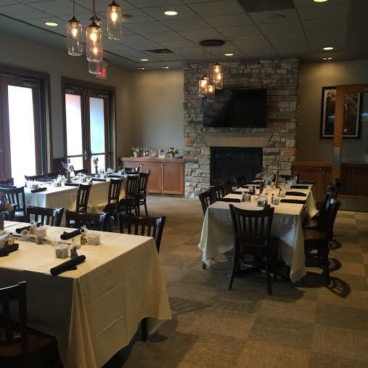
- Fresh Fruit Platter
- House-made Potato Chips

DINNER OPTIONS
(an option below must be chosen for groups of 15 or more, served after 3pm)

*It is greatly appreciated if you are able to give pre-determined individual menu orders to help
with food prep and operations of the event

Option A - $20/Person
Served with bacon & scallion mashed potatoes and steamed broccoli Also includes choice of starter house or Caesar salad

- ½ Grizzly’s Famous Wood-Roasted Chicken
- ½ Slab Sweet & Smoky BBQ Baby Back Ribs
- 6 oz Fresh Norwegian Salmon
- 6 oz Wood-Grilled Sirloin

Option B - $27/Person
Served with bacon & scallion mashed potatoes and steamed broccoli Also includes choice of starter house or Caesar salad

- 30-Day Aged Wood-Grilled Ribeye – 14 oz
- 6 oz Wood-Grilled Sirloin & Grilled Shrimp
- ½ Slab BBQ Ribs & ¼ Wood-Roasted Chicken
- Full Rack of BBQ Baby Back Ribs

