STARTERS

WOOD-FIRED WINGS
Buffalo, BBQ, Sweet Chili, Garlic Parmesan, Spicy Garlic, Blackened, or Signature Dry Rub. 11

HOUSE MADE BONELESS WINGS
Buffalo, BBQ, Sweet Chili, Garlic Parmesan, or Spicy Garlic. 11

PRETZEL BITES
Soft pretzel bites served with house cheese sauce. 9

TAVERN MUSSELS
One pound of mussels cooked in rich craft beer cream sauce. Served with grilled bread. 13

HOT ARTICHOKE DIP
Served with fresh bread & tortilla chips. 9

TEXAS EGG ROLLS
House pulled pork & veggies with sweet chili dipping sauce. 10

WOOD-ROASTED QUESADILLAS
Wood-smoked chicken, pico de gallo, pickled jalapeños, cheddar & jack cheeses, seasoned sour cream & salsa. 10

WISCONSIN CHEESE CURDS
Giant house cut cheese curds served with ranch. 9

SMOKED GOUDA NACHOS
Wood-roasted chicken, fire roasted corn salsa, fresh pico, pickled jalapeño & lettuce with smoked Gouda cheese sauce. 13

HOUSE MADE GUACAMOLE & CHIPS 7
POTATO SKINS
Crisp fried potato wedges with cheese, bacon, green onions & seasoned sour cream. Half 7 Full 9

GRIZZLY’S ENTRÉES

BEAR CREEK PASTA
Angel hair pasta, wood-roasted chicken, bacon & sautéed mushrooms, tossed with dijon-honey or Alfredo sauce, topped with cheddar-jack & mozzarella. 14

WOOD-GRILLED SIRLOIN
Red oak-fired USDA choice Certified Hereford Sirloin topped with roasted garlic butter, served with bacon & scallion mashed potatoes & charred broccoli. 6 oz 15 9 oz 19

WALLEYE FISH & CHIPS
Crisp breaded walleye with piping hot french fries, creamy coleslaw & house walleye sauce. 16

FRESH NORWEGIAN SALMON
Fresh Norwegian grilled salmon topped with charred corn salsa & shoestring potatoes. Served with bacon & scallion mashed potatoes & charred broccoli. 20

WOOD-GRILLED RIBEYE
14 oz corn-fed, 28 day aged, Certified Hereford Premium Beef, red-oak grilled & served with caramelized onions, loaded baked potato & charred broccoli. 28

WOOD-ROASTED And OFF THE SPIT
GRIZZLY’S FAMOUS WOOD-ROASTED CHICKEN
Served with a loaded baked potato & roasted brussels sprouts. 15
SWEET & SMOKY BABY BACK RIBS
Served with piping hot french fries & creamy coleslaw. Half-Rack 16 Full Rack 23
BABY BACK & BBQ ROTISSERIE CHICKEN COMBO
Served with piping hot french fries & creamy coleslaw. 20
WILDFIRE CHICKEN
Our famous wood-roasted chicken charred on our red oak grill & glazed with wildfire sauce. Served with cheese hash browns & roasted brussels sprouts. 16

SANDWICHES And TACOS

All sandwiches come with your choice of fries, cheesy hash browns, soup or creamy coleslaw. Upgrade to potato skins, fresh fruit or sweet potato fries. 2
CHICAGO STEAK SANDWICH
Ribeye shaved thin & grilled with giardanera & cheese sauce. Served with au jus for dipping. 15
CHICKEN TACOS
Grilled tacos filled with rotisserie chicken, black beans, roasted corn salsa, pico, lettuce & chipotle ranch. 11

WALLEYE TACOS
Your choice of Blackened or Shore Lunch Breaded walleye with green cabbage, mozzarella, lemon aioli & pico de gallo. 13

HOUSE SMOKED BBQ PORK
Topped with creamy cole slaw on a buttered bun. 10

AVOCADO BACON ROTISSERIE
Chicken, avocado, thick-cut bacon, provolone, ranch dressing, tomato & spring mix. 13

PEPPER JACK TURKEY MELT
Thick-cut bacon, lettuce, vine ripened tomato & spicy mayo on a pretzel bun. 13

WALLEYE SANDWICH
Lemon herb aioli, field greens, tomatoes & pickles. 14

SOUTHWEST SPICED-CHICKEN SANDWICH
Seasoned wood-roasted chicken, peppers, pickled jalapeños, onions, pepper jack cheese & spicy mayo on ciabatta bread. 11

BRICK OVEN PIZZA

BUILD YOUR OWN
House shredded mozzarella and house tomato sauce with your choice of toppings. 9

THE DOUBLE PEPPERONI
House made pizza sauce, jumbo sliced pepperoni, diced pepperoni, mozzarella & fresh herbs. 12

BBQ CHICKEN
Rotisserie BBQ chicken with red onions, green peppers, cheddar & jack cheeses. 12

SAUSAGE & MUSHROOM
House made fennel sausage with fresh mushrooms, mozzarella, tomato sauce & fresh basil. 12

THE WORKS
Pepperoni, sausage, green pepper, chopped green olives, mushrooms & onions. 13

EACH ADDITIONAL TOPPING
Rotisserie chicken • Pepperoni • Bacon • Italian sausage 2 each
Mushroom • Green pepper • Pineapple • Jalapeño • Red pepper • Red onion • Chopped green olives 1 each

SALADS & SoUPS
Add to any salad: rotisserie chicken 4 or fresh salmon 7

STARTER HOUSE SALAD
Mixed greens, craisins, pepitas, goat cheese with blood orange vinaigrette. 5
STARTER WEDGE SALAD
Iceberg lettuce, thick-cut bacon, cherry tomatoes, fresh herbs with bleu cheese dressing. 5

APPLEWOOD BACON & FAJITA CHICKEN SALAD
Fajita seasoned rotisserie chicken, fresh peppers, onions & roasted corn on top of crisp romaine with smoked bacon, cheddar jack cheeses, tomatoes, black beans & chipotle ranch dressing. 13

ROTISSERIE CHICKEN SALAD
Fresh romaine, wood-roasted chicken, tomatoes, bacon, cucumbers, cheddar & jack cheeses, carrots, toasted pecans & creamy house ranch dressing. 13

PERFECT SUMMER SALAD
Fresh romaine, fresh strawberries, fresh raspberries, pineapple, mango, red onion & pecans served with house poppy seed dressing. 11

COCONUT SHRIMP & TROPICAL FRUIT SALAD
Mixed greens with fresh mango, pineapple, raspberries, almonds, feta cheese & coconut shrimp topped with our house made Parmesan vanilla dressing. 15

WOODY’S CHOPPED SALAD
Wood-roasted chicken, mixed greens, bleu cheese crumbles, vine-ripened tomato, avocado, charred corn, thick-cut bacon, green onion & corn tortilla strips tossed in our house made honey-lime vinaigrette. 14
HOMEMADE SOUPS Cup 4 Bowl 7
- CHICKEN WILD RICE SOUP • WHITE CHICKEN CHILI • SOUP OF THE DAY

WOOD-GRILLED BURGERS
All burgers come with your choice of fries, cheesy hash browns, soup
or creamy coleslaw. Upgrade to potato skins, fresh fruit or sweet potato fries. 2 Add to any burger: Bacon 2, Mushrooms 1, Cheese 1.5, Grilled Onions 1
GRIZZLY’S SIGNATURE CHEESEBURGER
Double American cheese, fried onions, sliced pickles & signature burger sauce. 10
BROWN SUGAR BACON & SMOKED CHEDDAR BURGER
House made cinnamon brown sugar bacon combined with smoked cheddar cheese, fried onions & BBQ sauce. 12

HANGOVER BURGER
Cheesy hash browns, a sunny side up egg, American cheese & Grizzly burger sauce. 11

ITALIAN INFUSED BURGER
Giardiniera, pepperoni, and mozzarella infused into a ground angus patty. Topped with provolone & served with spicy mayo on a “dipped” focaccia roll. 12

JALAPEÑO SMOKED CHEDDAR BURGER
Jalapeños, bacon & cheddar jack cheese infused into a ground angus patty. Topped with smoked cheddar cheese & spicy mayo. 12

FOOD WARNING: State food safety agencies advise that eating raw or undercooked meat, poultry, eggs, or seafood poses a health risk to everyone, but especially to the elderly, children under 4, pregnant women, & other highly susceptible individuals with compromised immune systems.

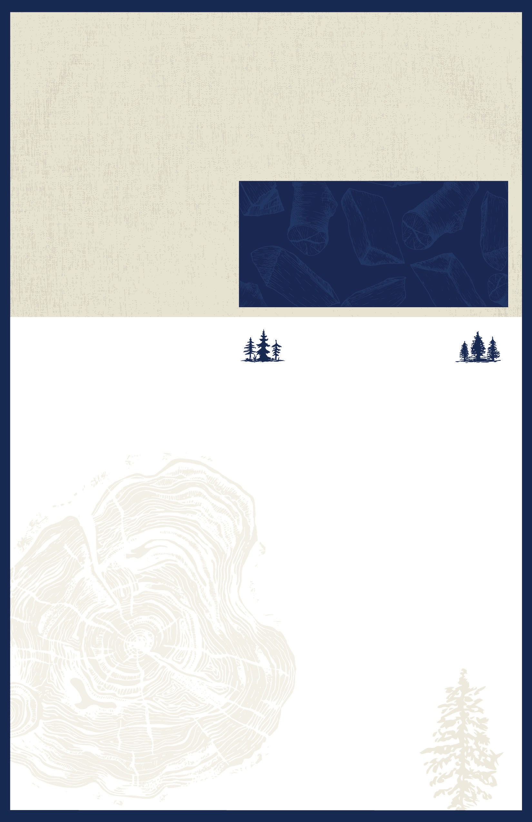
0418400WFGPLY

