Siren Imports website
This website is for a retail/wholesale company. It will have only one page layout used by all pages. However, that layout needs to include all common HTML elements and UI.
Here is the list of elements you need to include on your template with some examples:
- Top level menu above main menu, including
  - Phone
  - Email
  - Profile link
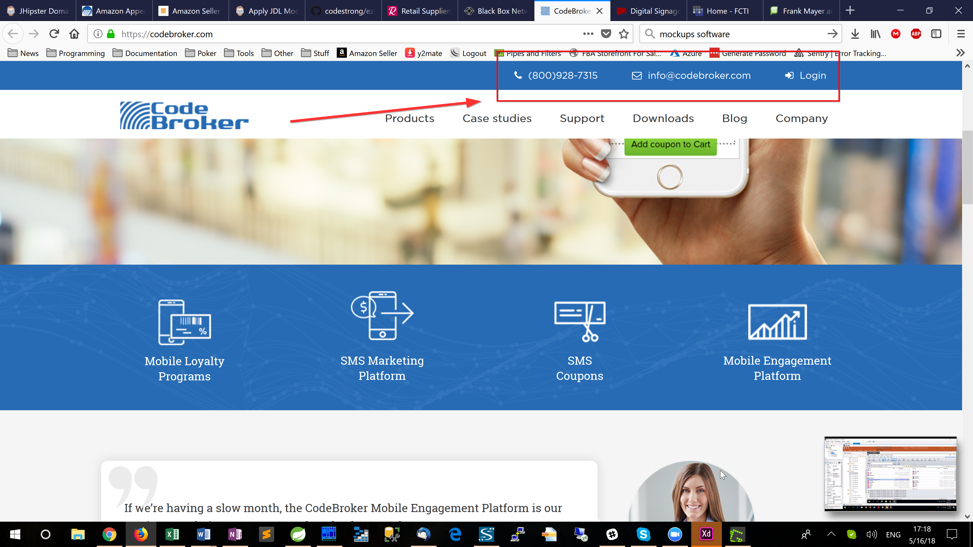
- Horizontal main menu with 1-level dropdown
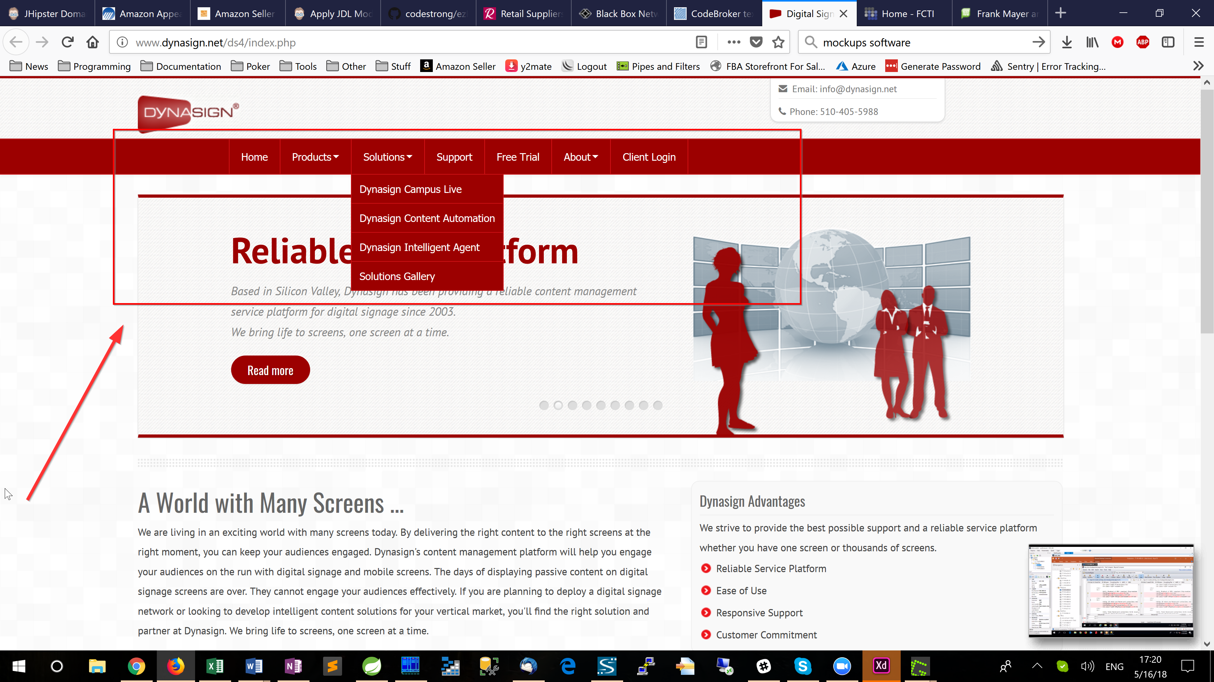
- Breadcrumbs
- H1, H2, H3 headers
- Table with a header row
- Unordered list
- Ordered list
- Footer with
  - Logo
  - Site map (on the example: Product gallery, Our Process, etc)
  - Social icons
  - Copyright
  - Links to XML site map and privacy policy
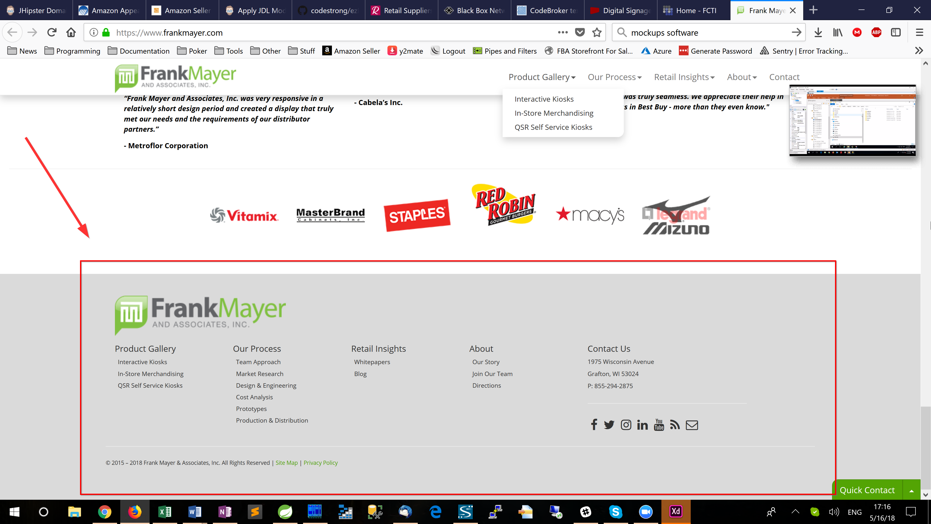

It will not be a responsive design.
It will be mobile compatible.

