NUTRITIONAL INFORMATION
Serves per Jar: 17
Serving size: 15 g

 | Per Serve | Per 100g
Energy | 212kJ | 1416 kJ
Protein | 0.05g | 0.3g
Fat - total | 0g | 0g
-saturated | 0g | 0g
-trans | 0g | 0g
Cholesterol | 0mg | 0mg
Carbohydrate | 12.5g | 83.1
-Sugar* | 12.4g | 82.5
Sodium | 2.3mg | 15mg
*Sugars naturally occurring in honey
Ingredients:100% Pure Australian Honey
Our Australian Manuka honey range are independently laboratory tested.

Lot 17 Weary Bay Road,

Ayton Australia 4895, +61 437412664

Bare Code

Recycled Container logo
Our Australian Manuka honey is sourced from pristine native leptospermum forests situated in tropical north Queensland.

Manuka honey gets it’s unique antibacterial properties from naturally occurring methylglyoxal (MGO). The higher the MGO rating the stronger antibacterial properties.

Simplified outline of map of Australia with a maker of our location Cairns
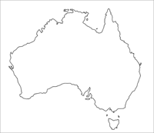
Bee (logo)Tropical

Australian Manuka honey
Leptospermum Polygalifolium Tropicum

250g Net

MGO
+183
NPA
+8

