NUTRITIONAL INFORMATION
Serves per Jar: 17
Serving size: 15 g

 | Per Serve | Per 100g
Energy | 212kJ | 1416 kJ
Protein | 0.05g | 0.3g
Fat - total | 0g | 0g
-saturated | 0g | 0g
-trans | 0g | 0g
Cholesterol | 0mg | 0mg
Carbohydrate | 12.5g | 83.1
-Sugar* | 12.4g | 82.5
Sodium | 2.3mg | 15mg
*Sugars naturally occurring in honey
Ingredients:100% Pure Australian Honey

Lot 17 Weary Bay Road,

Ayton Australia 4895, +61 437412664

Bare Code 0735850476605

Recycled Container logo

Simplified outline of map of Australia with a maker of our location Cairns
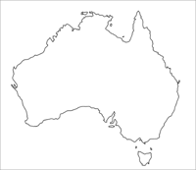
Our bee are located neighboring the Daintree and Cedar Bay National Parks. The bees forage from these pristine untouched rainforest producing a unique mixed flora source honey. One unique flower is that of the Pink Euodia. The Pink Euodia is also the host tree of the Ulysses butterfly.
Bee (logo)Tropical

Rainforest Mixed Flora Source Honey
1 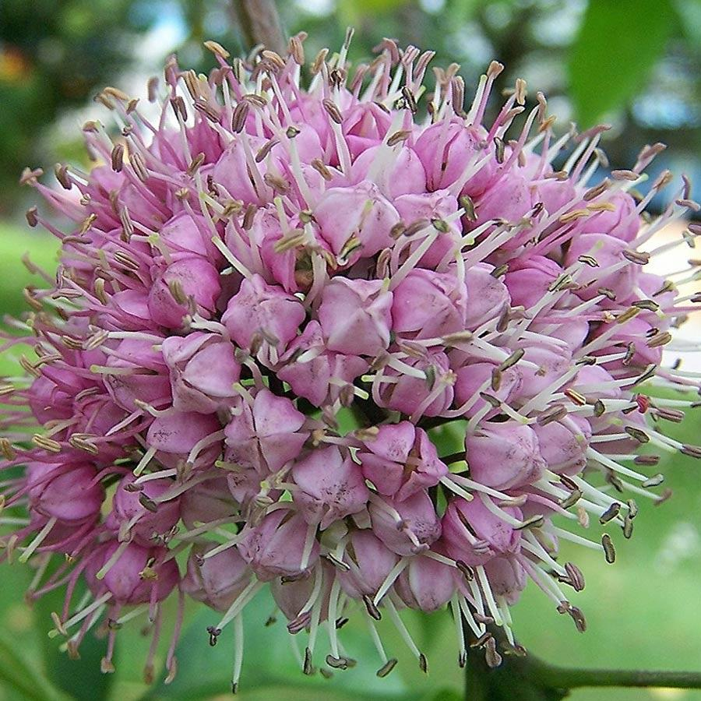kg Net

