A very small stiff brush, that is going to function as a tool for road cyclists to clean stones and grid off the tire while they are riding (small stones get into the tire - highlighted with green). The brush should be very small and should be able to attached to the stem or seat post (the places where it should be able to be attached is highlighted with red). The usability of the brush required to:
- Be small, so you can hold it with your fingers
- Have strong hairs, that doesn’t break when you put them in the rolling tire
- Have an attachable system, so you can take it off when you need it and put it back when you don’t need it

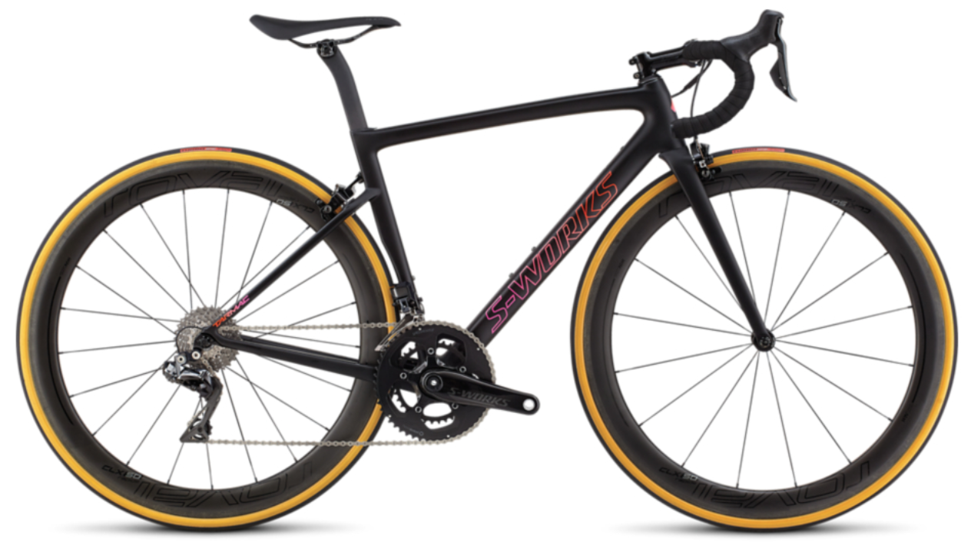

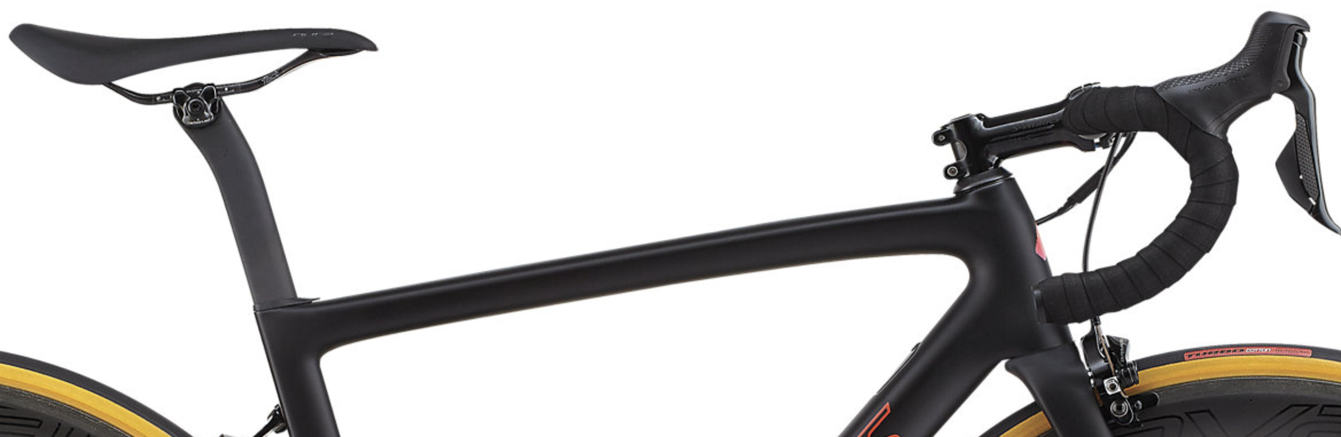
Sand, splinters and dirt on the tire

