Requirements for Logo: www.improvetheplanet.com

1) Describing our business
- This site is centred around ideas for a business or inventions that improve our world, this is very diverse, and can be crop production in a famine area, clean water, climate, medical, crime reduction, fitness and wellness, elderly care affecting large numbers of people or as simple and as targeted as a new cyber youth club in an inner city area. To understand more about us visit www.improvetheplanet.com

- What’s more we are not limited by borders or size, you may want to discuss your local area, you may have an idea that improves your local park, you might want to promote people that are doing good things encouraging others to join in, or on the other scale you may be interested in Global initiatives, you may want to discuss a global issue, you may have an idea that can improve the lives of millions, the choice is yours and the platform is here to facilitate you! Any important brand values or stories important to your brand

2) Logos we like
• examples of logos we like

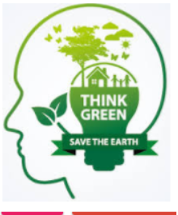
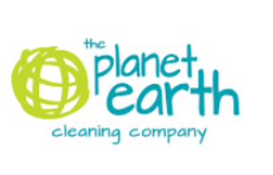

• logos we dislike

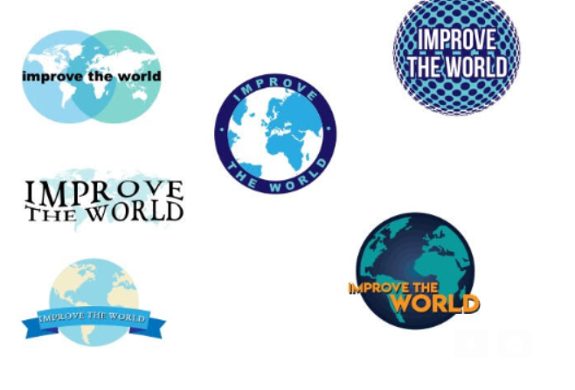

3) Your ideas
It’s ok if you don’t have any ideas and you wish to leave this to the discretion of our designers, but the more of an idea you can give us of the sort of thing you might like the better.
• Here are some of our concepts or inspirations we have created.

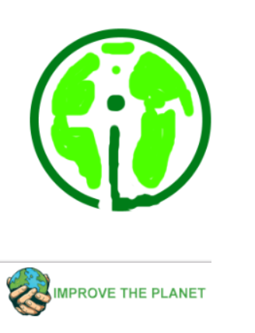

4) Feelings to convey
This is very important as the feeling you want to convey makes a big impact on the style, colour and font choices of the designer.
• The feeling is we are looking for a logo which shows we are environmentally friendly and encompassed our Brand ‘Improve the Planet’
• Are logo represent and encompass the values of the being Green, environmentally conscious and providing humanity hope.
• We are global and any wording needs to be translated across the site.
• We would like to consider the use of ITP (Improve the planet)

5) Colours and fonts
• Colour lovers – we like the Green and Blue, we would like to support Black & white.
• Font – Open to options.

6) Where will your logo will be used
• Websites
• Clothing – we will be looking to have a ‘ralphy’ top left small logo right through to spash designs on tshirts.
• Stationery
• Products and equipment
• Signage
• Labels
•

7) Who is your target market?
Our target market is very important for us to understand the style
• Targeting all Companies which are benefit the planet and humankind. Ethical companies and people. To get a feel google substainability.
• Targeting all genders and races.
• Targeting all age groups.

