Home
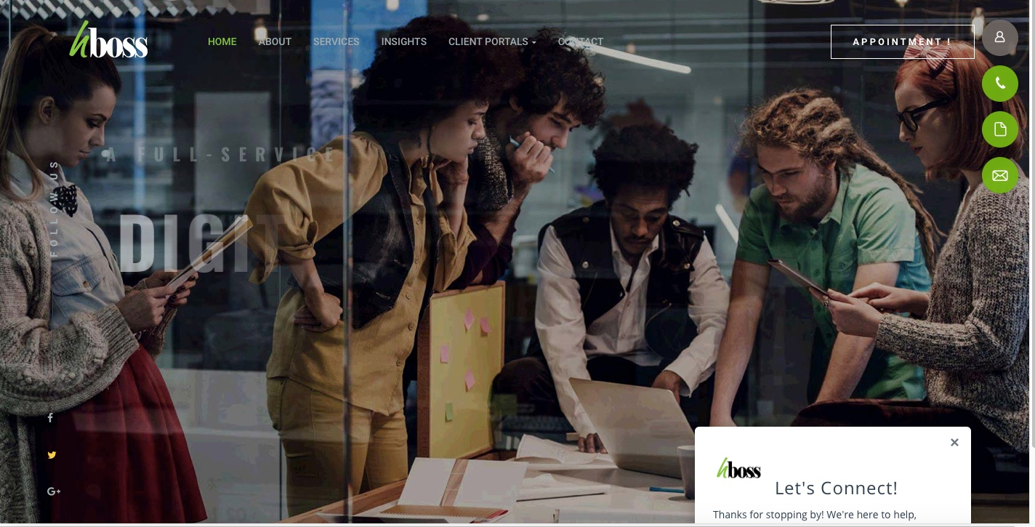
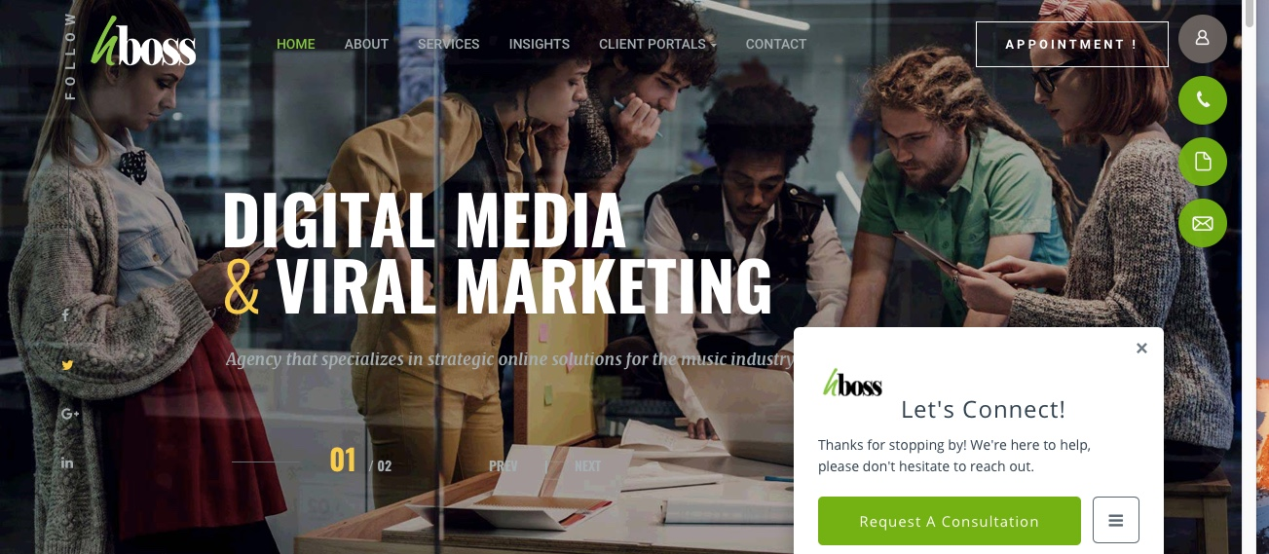
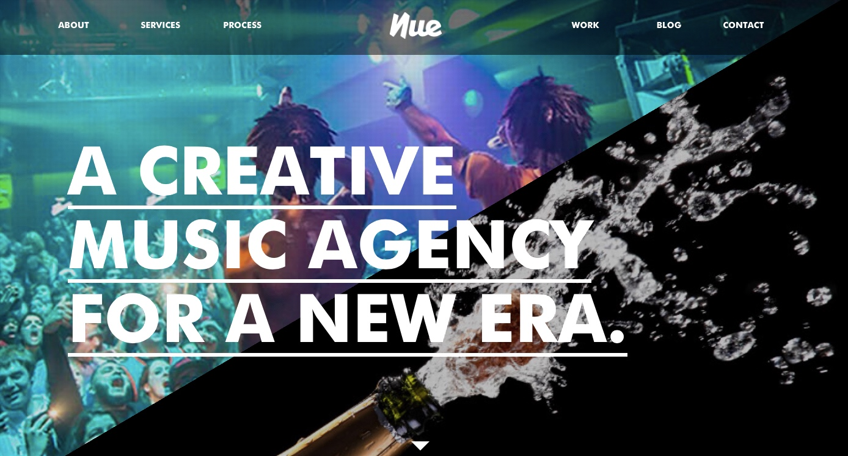
Notice that this homepage has a slider image
So Home Page Slide 1 will read

“Urban Grace Media, A Full Service Digital Marketing & Viral Marketing Agency
that specializes in strategic online solutions for the music industry.

Home Page Slide 2

Urban Grace Offers
Consulting services that increase profitability and engagement.

About
A PERFORMANCE BASED DIGITAL MEDIA AGENCY

WE ARE URBN GRACE MEDIA

We are an award winning, rapidly growing company that sits at the center of music, brands and technology.
Urban Grace Media is a full-service digital marketing agency that specializes in premier digital media solutions to connect musicians with their intended audience. In today’s age, the Internet boasts an unlimited number of opportunities for artists of any age or caliber. However, the Internet is only an effective tool if used correctly. The experts at Urban Grace digital offer innovative, effective, and insightful online marketing methods to increase the artist’s online presence, further establish their personal brand, and foster long-term success. Through the utilization of strategic methods and innovative technologies, hBoss proudly crafts engagement, monetization, and scaling solutions for both the individual artist and the enterprise-level business.

Services
Blog
Case Studies
Process
Work
Blog
Contact
http://music-club.bold-themes.com/main-demo/home-landing/home-female/
https://www.hbossdigital.com
http://www.trendsettermarketing.net
http://independentmusicpromotions.com/wp-content/uploads/2018/01/IMP-2018-i8pg-web.pdf
https://www.theblossomagency.com/contact/
https://www.thekarpelgroup.com/music
https://www.flytevu.com
http://nueagency.com
https://www.amworldgroup.com/music-pr
http://viewmaniac.com
Famehouse.com

