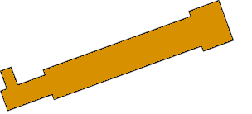
RUMMAGE
Inc.

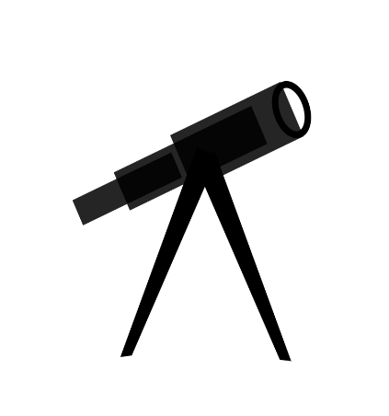
RUMM GE
INC.
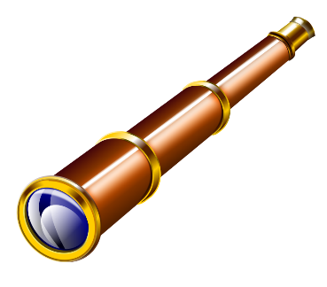

The word “Rummage” means search. We are a recruiting firm – i.e. a search firm. We would like the logo to be simple, clean and classy. Gave some ideas we came up with above, but really not sure. Maybe a spyglass incorporated like the one above – not sure. We look forward to ideas. Thanks,

