Brief for LBA Logo

Loyola Blakefield Aquatics (LBA) is a competitive swim team made up of kids aged 5 through 17. We are a small, but competitive team in the Baltimore, Maryland area. We want a logo that is professional looking, but fresh and fun, and most importantly easily recognizable. The logo should primarily consist of the letters LBA and can (but doesn’t need to) include the text Loyola Blakefield Aquatics. This logo will go on swim caps, bathing suits, and apparel, so it is important that the logo stands out and is clear so that when our swimmers swim, other teams and potential swimmers know what team they are looking at.

Mission Statement: To Strengthen the Greater Loyola Blakefield Community by helping swimmers, coaches and families explore and discover their full potential in the sport of swimming

Our Web Site: https://www.teamunify.com/Home.jsp?_tabid_=0&team=mdlba

Requirements:
- Logo Can be a Maximum of 2 colors
- Logo must include or use the letters LBA prominently
- Logo must look good when printed on black and/or blue bathing suites (see image below)
- Logo must have a fresh feel that looks professional but appeals to younger kids (main team demographic is 5 to 16 years old

Logo on Bathing Suit
- Logo will be printed on a bathing suit in similar locations to below.
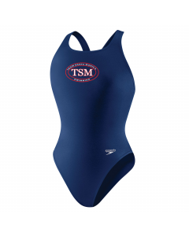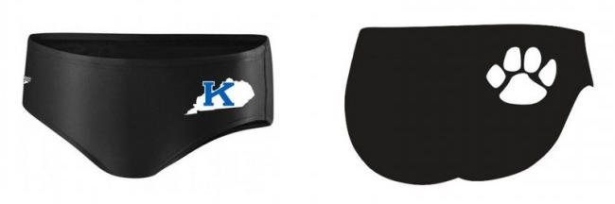

Current Logos:
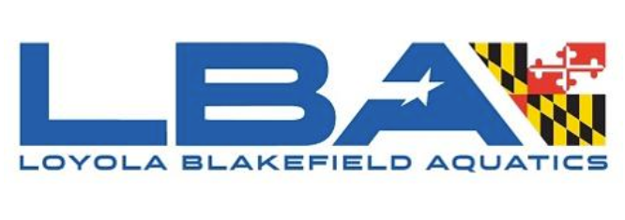
Blue: #245DAA
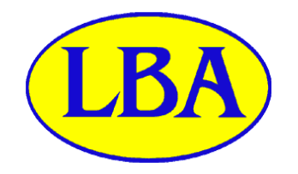
Blue: #1109DA
Yellow: #FFFD00

Logo Inspiration
