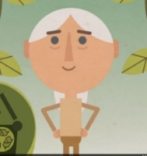
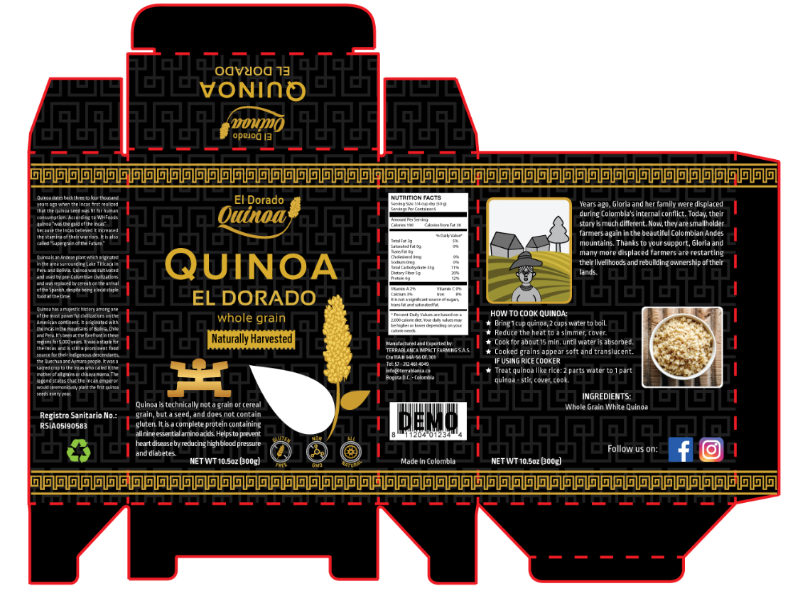
Please send this to the left, just above the net weight, and lower the recipe accordingly
Please make these logos a bit smaller, it doesn’t adjust well with the Net Weight sentence next to it
Please delete the sentence “It originated with the Incas in the mountains of Bolivia, Chile, and Peru. It’s been at the forefront in these regions for 5,000 years”
Please delete the sentence “Helps to prevent heart disease by reducing high blood pressure and diabetes”, and reorganize accordingly
Please center text with farmer image, both to have the same length
Can you try something more like this one? (but keeping the mountains and houses in the background)

