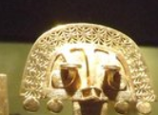
FRONT Box dimensions: 20.5 x 10 x 4 centimeters


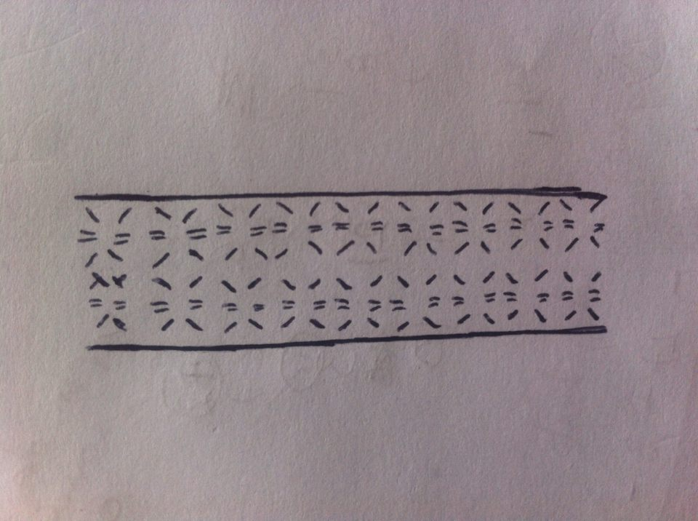
Golden tones and use of prehistoric shapes as sequence. NO NEED to use the same shape. Multiple shapes can be alternated.

LOGO
Mostly Black Background

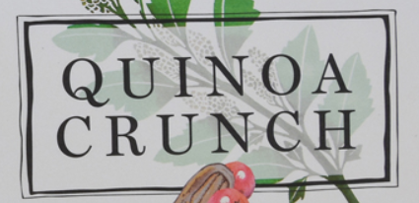
Quinoa El Dorado

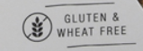
Small Text Description of the Product. In White color fonts with the same black background
Product Info Text and Icons

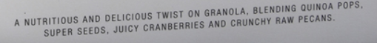
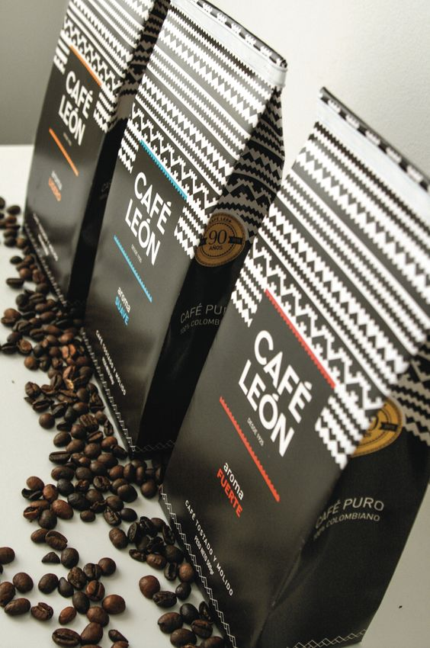
Example

SIDE 1 Box dimensions: 20.5 x 10 x 4 centimeters

Ideas are welcome

SIDE 2 Box dimensions: 20.5 x 10 x 4 centimeters

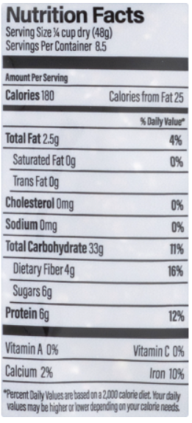

Small Text Manufacturing Description. In White color fonts with the same black background.
Made in Colombia….


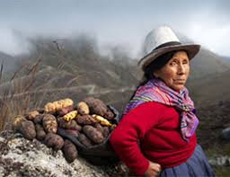
BACK Box dimensions: 20.5 x 10 x 4 centimeters
Recipe description
1.
2.
3.
4.

Recipe picture
Instead of a real picture, please create a cartoon version of a similar lady. Example (but turned into a farmer):

Small Text Manufacturing about the story of the farmers and origins of the product.

Small Text Manufacturing about the story of the farmers and origins of the product.

