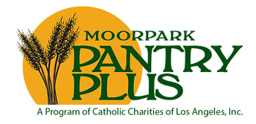

The 5th Annual
Moorpark Pantry Plus
Harvest Dinner & Casino Night

Friday, October 27, 2017
Doors open at 6:00pm!

Moorpark Country Club
11800 Championship Drive
Moorpark, California 93021

Join us for an unforgettable evening as we celebrate and support Moorpark Pantry Plus.

All proceeds go to Moorpark Pantry Plus to serve
the greater community!

The benefit will feature casino tables and great raffle prizes!

Reserve your tickets ONLINE for the early bird price of $85 per person.
www.pantryplus.org
E-mail: events@pantryplus.org
Phone: (805) 529-0720

