Ice & Fire Distillery, Caithness, Scotland
Background information
The name Ice & Fire comes from the aurora borealis which we see all winter in the Caithness skies. I see the aurora from my back door and often watch it through the night. People often think that you can only see the aurora in Iceland or Norway but stunning examples of what we see are on you tube (see following links)
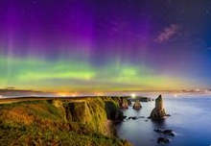
https://www.youtube.com/watch?v=qpMa-vNB9mo
https://www.youtube.com/watch?v=fVsONlc3OUY
Ice & Fire Distillery will be a family venture consisting of three families who are crofters in the same area.
Highland Crofting is an important theme for our provenance. We were brought up on a croft and all went on to have their own crofts. The image of small single storey croft houses are important to us, as are ruined crofts as they evoke the image of the Highland Clearances.
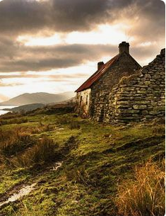
Purple Heather – heather is important to us image wise. In the summer months, we are surrounded by the purple heather on the hills and grouse moors. The birds and animals on the highland moors are important to us as we see deer, grouse, pheasants and partridges on a daily basis. They are a strong image for us.
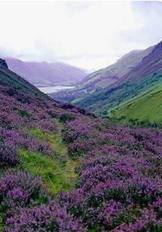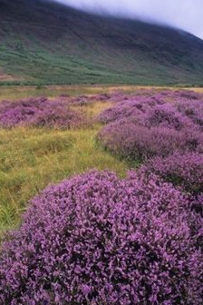
Deer and grouse – have been a big part of our life as my father and then Iain were gamekeepers on the moors.
Mountains – we can see the mountains, Morven, Scaraben and Maiden Pap from where we live.
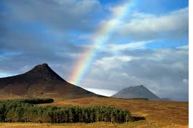
Sea – All three households can see the sea from our windows so the sea has always been important to us. This is the Latheronwheel burn that goes from our land down to the sea, I mile away.
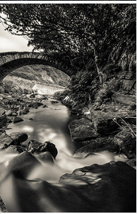
The area where we live is our USP –
We are looking for labels for our first gins to be produced. The first will be called Caithness Gin or Caithness Highland Gin and the second gin is called Crofter’s Tears. We are looking for label imagery that can be used a across a range of different gins that we will produce. We want the labels to evoke a luxury, premium brand as this will be at the top end of the gin pricing range. Gold or copper lettering/colours will tie in with our copper stills. We need the design to stand out on the shelf amongst a sea of gins in predominantly clear bottles with a lot of white labels. We need something with shelf appeal and something that is distinct on the bar shelf so it stands out from the others.
In terms of bottles, we have not made a decision. Cost will predominatly be the driver as we are a start up distillery and have not traded yet. The three options are:
Clear “oxygen” bottle from saverglass as follows
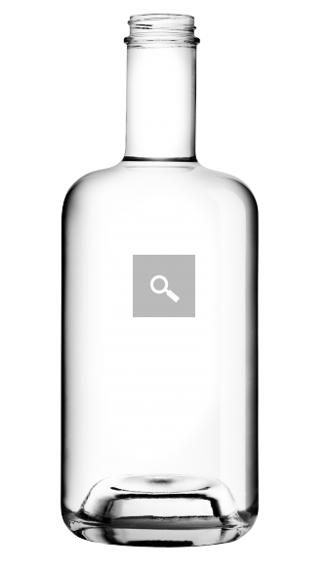

The second option is from Rockwood glass and is an interpretation of the following bottle. If we were to get this bottle, it would have a stag head on the top part of the bottle with the Ice & Fire Distillery etched into the glass at the top.
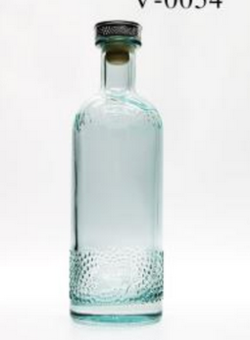

Option three is a black bottle but we haven’t picked one as we don’t know what our label is going to look like.

