We want a layout for a beach flag. The flag should draw attention to our socks shredder at an event. The dimensions and artwork can be found in the appendix.
Company colour: RGB 206/222/1
House font: Blender Pro Bold
The Backround must be in our green.
The following must be on the flag:
CEP Logo
((Text)) Socks Shredder
The face of a panther. The face must be made with triangle technique.
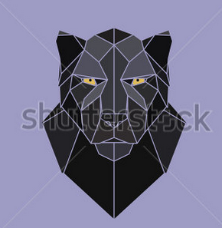
Example:

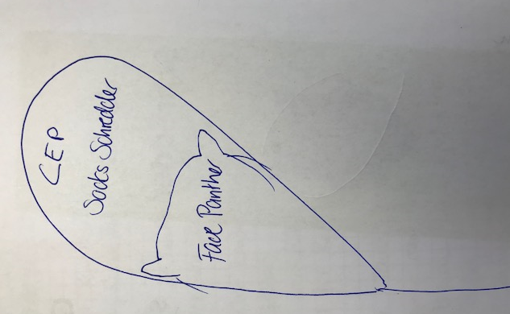

We imagine the layout like this.

