Front side: I would like to see the elements of the event included (although not necessarily bulleted like below) :
- Social hour
- Music
- Hors d’eourves
- Refreshments
- Santa Maria-style BBQ dinner
- Coffee & dessert
- Prize drawings
- Stories from camp

Perhaps the back side of the postcard (the half side with the address & stamp) would have copy similar to the following:
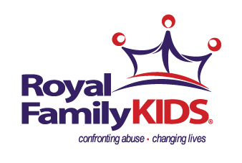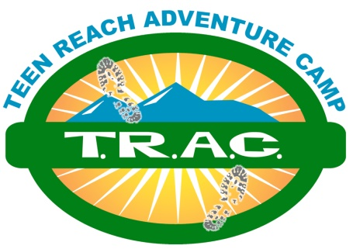
Royal Family KIDS Camp & Teen Reach Adventure Camp
of Ventura Missionary Church

invite you to join us for

FosteringHOPE2018
raising awareness & support for children of abuse

at the exclusive
Ancient Creek at Petersen Ranch
3400 Somis Avenue, Somis, CA
on
Thursday, May 24, 2018
6:30-8:00pm

Tickets $30 per person/Available at Eventbrite.com
All proceeds to benefit RFKC & TRAC serving children of abuse ages 7-14.

For more information:
RFKC: Director Ken Klopman (805) 432-6210 / rfkcventura@verizon.net
TRAC: Director Nick Mehle (805) 377-1360 / nickmehlephoto@gmail.com

