This is an updated version of the first outline

- Webpage

www.legal4sales.com

Legal4Sales
LI4IS
L4S
Legal4Sales
LI4IS
L4S
Legal4Sales
LI4IS
L4S

Business:

Contract Training
Contract Design
Contract Template

- Logos:

Letters black Transparent :



Letters Black, white Background:


Letter white, Black background:


Letters white, transparent:



Letters grey, transparent:



- Requirements:

Booking different trainings (online and local class)
Booking Appointment for Consulting (1st appointment free)
Request to be contacted
Payment via credit Card, etc.
Videos: introduction video free
Trainings Video after payment in login area
Striked out old price
Several links in header and footer
Connect Emails Info@legal4sales.com >> Google accoount
Run on phones/tablets

- Example Reference Webpage:

www.consulting.com use similar structure

See screen shots from “login area” for online video trainings or under “Consulting” below.

However, first draft should use as main colours: black (matt), white, light grey,darker blue, (a little green, but be careful, rather less)

No much scrolling down prefered, so a page should not be too long.

Not so many pictures, if at all.

Look and feel should be a mix of the following items:

- Colours and forms, layout, feeling, mix of colours, lean structure elements

https://www.sortlist.be/en/web-design/belgium-be
https://www.designcrowd.com/design/6374387or
https://www.designcrowd.com/design/6372391 or https://www.designcrowd.com/design/6374366
https://www.designcrowd.com/design/5896857
https://www.designcrowd.com/design/5902173
https://www.designcrowd.com/design/17197349
https://www.designcrowd.com/design/5464461
https://www.designcrowd.com/design/7180908

- Our current business Card image


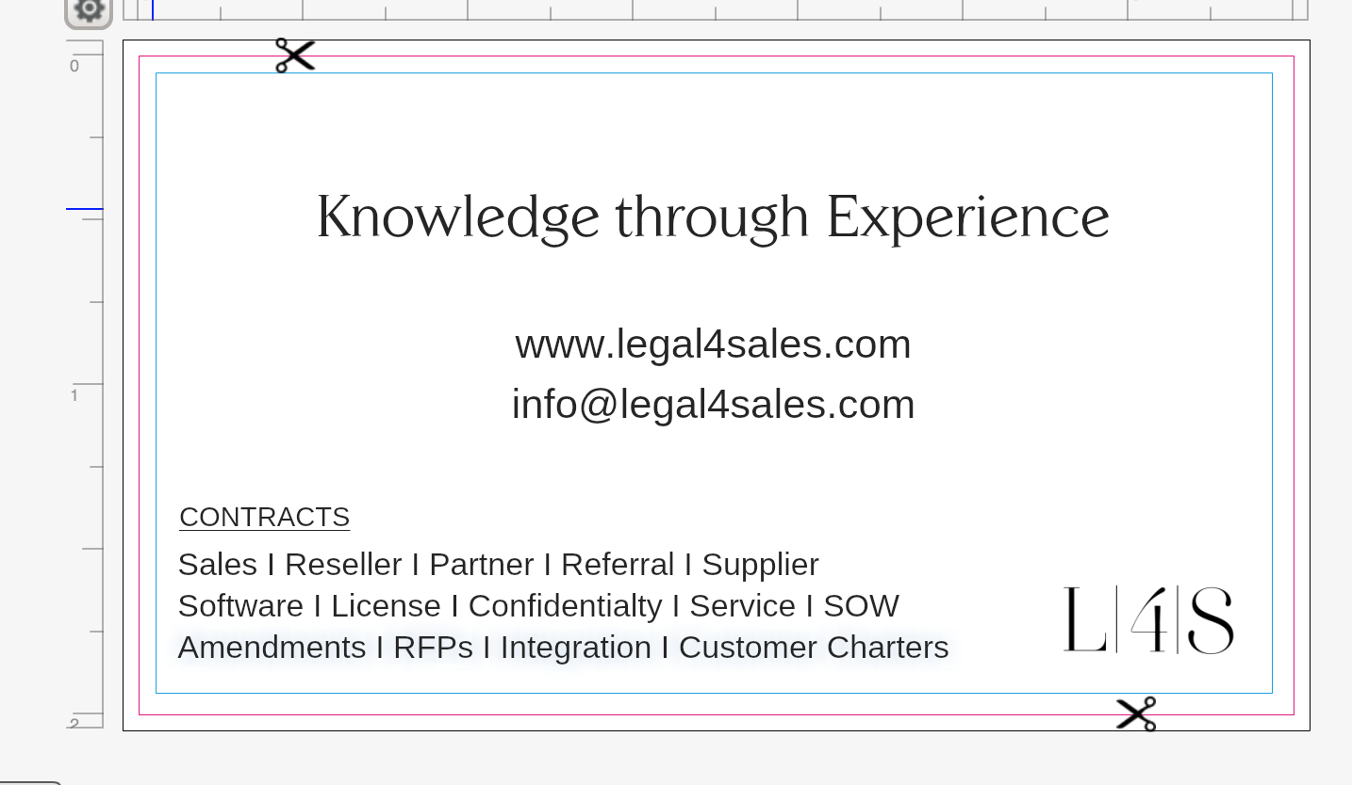

- A quick first wix draft from us, but consider the look and feel examples I provide please.
https://daniel-kalisch.wixsite.com/mysite-1

In the outline below, I changed the concept for new designers joining the contest. So please just don’t use “Enter”. I changed concept for the second part of the contest, if new designers join. So NO enter page. Selection of Service will happen already on the first page on the picture area.

PS: for the current developed drafts of designers, please keep everything as is.

>>> However, outline below needs to be applied. And your own creativity should be added to let it look professional. However, it needs to look lean and well structured. Straight forward.

- 1. Landing Page:

Picture with 3 buttons, no logo, no enter
Testimonials
Footer

>>>>>
I changed concept, Not only an enter pager, so please just don’t use “Enter”. I changed concept for the second part of the contest, if new designers join.

Picture

Picture with the following text:

Legal4Sales

CONTRACTS
Training I Design I Template

Training/Design/Template shall be 3 buttons to enter the next page.

Background: a dark/black transparent background with a business foto/related to the topic.

This page needs to be somewhat of value, but simple at the same time, in 16:9 format.

If I land on the first landing page, only the picuture part shall be seen. If I scroll down then I can see the testimonials

Testimonials
3 testimonials, more horizontal.
Little picture (round), stars, name company, quote.
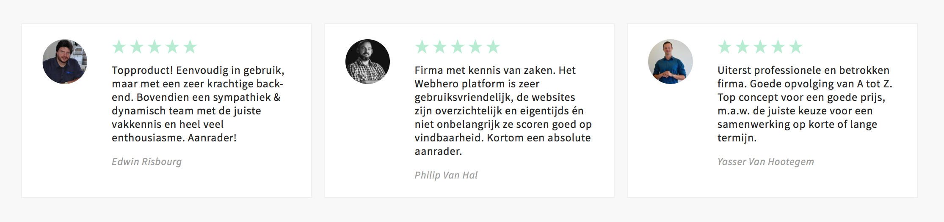

Footer

Evaluation Students Policies Team
Market Feedback Templates Tools Contact

©2018 Legel4Sales.com

Footer and header (shall not have the same links).

- After click on one of the buttons (Training, Design, Template) Header should be structured like this:

Logo Legal4Sales Refer Someone Services Partner Login

Contract Training: www.legal4sales/training

Layout?
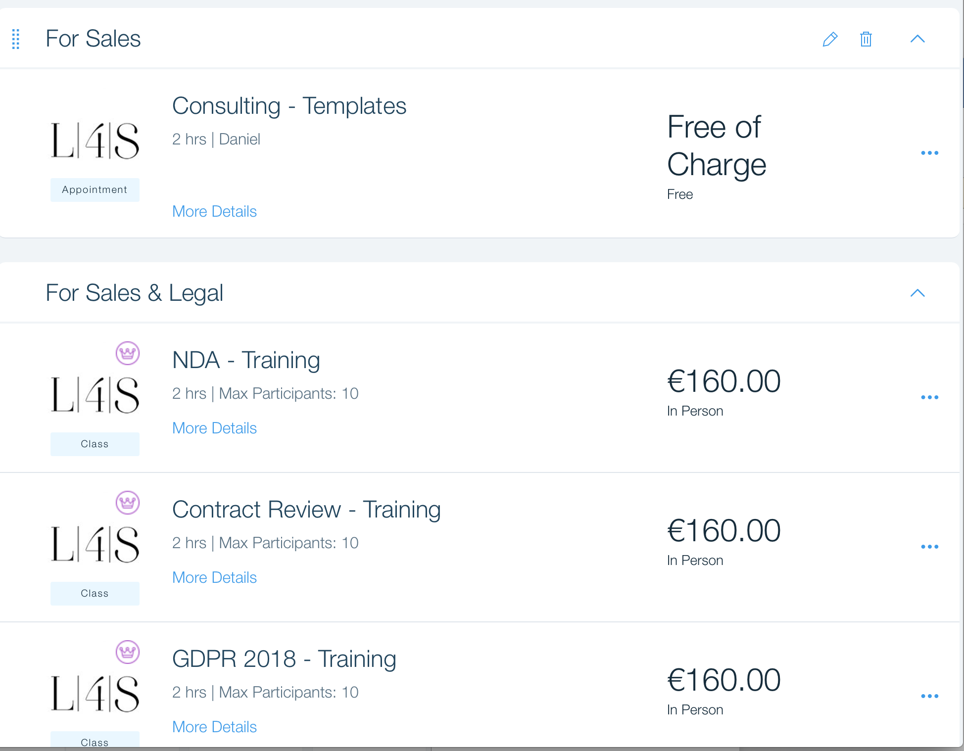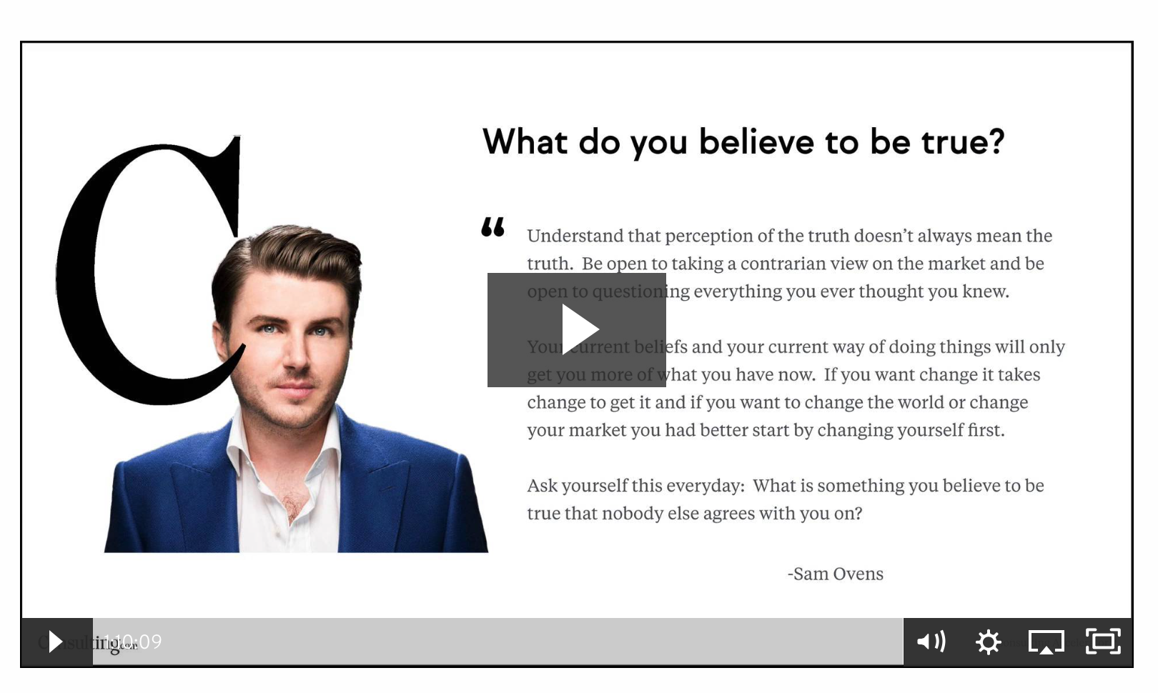
Teaser Video for each Training 1 min upon click

>>>>

Select Your Training

NDA Training Class Book
Online

Content Benefit Material
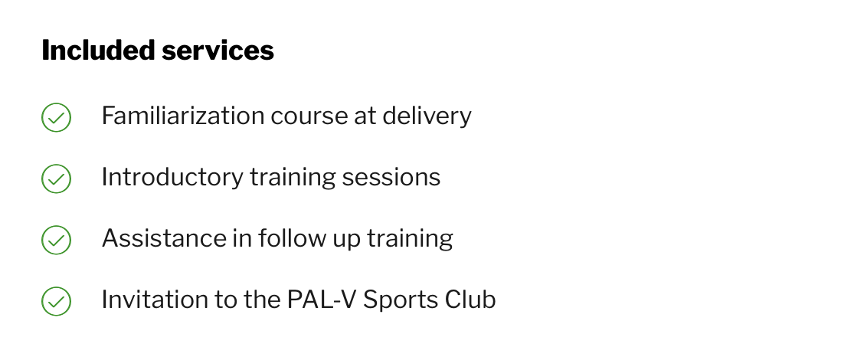

Contract Revewi Class Book
Online

>>>>
Content Benefit Material

To be added more

>>> if class>>

Calendar > show availability during the year + select
contact details>> Form
payment details >> Form , Visa, Mastercard, paypal signs
>> see below under payment (last page)

Email Confirmation

>>> if Online >>>

contact details
payment
Email Confirmation

>> If Online: Login area for 2 Weeks available
>> if not watched at all > 2 times extension
>> if watched no extension, after 2 weeks account is locked again
>> Password via email for each subscriber

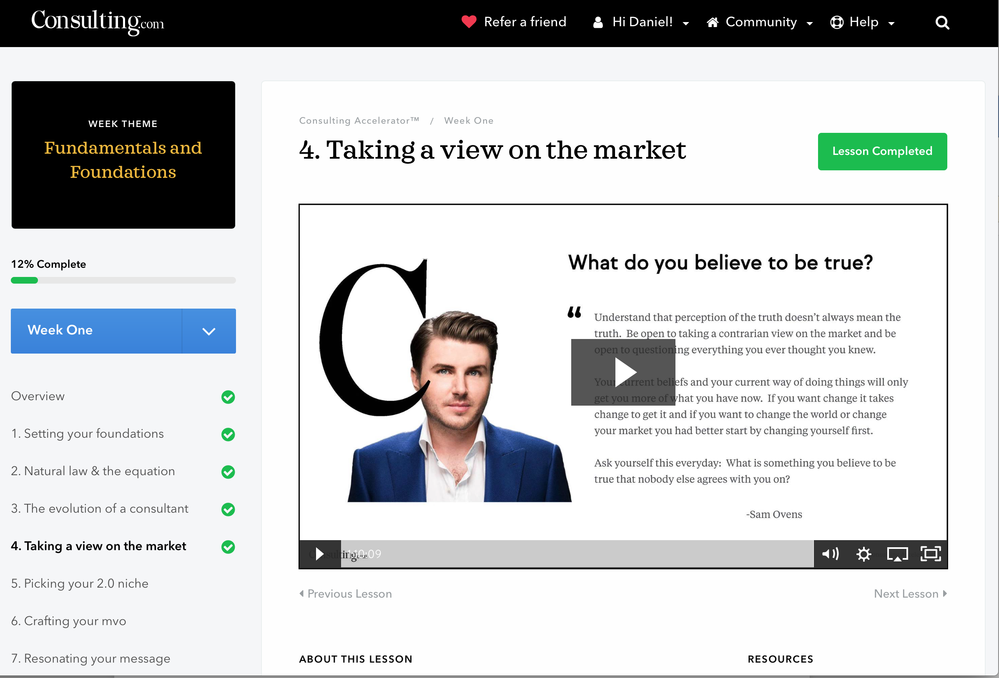

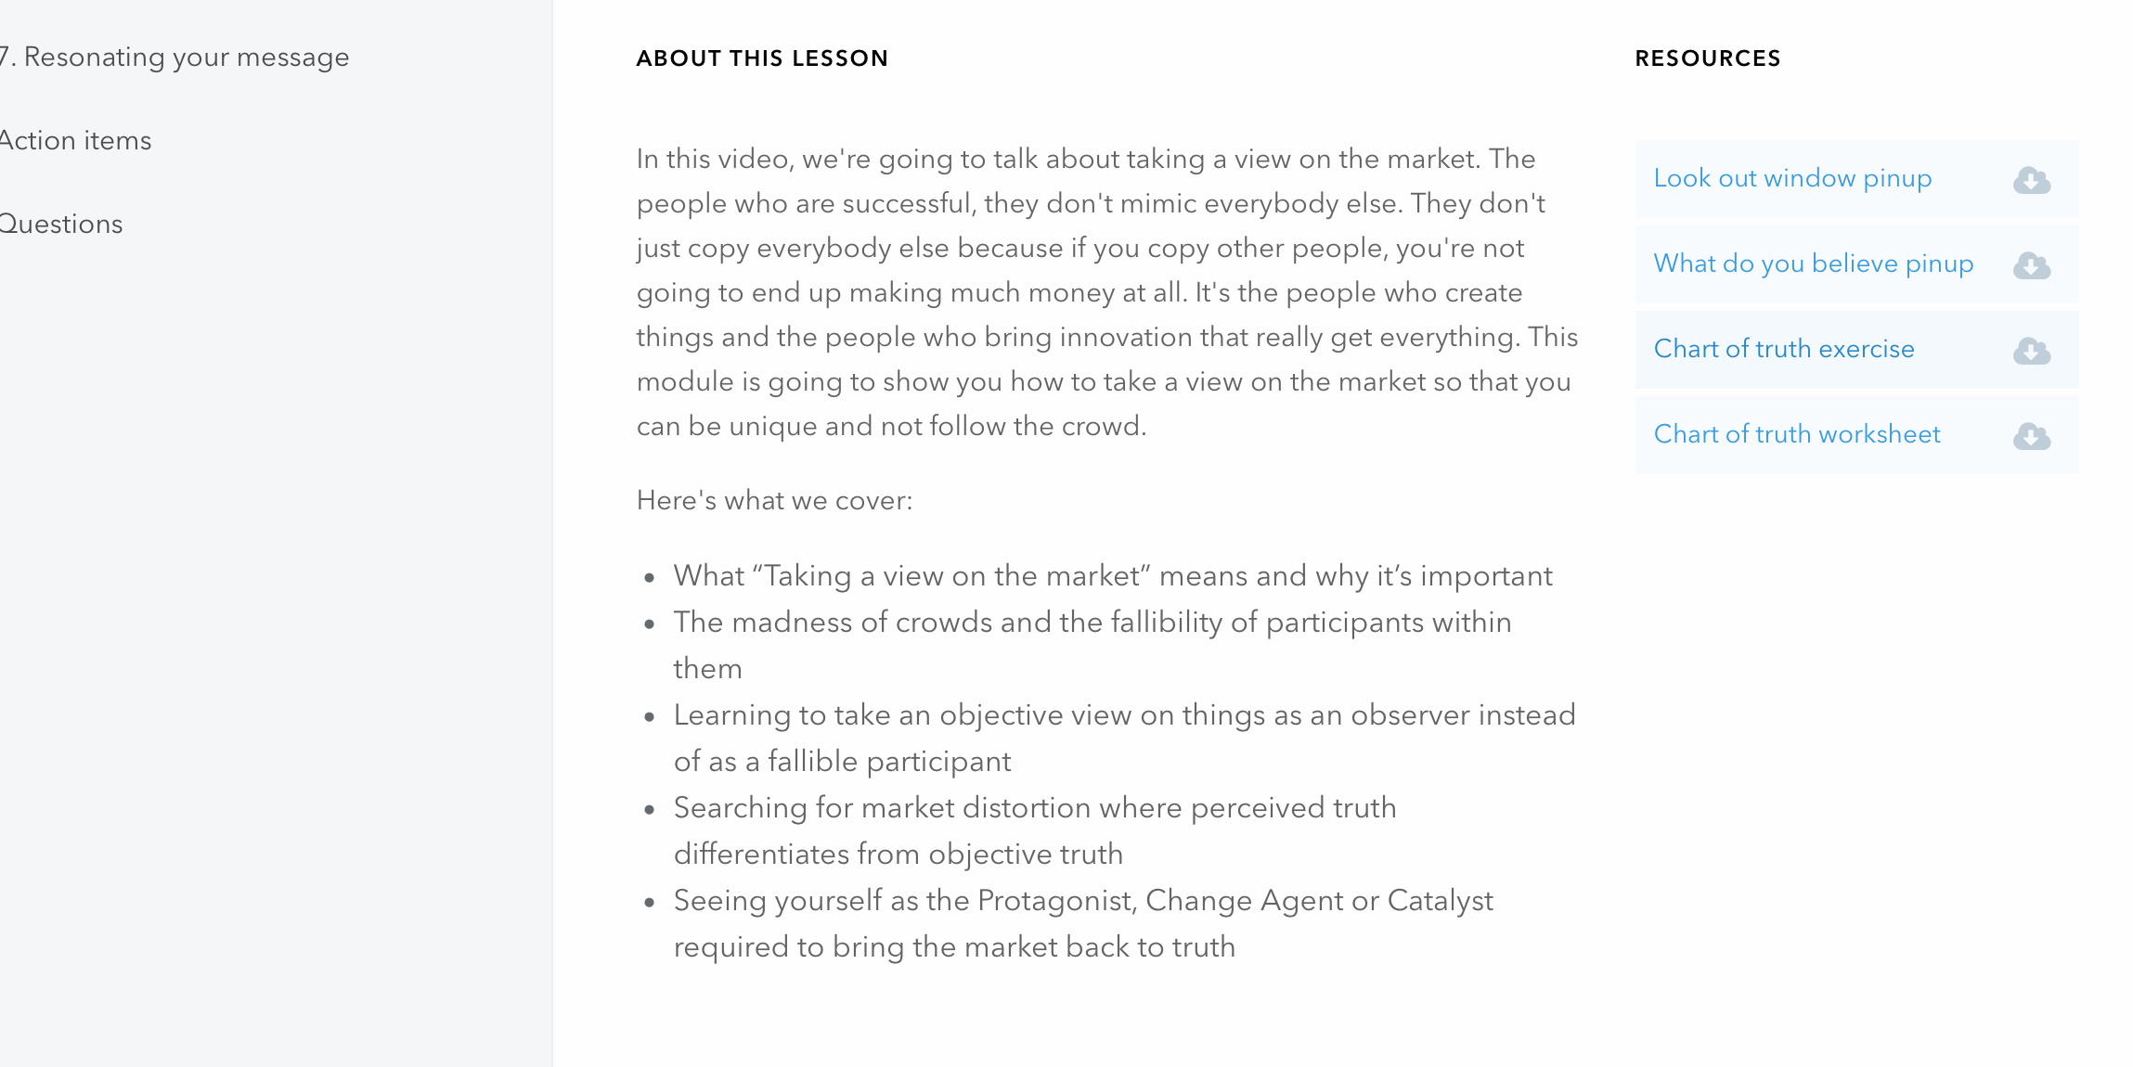

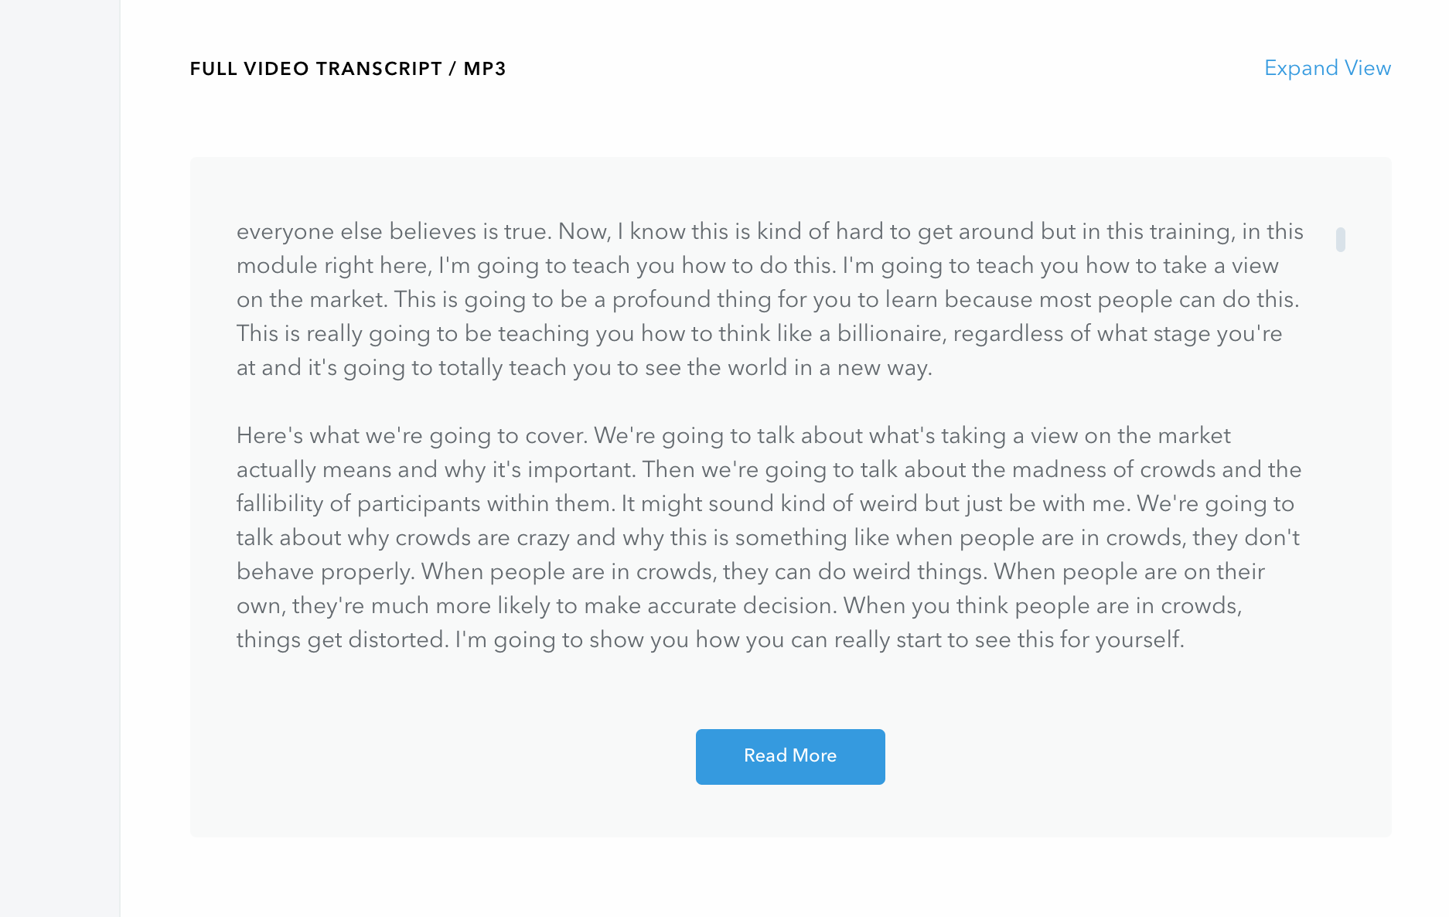

>>>On left hand side>>

- Welcome
- Training

More Trainings

Contract Design: www.legal4sales/consulting

Progress Line
- Request 2. Type of Template 3. Information 4. Appointment 5. Contact Details

OR Layout and structure like https://www.designcrowd.com/design-quote, with scroll down.

>>>> 1 Request >>

What is your request?

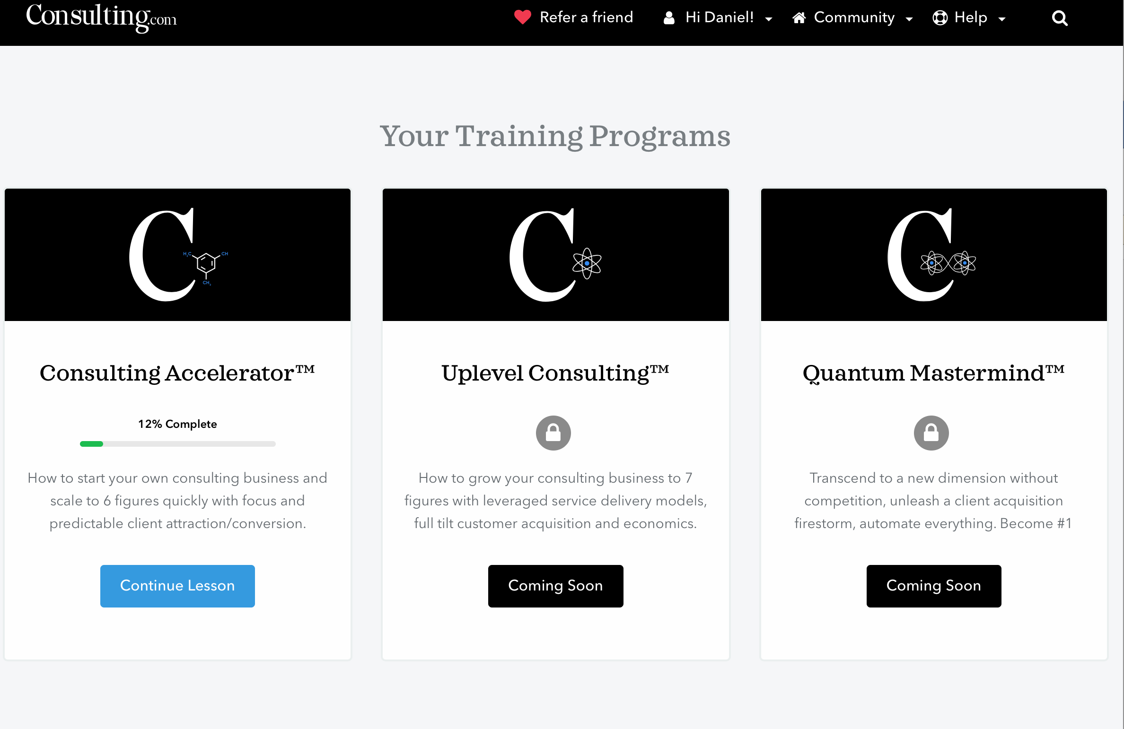

Template Optimization Template Design Template Online

Select Select Select

>>>2. Type of template>>

Please select the type of your template.

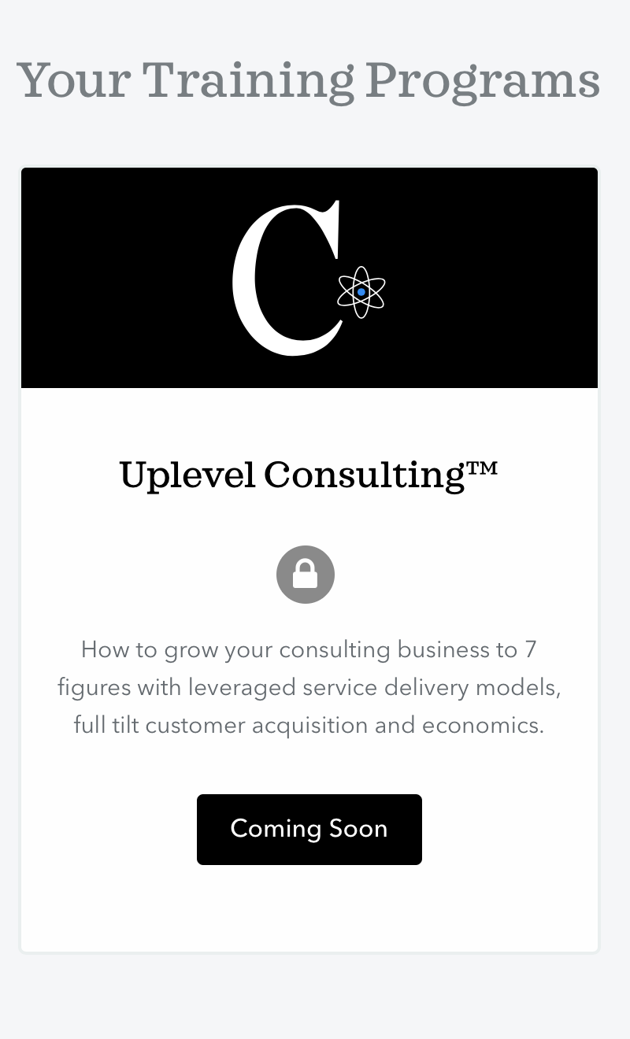

Type of Template

NDA
Sales Agreement
Procurement
Software License
Supply Agreement
Reseller Agreement
Referral Agreement
Others

Select

>> 3.Information>>>

Please provide us some background information

Comment box

Upload Document Possibility

Example in Internet

Questionnaire

>> 4. Appointment>>

Let’s talk.
When would you like to have an appointment?

Calendar View with availabilities

>> 5. Contact details>>

What are your contact details?

>> Auto entry in calendar(Legal4sales) - Google entry request for Customer

>> Confirmation Appointment on Screen and via Email confirmation

Contract Review: www.legal4Sales/review

You want us to review your contract?

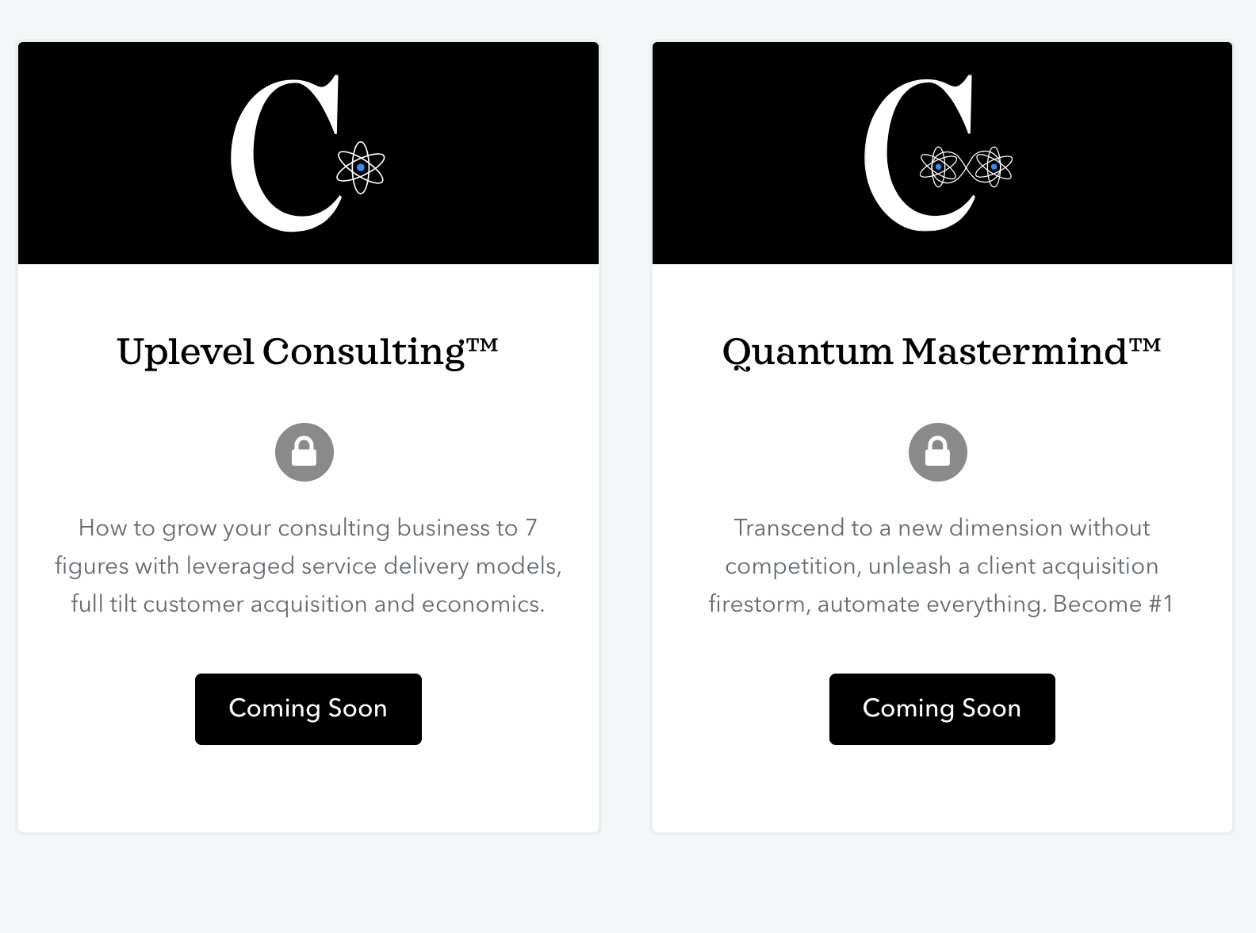

1st Appointment 1st Review

Free 50 Euro/Hour

Book Upload

>>> if 1st Review

Progress Line on top

Upload
Contact details
Questionaire
Payment

>>> if 1st Appointment

Progress Line on top

Let’talk.
When would you like to have an appointment?

Calendar

>>

What are your contact details?

>> Contact Details

Appointment

>> Auto entry calendar (Legal4sales) - Google entry request (Customer)

>> Email confirmation

Team: www.legal4sales/team

Description

Contact: www.legal4sales/contact

Contact Form

Policy: www.legal4sales/policies

General Terms and Conditions
Privacy Policy
Disclaimer
Web Page Policy

Partner: www.legal4sales/partner

You want to become our partner?

Partner

Email

Refer Someone: www.legal4sales/Referal

>>>layout
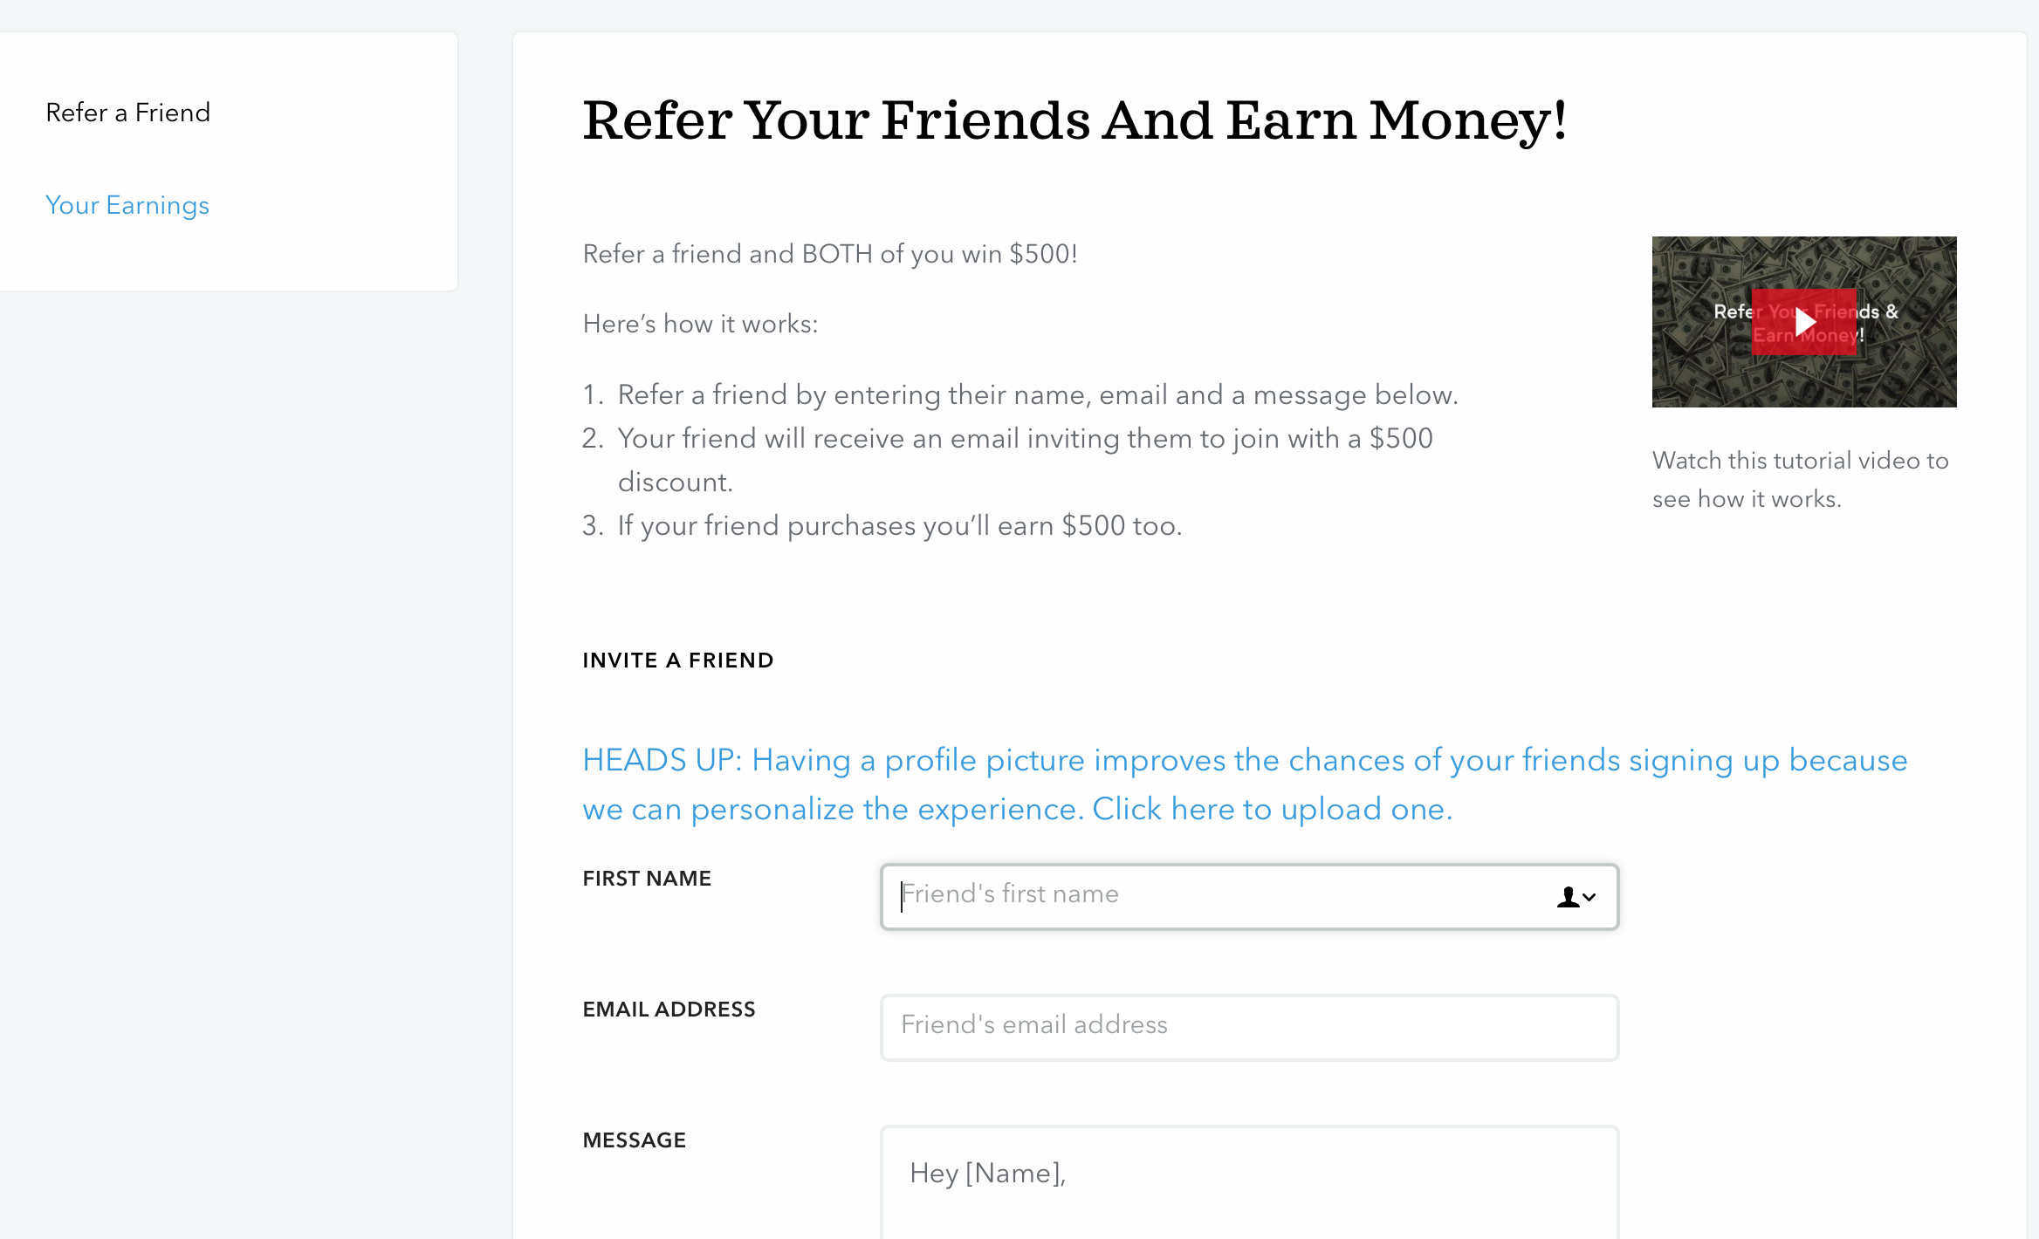

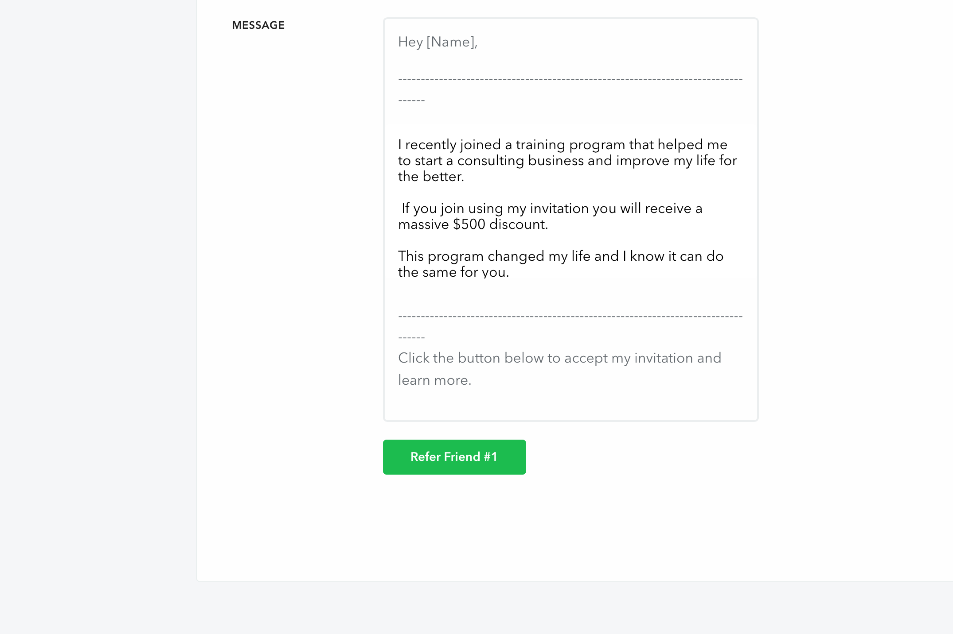

>>Content

Refer someone and get a discount!

Students: www.legal4sales/Students

Increase your chances on the job market.

Choose your Workshop!

NDA
Contract Management Workshop

Layout Like above.

Evaluation: www.legal4sales/evaluation

> after the training automatically

Questionaire. Format like this: https://surveyhero.com/c/4777fdad

Or

embed Code
Copy the code below and paste it in your page's HTML header, just before the closing </head> tag:
<script src="https://embed-cdn.surveyhero.com/popup/user/main.44d59b1c.js" async></script>
OR

Separate: if provided in email as a link

>>> Interview : www.legal4sales/interview

Please select your category:

Company Law Student Junior Legal

Layout: https://surveyhero.com/c/c56708a0

Or

Embed Code
Copy the code below and paste it in your page's HTML header, just before the closing </head> tag:

<script src="https://embed-cdn.surveyhero.com/popup/user/main.3834016c.js" async></script>

>>> Template Online: www.legal4sales/template-online

Select your Form

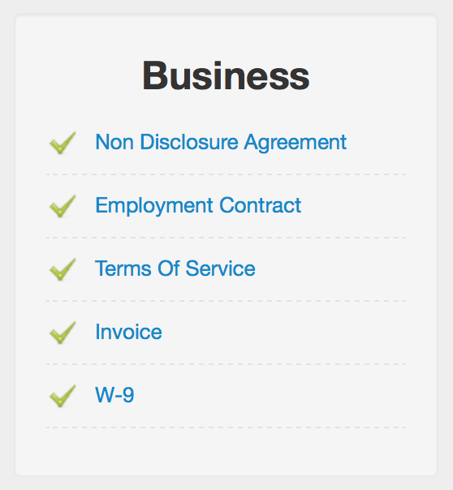

>>>>

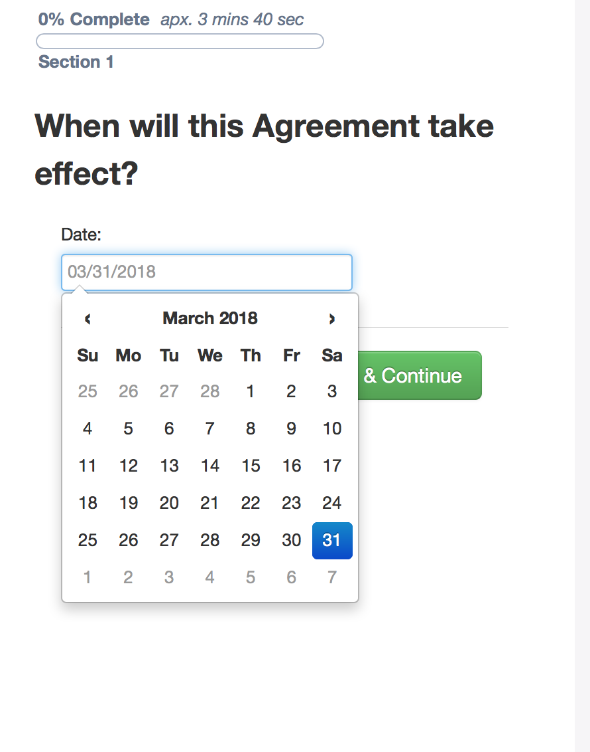
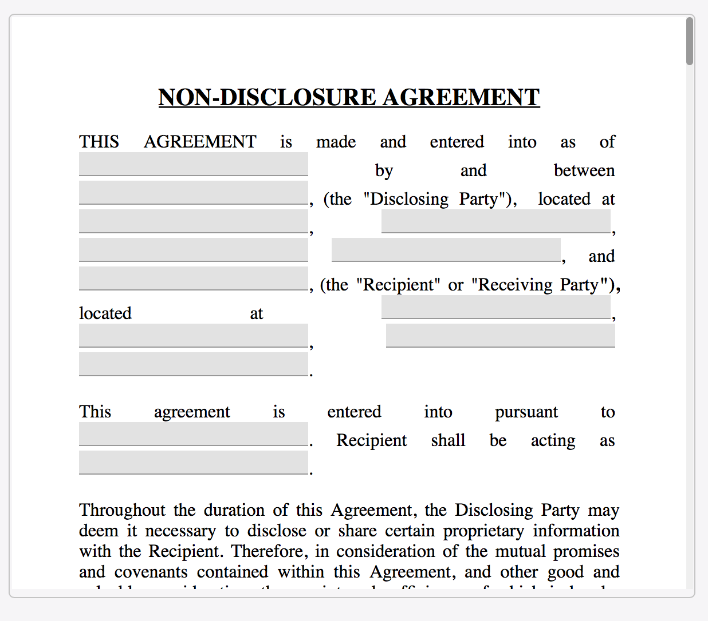

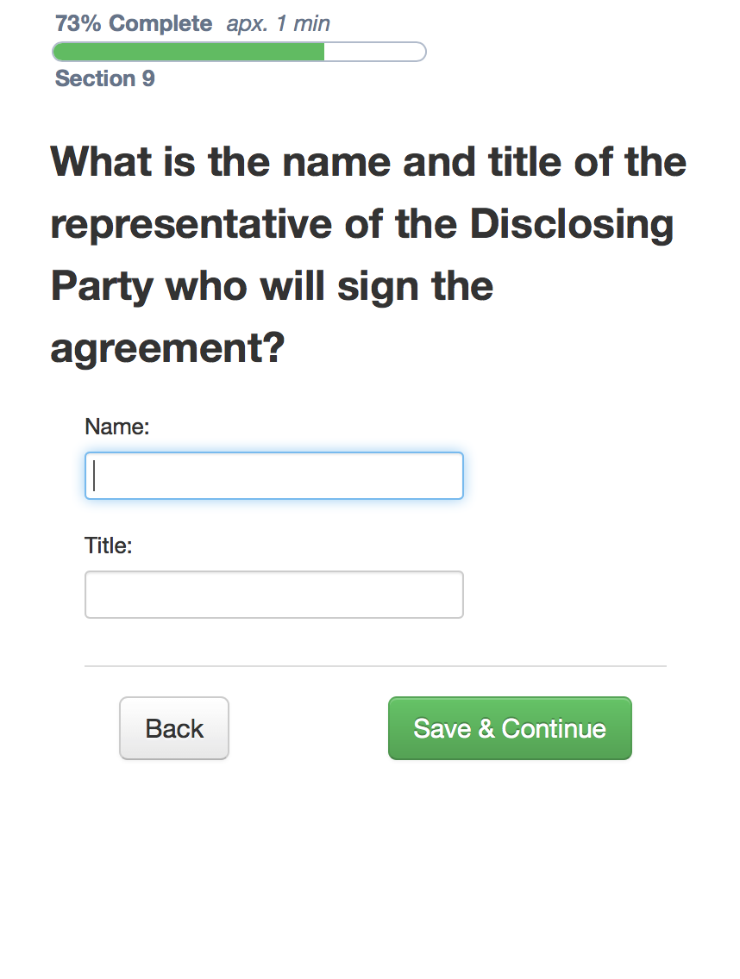
>>>>

>>>>

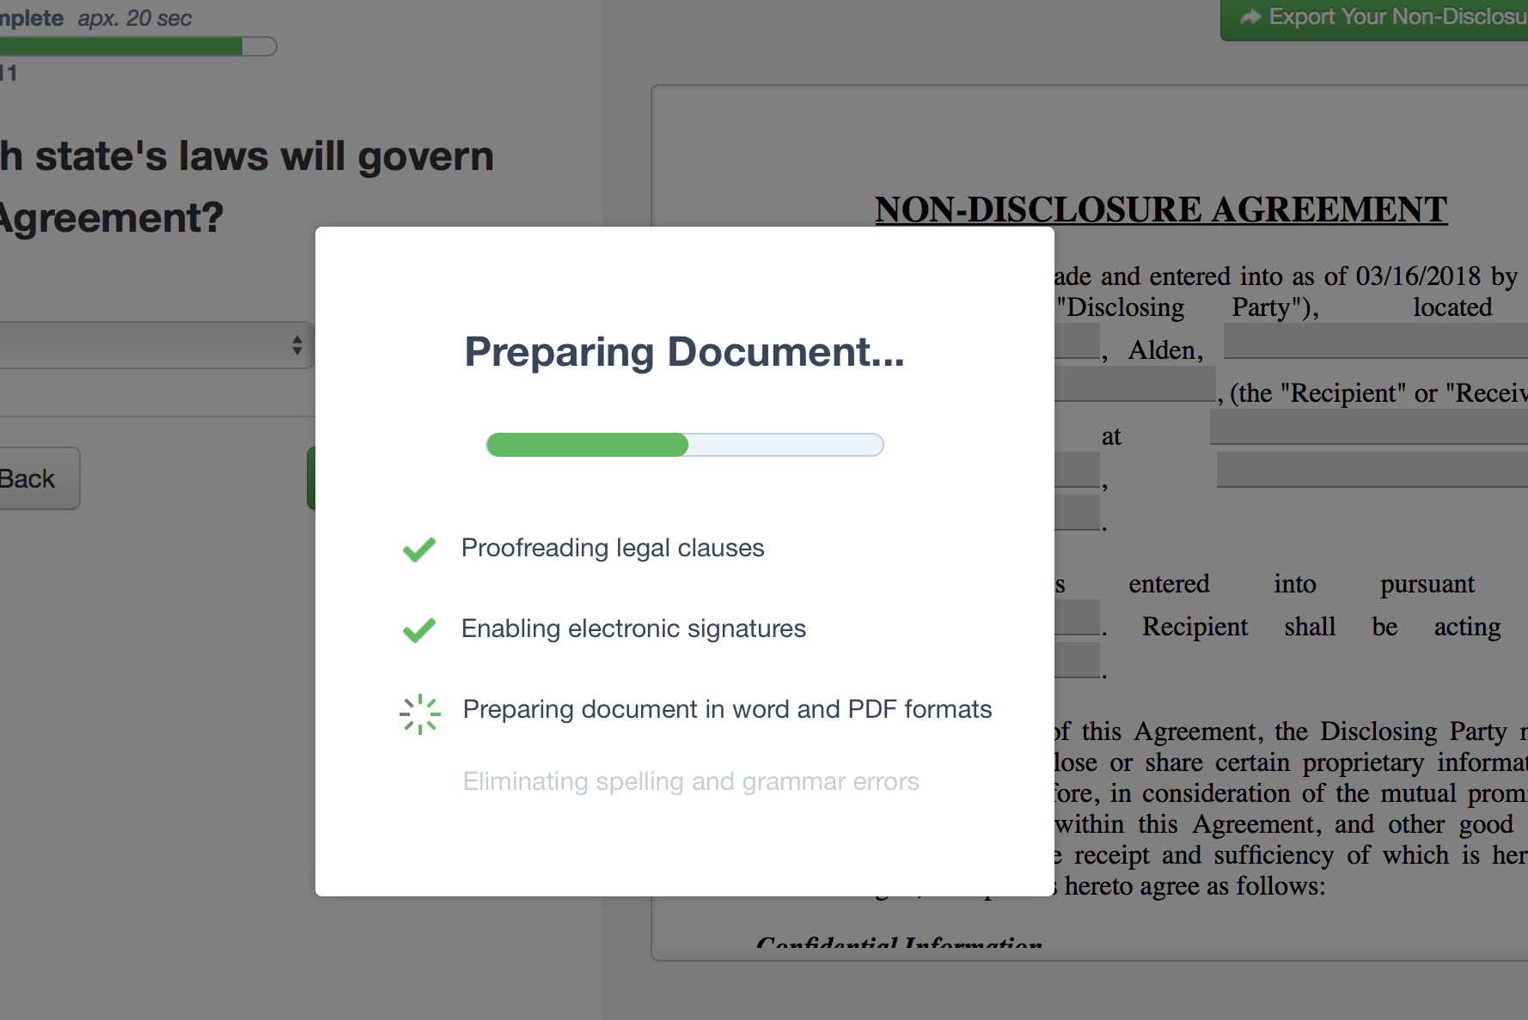

Final

>>>>

Contact Data

>>>

Payment

Tools: www.legal4sales/tools

PDF converter

E-Signature over web

>>> Quote: www.legal4sales/quote

>>> Layout and concept: https://www.designcrowd.com/design-quote
or https://en.99designs.de/launch/web-design/c36f84bb598668a4/brief

>>> Idea: quoting page/system to provide a fix price for drafting a template for client’s needs.

>>> Questionnaires’ would be here:

https://surveyhero.com/c/772814d1

Embed Code
Copy the code below and paste it in your page's HTML header, just before the closing </head> tag:
<script src="https://embed-cdn.surveyhero.com/popup/user/main.decf12b5.js" async></script>

Appointment: legal4sales/appointment:

Let’s talk.
When would you like to have an appointment?

Calendar View with availabilities to check free spot

>> Contact details>>

What are your contact details?
Form

>> Auto entry in calendar(Legal4sales) - Google entry request for Customer

>> Confirmation Appointment on Screen and via Email confirmation

>>After booked successful > Welcome Video

>> Email confirmation

Payment: www.legal4sales/payment

Show amount on top
