PLEASE BE SURE YOUR GREEN MATCHES GREEN IN OUR LOGO We have a logo it is the following

We would like to add the three green lines( Green lines for logo 4)
(above and one green line below the logo as seen in the following example f the tornado
Green lines for logo 4
We would like to use the tornado shown separately also miniaturizing the recycle sign and putting it beside the tail of the tornado

We like the Tornado on (Final Yard Yassine Voinchet #18291976)


We like the Tornado onYassine Voinchet #18291976
the best but want the lines around it to show action
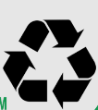

The completed logo we then want added to the bottom of the design we picked for banners /yard signs/magnets/trifolds ect….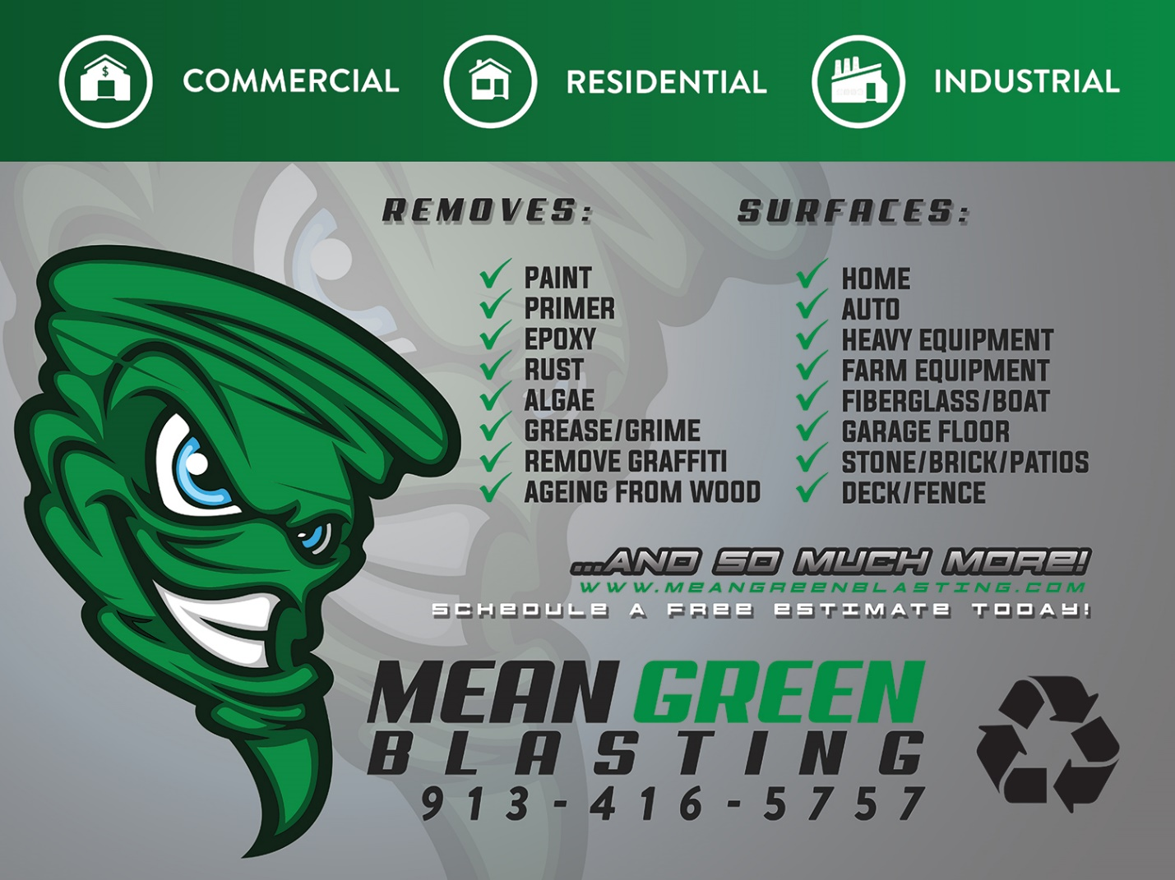
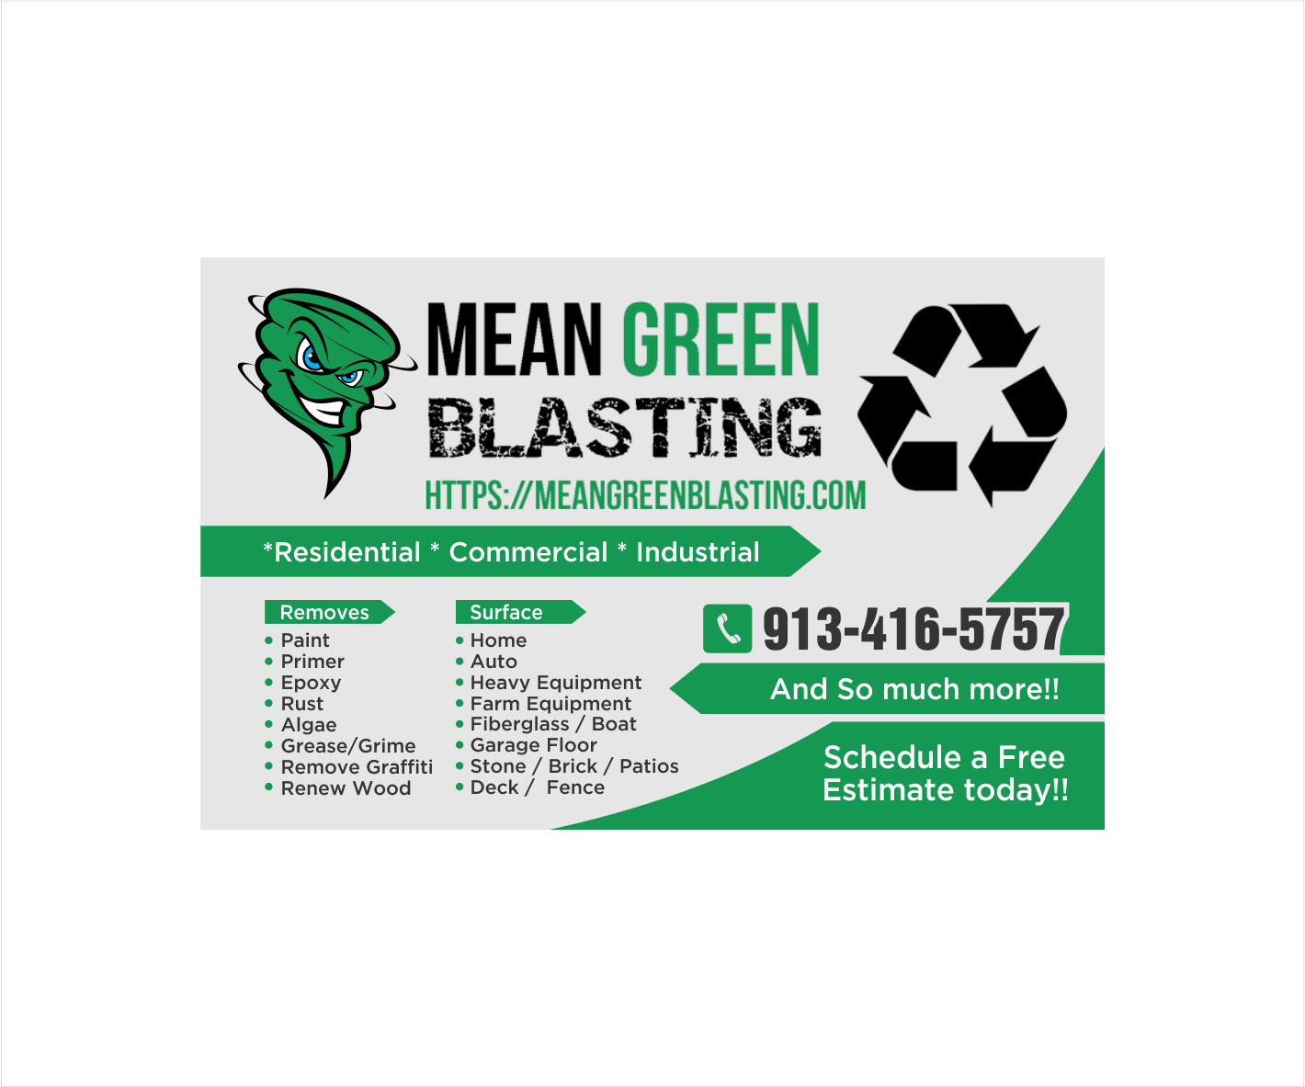
We then want that logo on our business cards with front and back printing with the following layout Please see Complicated changes for complete idea of changes desired

