Final design Changes-- Banner yard signs
This is our logo please Replace Yours at the bottom of the page with ours I
Have provided several sizes on another page marked final logo. We love yours but must use ours for brand recognition. Your ground should show through the word blasting 
Yard sign 6 tornado Green lines for logo

We hope to use your Tornado to replace this one on our shirts/hats and letterhead!

Notice the black and yellow lines around this tornado they show momentum can you add something like this to our design
We love these green lines above and below the logo and would appreciate it if you could add them to your design
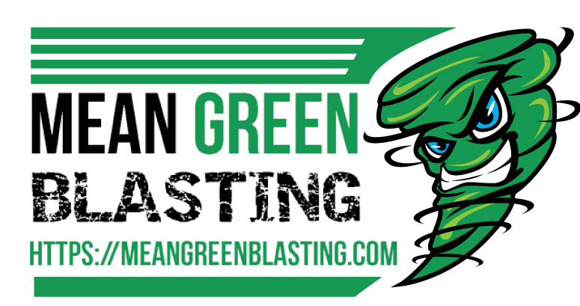
T SHIRTS/ HATS Top of business cards
With very small recycle sign here

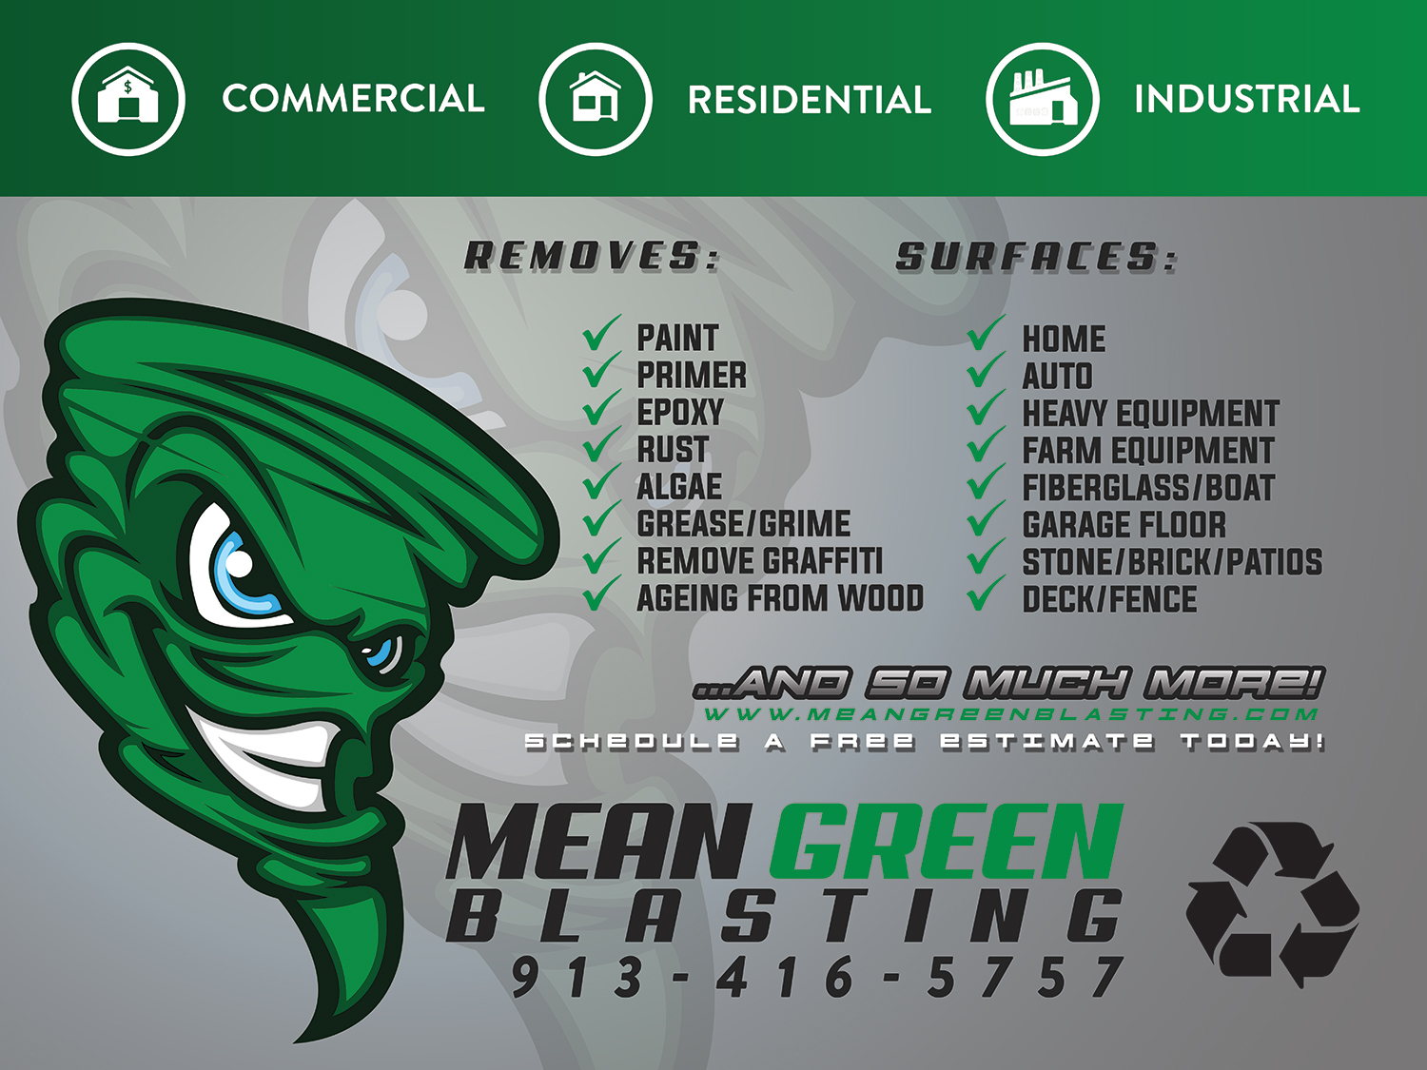
Banner/ magnets/Yard Signs

This green area can be smaller along with smaller icons

Remove URL it is in LOGO
Make Free Estimate Bigger font
Add phone # under Free Estimate
Will be our logo
Can you put green lines above and below logo?

BUSINESS CARDS 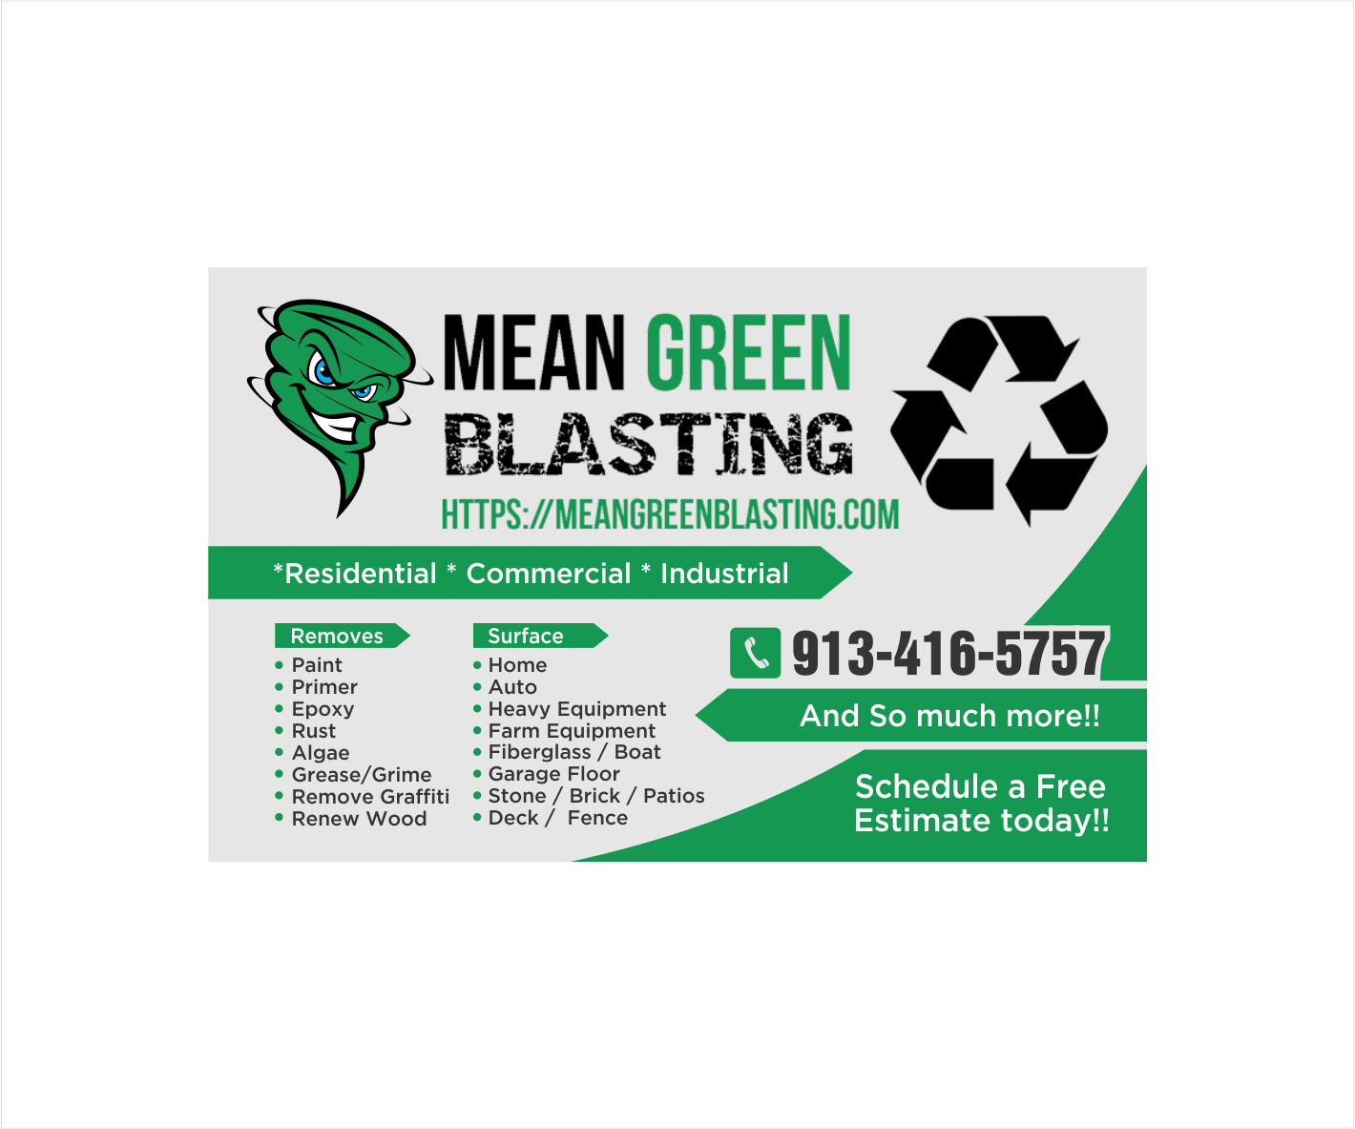
Front and back of card
Only on back of card bigger print
Phone sign removed But number on both sides
fRont and back
Use logo design for hats t-shirts and cards with lines above and below tornado facing the other way very small recycle sign

Remove phone sign

Mobile Dustless Blasting--- on front
And so much more--- on back
Front of first Card
Dave Diederich Proprietor
dave@meangreenblasting.com
1104 W. Ashbury Olathe, Kansas 66061
Front of second card
Christina Diederich Marketing
cdiederich@meangreenblasting.com
1104 W. Ashbury Olathe, Kansas 66061

