WELLIFE
Design Briefing Document
Brief Version 01.1
April 2017

Background
Today’s elderly citizens are deemed to be the fittest, most attractive and most
mentally active in history. But even so there are still many problems they encounter and eating is a key one. You probably don’t put much thought into where your next meal is coming from or how you will get it, but for older persons living alone, it’s a bit more complicated. There are a number of hindrances to eating well. First of all, there are a number of physical and social aspects to eating. Even if a person living alone still enjoys cooking, he or she may have problems with being able to stand for the length of time it takes to prep and cook a meal. Maybe preparing a decent meal for one is just too much bother, especially if that person is used to cooking for an entire family. Perhaps the person does not like to eat alone, so he or she settles for grabbing something easy and sitting in front of the television; after all, the television is better company than none at all. Similarly, many men always had someone to prepare their meals, so they haven’t a clue about how to make a nutritious meal for themselves. Many seniors find themselves reliant on ready-to-eat meals. While frozen and prepared foods are convenient and easy, they contain tons of sodium, fat, and other ingredients that aren’t healthy, especially for people who are on diabetic or other special diets.

WELLIFE is a new type of ready meal specifically designed for this older generation. It is a cross between a ready meal and a meal kit. There is an element of cooking involved because there is a sense of self care about cooking and it nourishes your life as much as your body.

WELLIFE was borne out of our desire to ensure the elderly look after themselves and are provided with the right nutrients so that they can live long and happy lives, and be there to experience the lives of their grandkids. WELLIFE is also about putting meaning back into cooking. While previously they were cooking to create a healthy and happy family, now they are cooking to create a healthy and happy self so that they can show their family they are the best they can be.

WELLIFE is a care pack of fortified and nutritious foods is an easy to prepare format. It comes with a selection of recipes so they can have variety. The portions are small but packed full of nutrients.

The Core Fundamentals:

- Key Consumer Insight:
  - Provide for and nurture my family by showing them I am the best I can be.
Cooking was always a way of providing for and nurturing my family but now that I live alone it has become meaningless and a signifier that I am alone. WELLIFE helps me to give my family the best because it helps me to be the best I can be.
- Key Consumer:
  - Older consumers, living alone, they want to live a full and active life which means staying fit and healthy but find cooking for themselves a chore.

- Design Objectives with Success Criteria
  - WELLIFE – small bites of food for BIG BITES OF LIFE
  - This food kit is not a ready meal; it is a delicious and nutritious meal that is specifically designed for the older consumer. The pack design needs to say this loudly and proudly.
  - The secret to cracking this is down to the following formula:
    - Deliciously tasty with fortified goodness and totally simplified
    - Specifically:
      - WELLIFE is specially designed for the older consumer
      - WELLIFE is fortified with protein and calcium to maintain muscle mass and bone health
      - WELLIFE is small portions to suit older appetites
      - WELLIFE is packed full off all the nutrients you need in small but mighty portions
      - WELLIFE is easy to use and the directions are easy to follow
      - WELIFE leave no waste
      - WELLIFE packaging is all recyclable or biodegradable
      - The overall feel should be simple, delicious, nutritious and simplified.
- Design Strategies
  - The font should be big and bold and easy to read
  - The design should appeal to older consumers but not be patronizing to them
- Communication Hierarchy
  - The design should first indicate WELLIFE, the small portion and the fortification

- Product Details

  - A range of single meal kits
  - Japanese Ramen Broths with fresh vegetables
  - Italian pasta
  - Irish Stew
  - Japanese curry

- Package details:
The packaging will be similar to this box. It will also have a handle on each side to make it easy to carry.
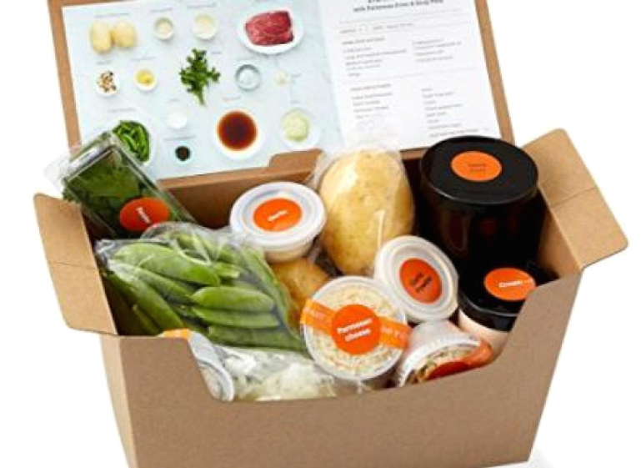
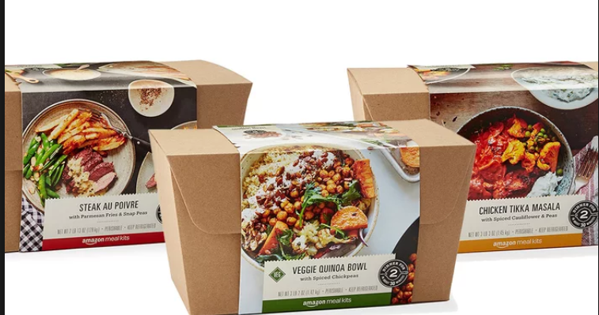

- Product Name
  - The product name is WELLIFE and this should remain.

