LOCATION DOCUMENT

Landmark flags to be incorporated into image + words below MARINA MIRAGE in Blue

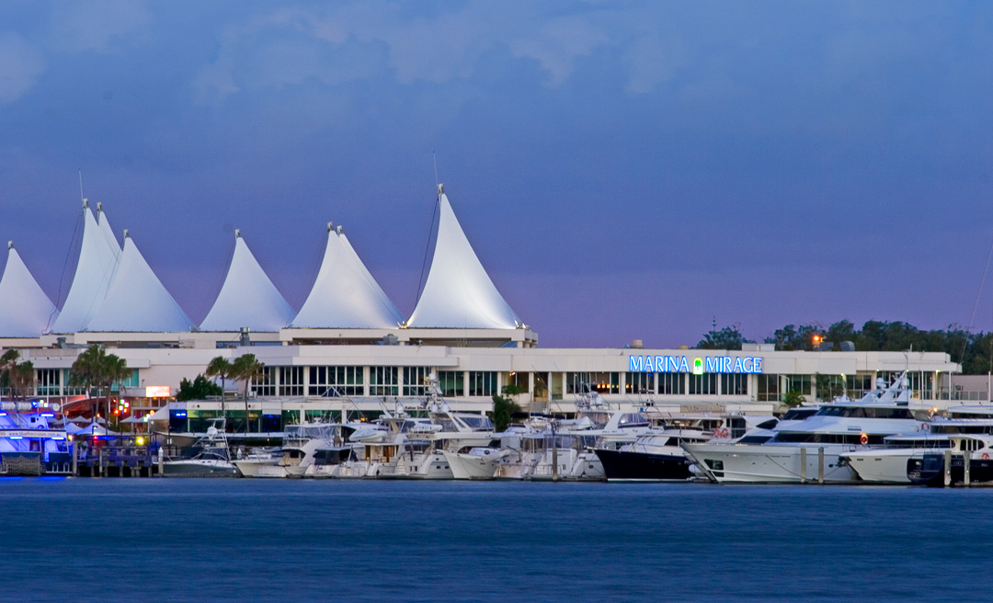

Please insert this landmark building into the image

