Website: QBDarla.com
Driven with Purpose.
LOOK OF HOME PAGE: FUN, PROFESSIONAL, SPORTS-THEME (TURF BACKGROUND)

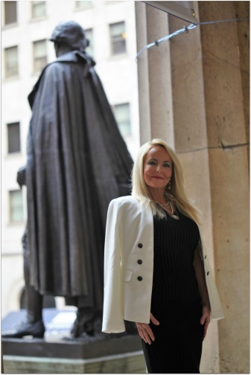

HOME PAGE:
Darla Hall is the owner of In the Sports Zone and author of hundreds of children’s activity books, storybooks, and adult coloring books for sports teams, leagues, and brands. Hall started with a blank piece of paper and a desire to make a child smile. In 2011, one of her marketing clients’ sons was struck by a car and he broke both of his legs. Hall knew that he loved Alabama football so she stayed up until 3 a.m. crafting the first-ever Roll Tide Activity Book as a gift for him. She has grown her business and expanded her line to include 39 NCAA teams, 32 NFL teams, 30 MLB teams, 30 NBA teams, a non-licensed sports line, and non-sports titles. She donates activity books to children in local hospitals as she makes business visits across the country. She is driven with a purpose and that is to create champions in education and sports, while making an impact on those around her.

Darla believes that you’ve got to take the bull by the horns if you want to achieve greatness. Life is tough, but when the goin’ gets tough, the tough take action and makes things happen. She believes that you need to step up to the plate and take a swing because if you don’t, you’ll never know the possibilities this life has to offer. She threw the hail mary and took a chance on her dreams and she wants you to be inspired to take a swing, throw the pass, kick the goal, shoot the ball, and give it your best effort. She has enough energy to ignite the room and will not put you to sleep.



Hall wants to share her story with the world with hopes of motivating others to live life to the fullest, use their fingerprint to make an impact, and be armed with skills to improve their journey. Her amazing bond with these children can be heard in her voice as she tells stories about her encounters with them. In her speech, she talks about meeting kids on her journey that have inspired her to get up every day with a new zest for life. She uses these emotional stories to encourage people to think about life in a whole new way. She utilizes her business savvy to teach and share knowledge, lessons learned, and the powerful ability to start each day with a new attitude. Hall’s love of sports shines as she may grab a football and throw a hail mary or run for a first down. She is a quarterback of life that you won’t want to miss. Down, Set, Book her today!

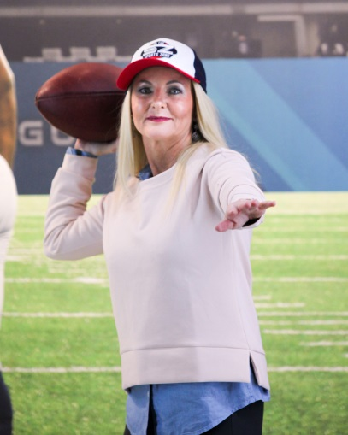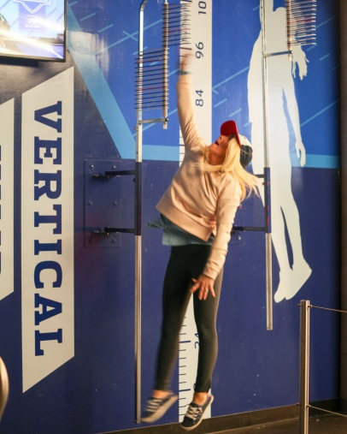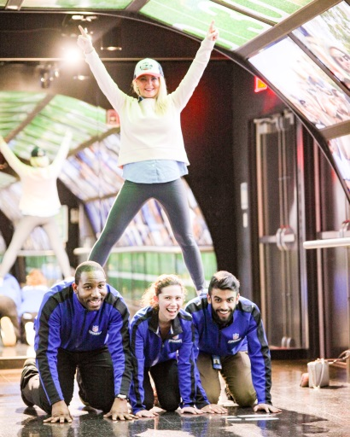

Speaking

About

Darla Hall was born in Martinsville, Indiana. She grew up in the small town of Cloverdale, Indiana, not far from Bloomington, where John Cougar Mellencamp was born and sings about. Her parents were instrumental in teaching her to be a strong and independent woman. She was often told that dynamite comes in small packages because she has so much energy and lights up any room she is in. The song, “Small Town” was one that she grew up listening to.

Well I was born in a small town. One stoplight, one Dollar Store, and one ATM. She sees John Cougar Mellencamp at an IU basketball game from time to time and has always enjoyed his music. Her favorite movie is Hoosiers and she is a sucker for the underdog and stories where teams make a comeback.

Used to daydream in that small town. I dreamed about getting a job, getting married to the star basketball player, and living the good life. Now, my dreams consist of building a business, helping others and making a difference in the world. My dreams revolve around kids and helping them reach their dreams.

No I cannot forget where it is that I come from. The humble people, the kind neighbors, and the hard workers. Success may look different for people in different communities, but it all boils down to what makes people happy.

Oh, and that's good enough for me. She wouldn't change a thing. Her humble beginnings are what made her who she is and for that, she is thankful.

Hall has worked hard all of her life with a focus in sports marketing, retail, and hospitality. From 2005-2011, she owned her own marketing company. From 2011 to present day, Hall has single-handedly built In the Sports Zone from scratch as a gift for a little boy who was hospitalized. She loves to make an impact on people’s lives wherever she goes. Strangers become friends. Friends become supporters. Supporters become customers. The power of the internet and social media has been extremely helpful in building her platform without a lot of marketing dollars. She now has 200+ titles of children’s activity books, storybooks, and adult coloring books for NCAA, NFL, MLB, NBA, and other brands. She will be launching a public safety activity book and anti-bullying storybook line in the near future.

Hall is currently writing her memoir, which she will be launching in 2020.

Her greatest accomplishment has been raising her children and her favorite things to do are spend time with them, travel, and make a difference in people’s lives.

Book QB Darla
Down, Set, Book Darla Hall and allow her to be your group’s Quarterback for the day! She will teach, motivate, and inspire your audience to throw the hail mary and take risks. She will come out of the pocket to share emotional stories that will impact lives and make people reflect. QB Darla will shake and bake until the audience is engaged. She will take the snap and share lessons that she has learned over the years in life and business. All QB’s fumble a time or two and I’m certain that she will do that. After all, it is OK to be imperfect as long as you use failures to learn and grow.

She will:
-Motivate and engage the audience
-Throw the hail mary and inspire your audience to do the same
-Energize the room
-Challenge them to do something with their unique fingerprint
-Make them laugh, cry, and reflect
-Speak with the goal of helping her audience
-Empower greatness

She won’t:
-Put your audience to sleep
-Be like any other speaker that you have had in the past
-Bore them
-Speak about things that aren’t important
-Say the same things that everyone else says

Score a touchdown and book her today!

Video
I’m creating a video to use that will be a compilation of me speaking, Gideon footage in hospital, Gideon’s parents telling his story, photos.

Testimonials
I won’t have any testimonials in the beginning, but will want this capability as I get them.

Blog

I’ll want to write blogs on this website. Links to all social media (Linkedin, Facebook & Instagram- both ITSZ and Darla Hall, Twitter @IntheZone777.

Books

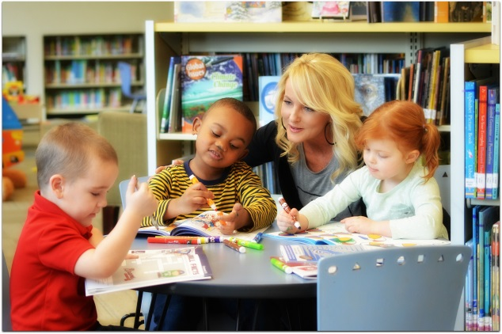
Include some images of the books to represent college, NFL, MLB, NBA- all product types

Author, Darla Hall has created 200+ activity books, storybooks, and adult coloring books for NCAA, NFL, MLB, NBA and other brands. Visit www.inthesportszone.com to purchase her products.

Hall is currently writing her memoir titled, “Ball Cap, Boots, Backflips & Business,” which will be released in 2020. Ball Cap, Boots, Backflips & Business will offer a new perspective into the world of entrepreneurship. Darla Hall started her business with nothing but a pen, piece of paper, and an idea to make someone’s life better. She was raised in a small town and grew a business from scratch. Her journey will enlighten and inspire you. The emotional stories that have influenced her to continue building her business will touch you. Her thought provoking ways of doing business will help you reach your goals. And, her story is one that will give you courage to dream big and not settle for anything but the best. She can be found at hospitals visiting kids in a ball cap, blue jeans, and cowboy boots. Or, she may be in the office in heels and a dress doing an investor presentation to large companies. She is right at home in the country fishing with her dad or loving on those around her. She is also right at home in the big cities meeting with powerful people. She stands just 4’11 ¾” tall. She is small, but mighty. Mighty Mo, that is. No matter where she is, LOOKOUT because she will buzz by you doing backflips and cartwheels to make a difference in people’s lives. Zoom! Zoom!

AVAILABLE SOON- PLEASE FOLLOW HER ON SOCIAL MEDIA TO HEAR THE LATEST NEWS & UPDATES

Giving Back

Darla Hall enjoys giving back to children in hospitals. She travels around the country donating her activity books to children and building special bonds with them. She will be donating $500 of every speaking engagement fee to help children and their families with medical expenses. Gideon and his family will be the recipients for 2018-2019. Hall will be speaking about Gideon in her speeches as he was her inspiration for pursuing this passion to share her story with the world.

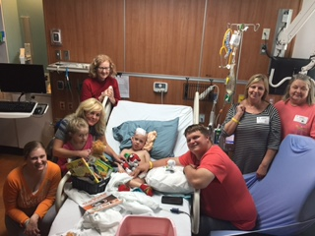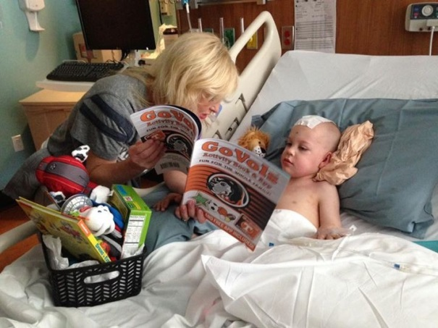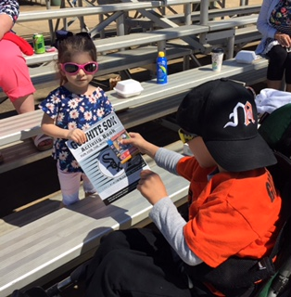

Insert video of Gideon hitting a homerun.

