Website: QBDarla.com
Driven with Purpose.

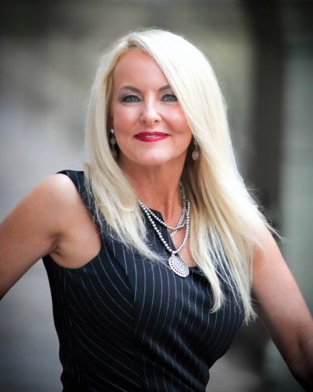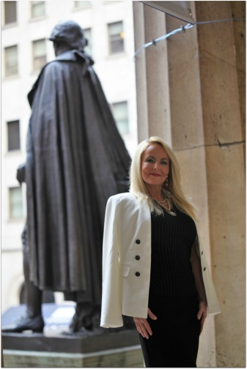

Speech 1
OPEN running out to podium with a hail mary to an audience member (planned in advance).

Take a Swing
My name is Darla Hall and I grew up in a small town. I was the smallest girl in my class with the most determination. I got the nickname Mighty Mo by my softball coach because the opponents would move in when I got up to bat, then every time I would knock it over their heads. In high school, I wanted to play front row so my dad out take up on the wall. I jumped and jumped until I hit the mark. Then, he would move the tape up. Repeat. I was an all around player recording kills by my junior year. I’ve been fox calling, coon huntin’, frog giggin’, fishin, four-wheelin, and muddin’.

I went from cowboy boots to high heels and started putting that work ethic into building my career. I landed my first job at the Amateur Athletic Union where I forgot to put my contact information on my resume. Then, I had several marketing jobs where I won awards and moved up the ladder by working hard.

In 2011, I owned my own marketing company where I wrote marketing plans for small businesses. One of my clients was Burdette Dental Lab. In September of that year, I was supposed to meet with him. When I called to confirm, he stated that his son was just struck by a car outside of his school and he had to run. My heart broke and he was on my mind the whole day. I went out to find the perfect gift for that 8-yr-old little boy and couldn’t find what I was looking for. I stayed up until 3M that night with a blank piece of paper and pencil and sketched out the first Roll Tide Activity Book as a gift for him. From there, I met with an attorney and decided that I could get this licensed and do more good with it. I decided to take a swing.

I cashed in $20,000 from my 401K and began to develop two activity books and two apps. I sought a local license through CLC and was successful. Then, I started to hustle. I made cold calls, I visited retail stores, I built relationships with licensing directors, I established a social media presence. The first year, I sold $10,000 in Activity books. Over the last four years, I’ve added more college teams, 32 nfl teams, and 30 mlb teams. This year, I’ll be adding 30 NBA teams. I now have three product lines-activity books, storybooks and adult coloring books.

I did not know how to do any of this before I started my business. The closest thing to a P&L I looked at was a PBJ. I had never used Quickbooks. I certainly knew nothing about licensing, retail or publishing. I learned every single thing from scratch.

I knew how to sell. I knew how to build relationships. I knew how to be authentic. I knew how to work hard. I started donating books to children in local hospitals and meeting the most amazing kids. I took them to events and grew to love them. Then, lost a few of them. Their lives and how they loved them to the fullest every single day made me more determined than ever to fight for my business.

Mighty Mo was not only ready to take a swing. I was willing to swing for the fences and go all in.

Be Bold. (Put on boxing gloves)
-Pick up the phone and call the CEO’s, the top decision makers.
-Take risks. You won’t even get on first base if you don’t step up to the plate and take a swing.
-Try things that are outside of your comfort zone.
-Protect your idea at all costs.

Be Determined.
-If something is hard, try harder.
-Don’t allow failure to defeat you.
-Put on your boxing gloves and fight for what you believe in.

Be Persistent.
-If someone tells you no, try again.
-Learn from your mistakes and use them to motivate you to do things better.

Put in the Work.
-A lot of people have great ideas, but only a few make it past the first 18 months. It takes hard work to grit it out and stand out.
-Put in the time, don’t be afraid to sweat.
-If it’s worth fighting for, fight.

Be Authentic. Be YOU.
-There is a one in 64 billion chance of you having the same fingerprint as someone else. That means that you can get up every single day and use yours to start a new day. To improve someone else’s life. To make a difference. You are designed to be on this earth for a purpose that only you can fulfill. Be authentic. Be real. Be you.
-Be different, not perfect. In the social media world that we live in, it’s important to be different. You need to separate yourself from the rest whether you are looking for a job, trying to get a promotion, or starting a business. Here are a few tips that I’ve learned over the past few years: 1) Be authentic. There are times when I feel like something I want to write isn’t going to impress anyone. I write it anyway because it’s me, it’s from my heart, and it’s real. Go with your gut. 2) Think about things in many different ways. Write down at least five ways to solve the same problem. Get feedback from peers on all of those options. Then, make your decision. 3) Don’t be afraid to take a leap of faith. If you don’t step up to the plate, you’ll never get a hit. 4) Realize that you do not need to be perfect. No one is. We all fail and that forces us to get up and become stronger. Just look. I fell on my head trying to do a back handspring in the middle of Central Park. Don’t ask. Just feel free to laugh. Laughter is good for the soul. (Put Photo on tables with website on it)

There is a hero that I know that takes a swing every single day of his life.

Meet Gideon. (SHOW VIDEO OF GIDEON- interview with his parents, talking about his illness, multiple surgeries, upbeat personality, incorporate me hitting his first homerun, photos of me giving book to him with crazy socks) Gideon’s Home Run- Add to video footage of his story- https://youtu.be/AFUbs9Ddj5A

DARLA TO CHANGE CLOTHES (overalls, tennis shoes, casual attire)….GO TO A GIANT BEAN BAG TO TELL THE EMOTIONAL STORY ABOUT GIDEON

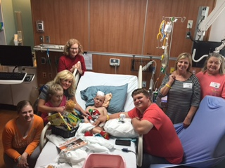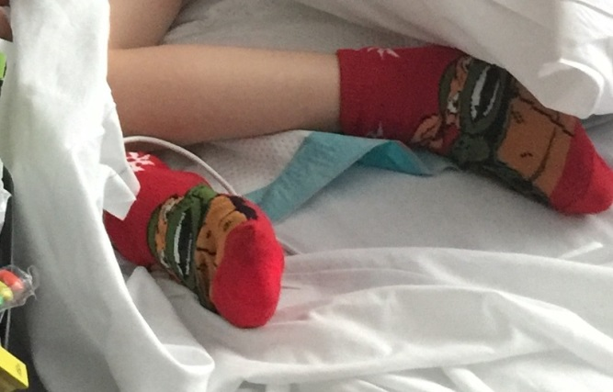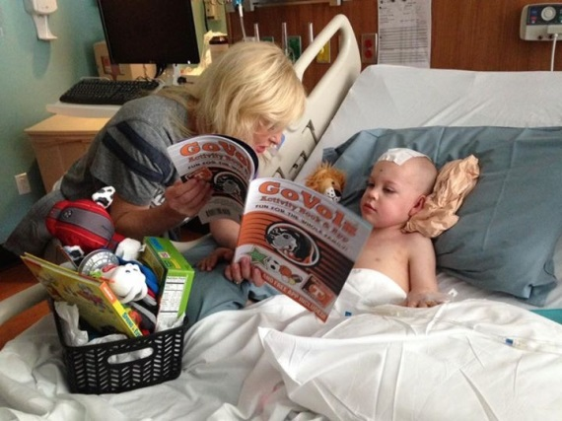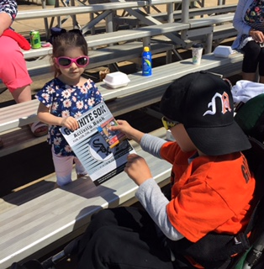

It was December of 2016 and I had an event booked at Railroad Park in Birmingham, Alabama. I complained about it and nearly cancelled my booth because it was so cold outside and I didn’t want to go. I remember complaining the whole way there. When I got there, no one was there. It was cold and empty. I begrudgingly stuck it out. I was tearing down my table when I saw a little boy in a wheelchair strolling by with two ladies and a little girl. They looked so happy to be outside enjoying the brisk day. I learned that he was a miracle and had multiple brain surgeries and was in recovery at Children’s Hospital. GIDEON has XXXXXX (explain his diagnosis). I gave him and his sister my Prayer activity books and didn’t hear from them for a while. One day, I was in tears sitting on my sofa wondering how I was going to pay a $19k invoice that I had when a Facebook message popped up on my screen from Gideon’s grandmother saying that she was reading those prayers to Gideon and that he loved Miss Darla’s activity book. I found out that he loved the TN Vols so I arranged to take him my Vols Activity Book, funky ninja turtle socks and some other prizes. I teased him and told him that his feet smelled bad. He smelled them and said, “Stinky Feet.” That inspired the poem called “Stinky Feet” that I wrote and is on the back of the blank piece of paper on your tables. He said, “thanks for the Mokey book” and got crazy with the sticky hands that I gave him. He would throw them and giggle, which made me giggle. From that moment on, I was known as the Tennessee lady to him. As you saw in the video, I went to his baseball game and helped him score his first homerun. I gave his team MLB activity books and he gave his to a friend that came to watch him play that day. He showed me that he was a very caring, unselfish little boy that was wise beyond his years. I have kept in touch with his family throughout his journey and he has become very special to me. When I considered speaking, I was hesitant because I wasn’t sure if I could do it. Then, I had an AH-HA moment realizing that I could use some of my speaking engagement money to help his family with medical bills. That alone gave me DRIVE WITH PURPOSE, which is why I’m able to stand here in front of you today. It became a MUST-DO. $500 of every speaking engagement fee is donated to Gideon’s medical fund as he spends months at a time in the hospital.

Take a Swing (BASEBALL BAT-TAKE A REAL SWING). You have one life. One fingerprint. Use it to make a difference and be driven with purpose.

ON TABLES: Blank pieces of paper with fingerprint faded in background for notes on front,

back side of paper:
Photo of Darla- Throwing the Football & Boxing the Bull

THROW THE HAIL MARY.

TAKE THE BULL BY THE HORNS.

TAKE A SWING.

MAKE YOUR FINGERPRINT COUNT.

PUT IN THE WORK.

BE DRIVEN WITH A PURPOSE.

HAVE FUN. LAUGH. DANCE.

Please follow me on Facebook, Instagram, Linkedin, and Twitter (@IntheZone777)

