New View Test Centers
Open House!!! – Tuesday April 17th & Tuesday April 24th from 4pm – 6 pm
Specialized High School Admissions Test Prep
SUMMER INTENSIVE!! “2018”
**Class size is limited to the first 25 registered & paid students**

I. Specialized High School Test Prep – “Summer Intensive”(July-August)
*For current 7th grade students taking the SHSAT in October 2018
Updated curriculum for the new SHSAT exam!
**Program Information (42 hours of learning plus unlimited online practice, review, & mini exams!)

Days & Times: Mondays & Tuesdays (9am – 12noon)

July: 7/2, 7/3, 7/9, 7/10, 7/16, 7/17, 7/23, 7/24, 7/30, 7/31

August: 8/6, 8/7, 8/13, 8/14

Price: $999 ($24 per hour)
Payment options: Cash or credit card. Full payment before first class or,
$550 by 5/31 and $550 on or before 7/2.

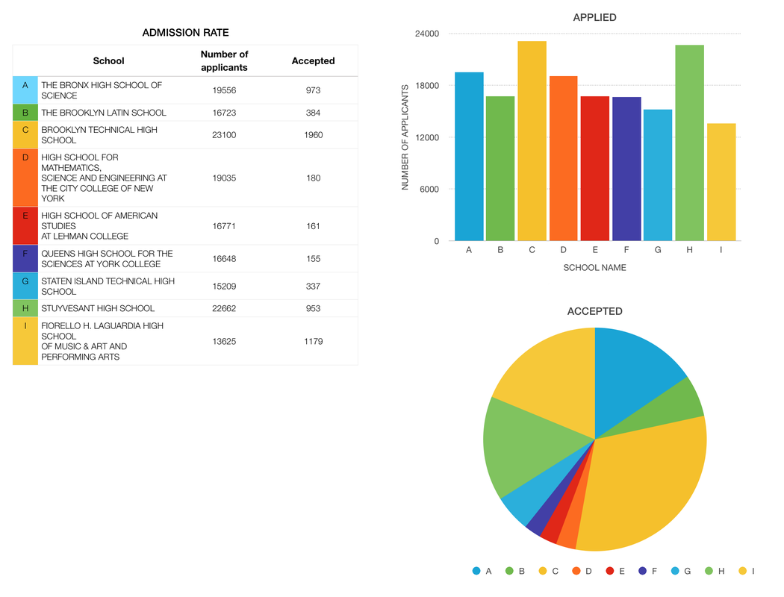
New View Test Centers
3250 Westchester Avenue Suite 126 (347) 281-8950 email: info@newviewtestcenters.com
(347

*Benefits*

-Expert, personalized, in-depth instruction!

-Updated Curriculum for the “new” SHSAT

-Unlimited computer based learning, review, & practice exams!

-Complete diagnostic feedback on strengths & weaknesses to maximize scoring potential!

***Ready for the NEW redesigned Specialized High Schools Admissions Test?

We have your back! (Next Steps)

-Email info@newviewtestcenters.com for more information

-Attend our Open House on April 17th or April 24th from 4pm – 6pm

-Register and pay to reserve your child’s seat!

