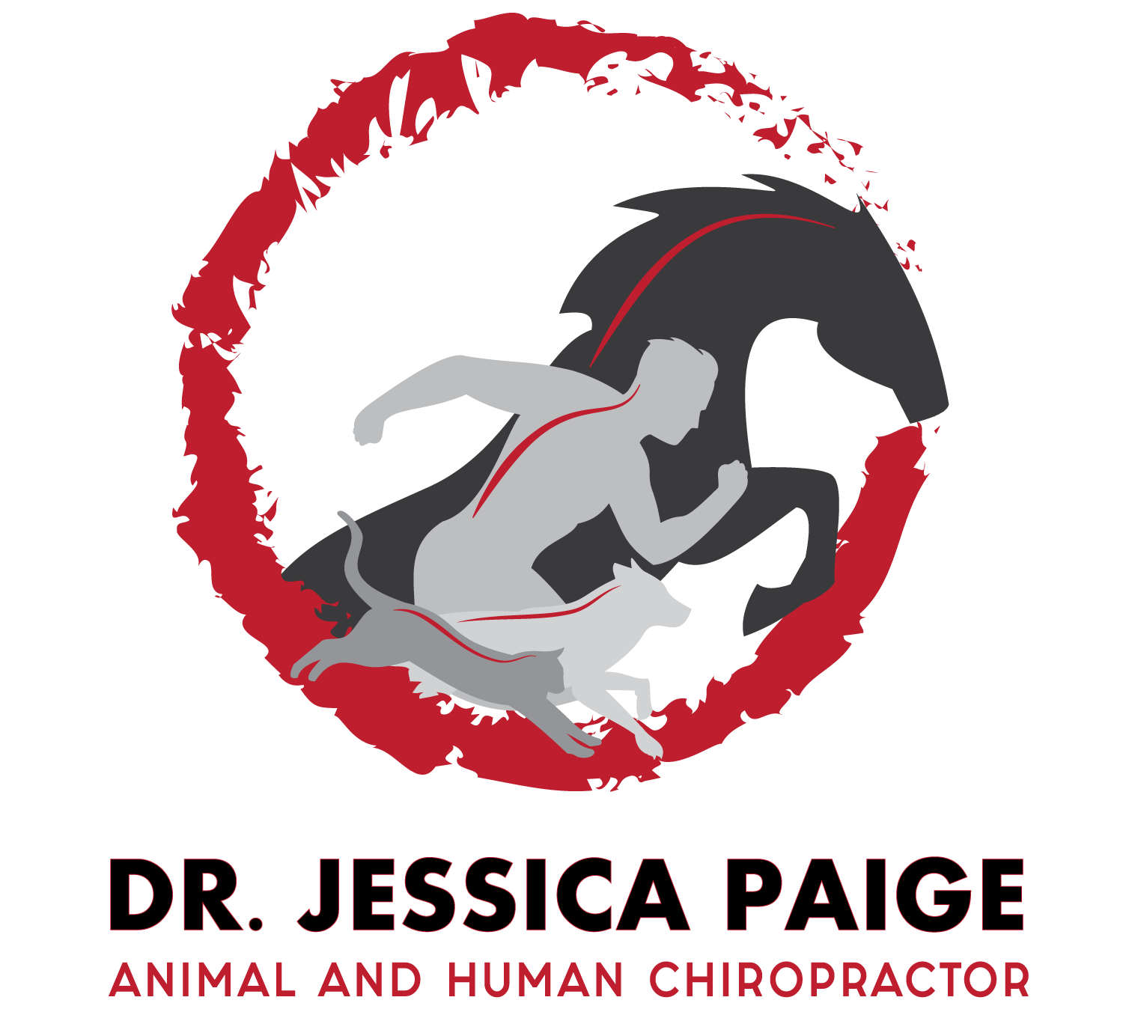
Chiropractic care for your pet!
Introducing Dr. Jessica Paige, chiropractor,
who has been providing chiropractic care for over 15 years!

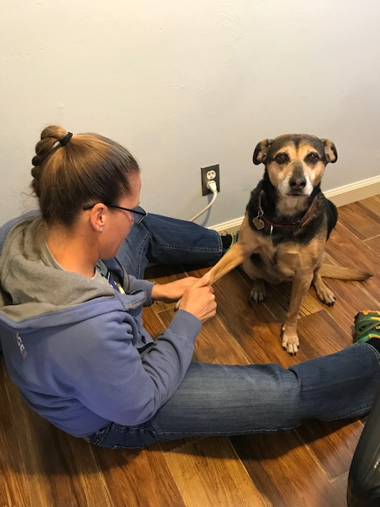 | Your dog or cat can benefit from Chiropractic adjustments if they:  - Have a limp that will not go away  - Do not want to jump in, out or on things as much or anymore  - Yelps with certain activities  - Are slow getting up or laying down  - Have been diagnosed with disc disease  - Wellness - prevention - a well moving spine will help prevent arthritis later in life  - They are in rehab from a current injury - sprain/strain, surgery  - Are involved in athletics - flyball, agility - top athletes receive regular chiropractic care  - Are working dogs - pulling wheelchairs, police dogs
Animal chiropractic adjustments are not only for pets with injuries, it’s great to start young so that we know how the spine/extremities are moving prior to a problem. Chiropractic adjustments definitely help with new and existing injuries. We also offer low level laser treatments to assist in the healing process.
To schedule an appointment or for more information, please give us a call at 408- 963-8919.
https://www.drjessicapaige.com/animal-chiropractic

