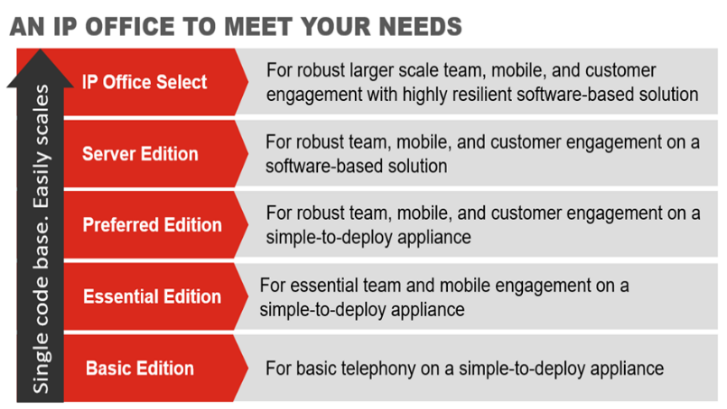



Unifies communication
Features call handling, messaging, conferencing, presence and IM

Connects you with your customers
Enables you to use the method they prefer – Voice, SMS, Web Chat, Email and Fax

Helps people work from anywhere
Integrates with your mobile, find me/follow me for secure working, irrespective of location

Professionalism
Use your office number instead of a personal phone number
Easy to use
Easily conduct conference calls with the click of a mouse
Easy to deploy
No hardware or software installation required
TESTIMONIAL
Registered in England & Wales number 08443224

Vapour Media Limited
Landline 0333 200 1142
Email info@vapourmedia.co.uk
Website www.vapourcloud.com
Did you know…
- On average, 37% of executives’ working weeks are spent away from their primary work location.
- 59% of mid-market companies have reduced or planned to reduce office space because flexible/remote workers need fewer desks

Vapour is one of six UK suppliers of the AVAYA IP Office product – a communication solution designed for growing businesses.

