

d

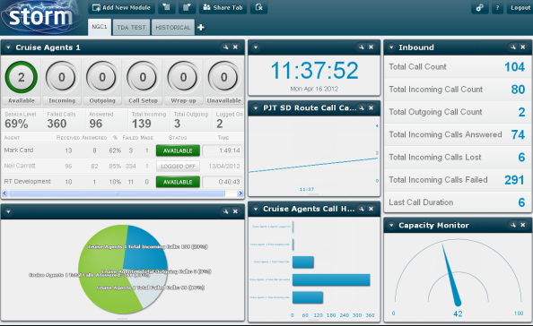

“Thanks to the Vapour team for installing their new Höllr hosted voice platform in our offices, not only did we save money for our current telephone system, but we now have far greater control and flexibility. Each member of staff can now decide how best they want to take calls, whether they’re in the office, out at a customer site or working from home. It’s enabled us to be far more efficient and most importantly we can now communicate much better both internally and with our customers!”.
Carl Whitham – Technical Director, Hollinbay Consultancy Services Ltd.

- .

Impressive uptime

- Our robust platform delivers 99.999% availability

- Largest platform, to meet and surpass the demands of business contact centres.

Omnichannel
Our multichannel capabilities deliver social media, SMS email, webchat, voice and video directly to the agent’s web browser
Integration
Users can integrate any third-party system, application or database directly into the platform
Scalability
Storm currently supplies the UK’s largest electricity distributor (UK Power Networks) allowing them to automate 93% of enquiries during peak times
Speed and Innovation
Users can have multiple streams and desktop sharing via the WebRTC in a single agent dashboard
Registered in England & Wales number 08443224

Vapour Media Limited
Landline 0333 200 1142
Email info@vapourmedia.co.uk
Website www.vapourcloud.com

Our cloud contact centre that is integrated with hundreds of third-party systems to connect large businesss together via an effective platform.

