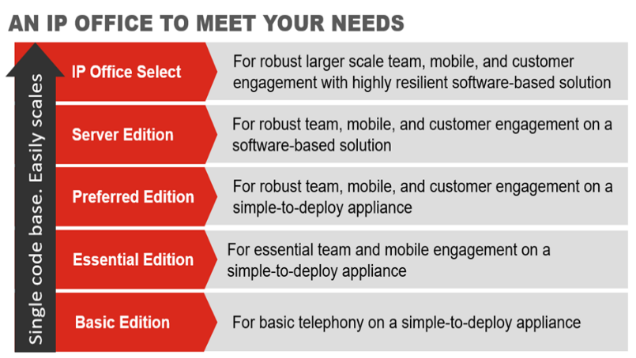



Unifies Communication
Call handling, messaging conferencing, presence and IM

Connects you with your customers
Uses the methods they want – Voice, SMS, Web Chat, Email and Fax

Helps people work from anywhere
Integrates with your mobile, find me/follow me

Use your office number instead of a personal phone number
Easily conduct conference calls with the click of a mouse
No hardware or software installation required

Interested in becoming a Reseller?
This will enable you to provide a white labelled service, allowing you to -
- Offer customers a great service
- Generate additional revenue streams
- Protect your client relationships from competitors
- Utilise our billing platform

Registered in England & Wales number 08443224

Vapour Media Limited
Landline 0333 200 1142
Email info@vapourmedia.co.uk
Website www.vapourcloud.com
TESTIMONIAL
Did you know…
- On average, 37% of executives’ work weeks are spent away from their primary work location.
- 59% of midmarket companies have reduced or planned to reduce office space because flexible/remote workers need fewer desks

Vapour is one of six suppliers of the AVAYA IP Office within the UK. A communication solution design for growing businesses.

