BUSINESS NAME & PIC to create LOGO:

CHARCOAL PURE AUSTRALIA
Logo Pic: Air symbol 3 twirls (see photos below)

TITEL OF PRODUCT:

Moso Bamboo
Natural Air Freshener

DESCRIPTION OF PRODUCT:

Absorbs Bad Odors, Bacteria, Allergens, Pollutants
Dehumidifies to prevent Mold growth, Mildew & smelly Bacteria

100% Chemical Free
Contains 100% Natural Activated Moso Bamboo Charcoal

To recharge, place the bag in direct sunlight for a couple of hours.

www.CharcoalPure.com.au

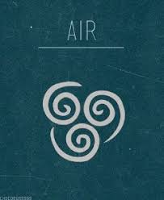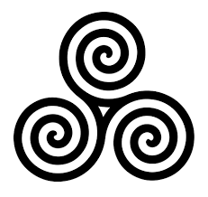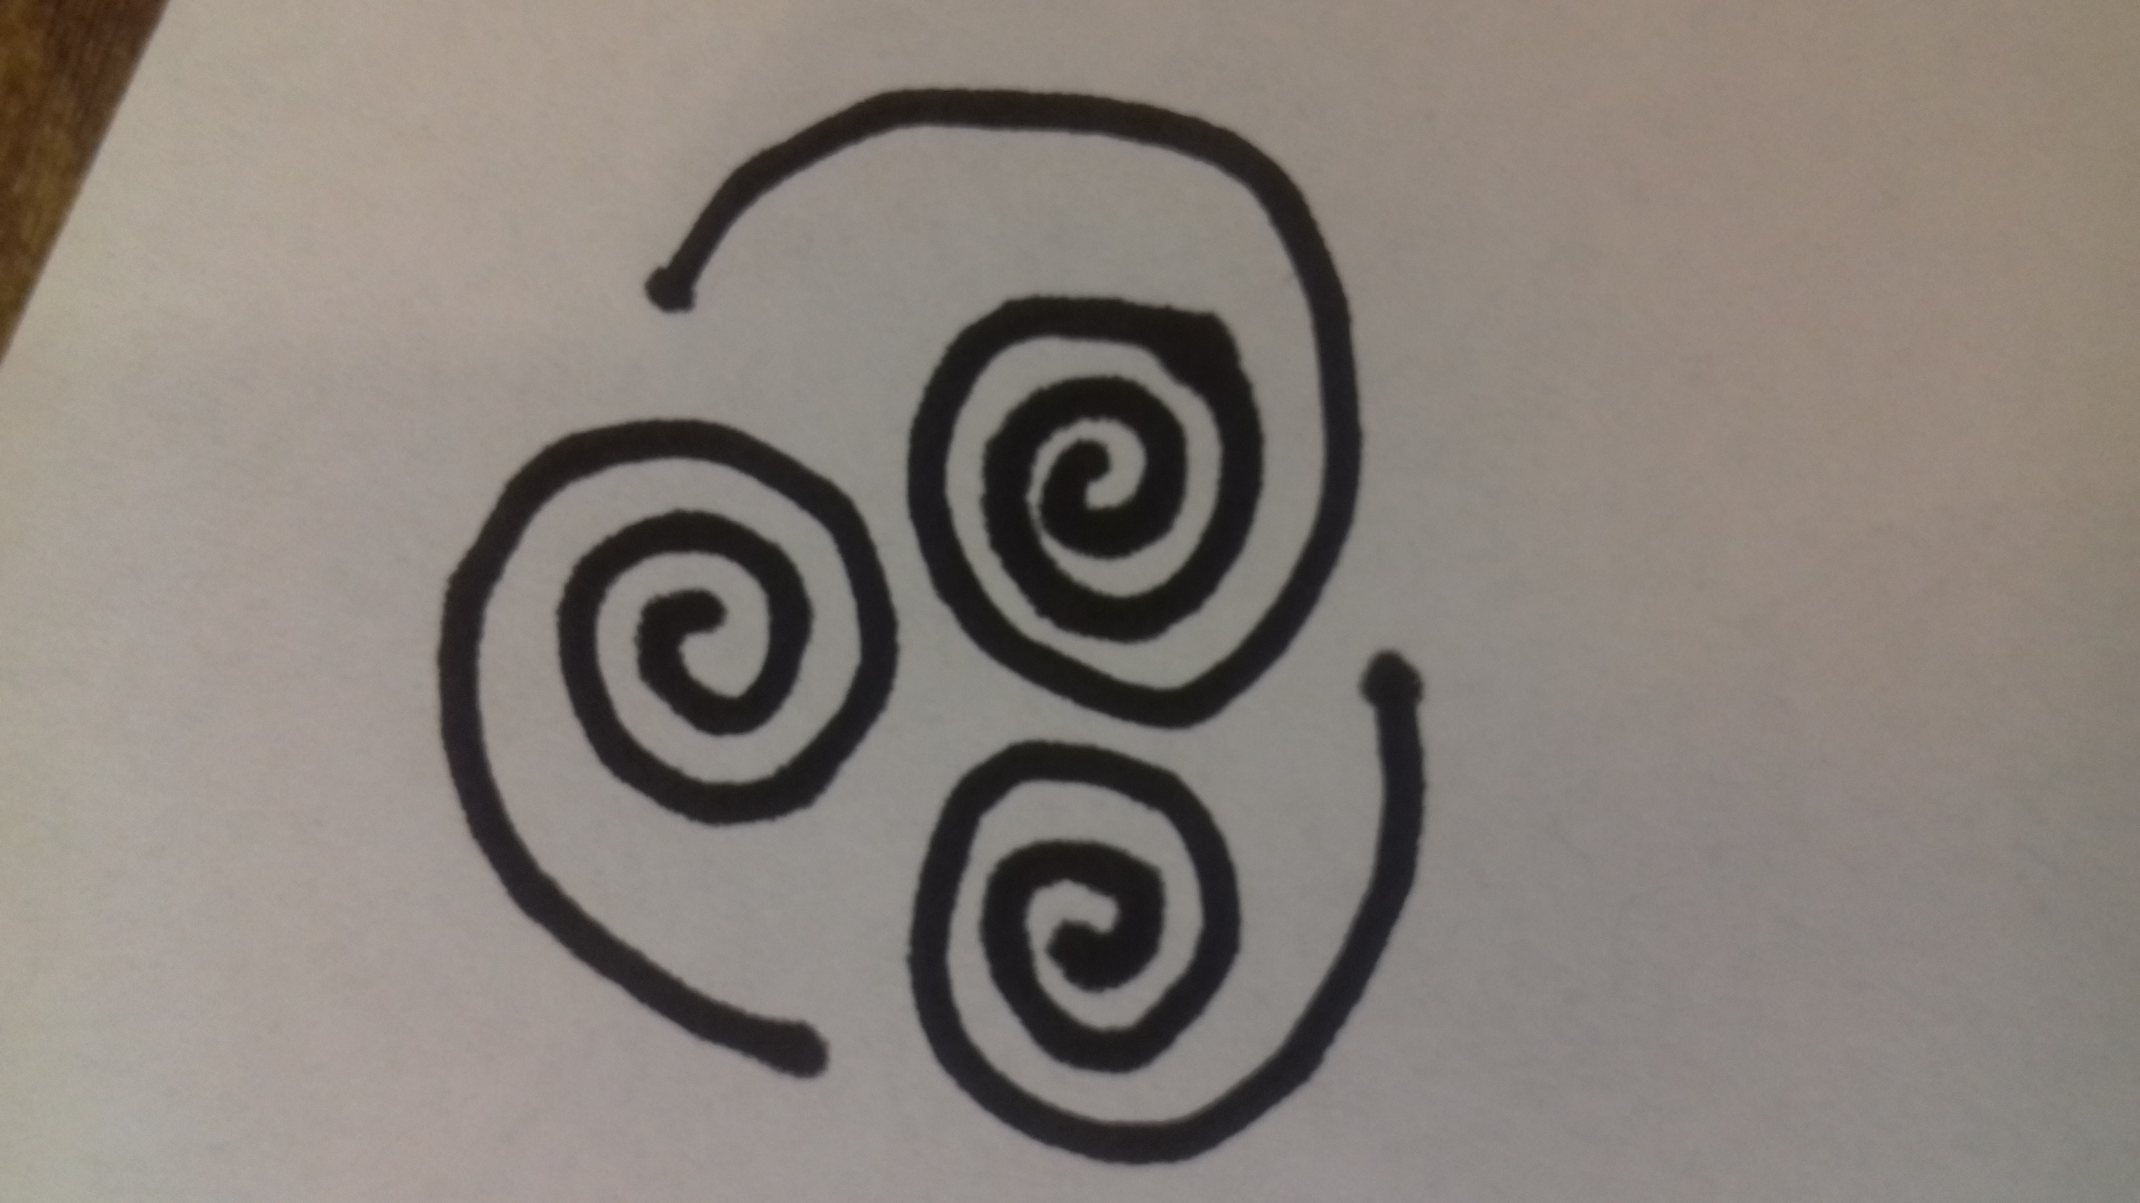
This is from pin interest so needs to be a little bit varied but this is something that we really like.
This is the original symbol for the air element that we would like to use for our logo
Our own raw version of what we are after as an example.

