Mental Health Illustrations

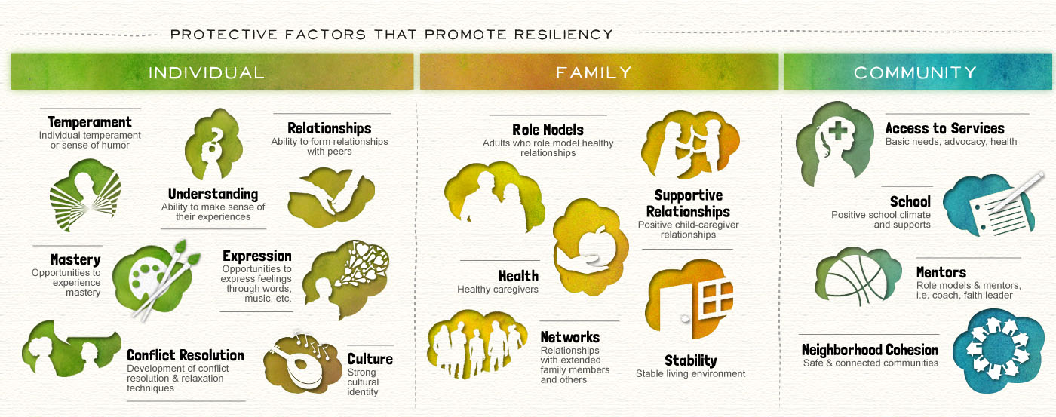
A. Defining Resilience - a) Individual, b) Family, c) Community

Note to designer - I would like a similar illustration to the one above that distinguishes between protective factors of resilience (individual, family and community). However, please link icons to the titles italicized below and include a text box for each.

Individual Protective Factors (9 icons required):
- Personality - Characteristics / traits you are born with.
- Self Regulation - Understanding and managing the cycle of one’s thoughts and feelings (including physical manifestations) and the effect on one’s actions.
- Problem Solving and Decision Making
- Goal Setting & Mastery - Ability to prioritise, plan, remain motivated, execute tasks as well as measure progress. This includes an awareness and utilisation of one’s strengths and limitations.
- Mindfulness: being able to pay attention to the present moment using different senses of the body with an attitude of openness and curiosity.
- Self Awareness - Knows and likes oneself (interests, skills, achievements, values).
- Self Efficacy - Confident to enact positive change and bring about a desired outcome.
- Physical Wellbeing - Inclusive of regular exercise, good nutrition, abstinence from smoking, drugs and alcohol and a healthy sleep-wake cycle.
- Authentic Relationships - Good connections with others based on an ability to negotiate, actively listen, attend to verbal and non-verbal cues, empathise, take perspective, appreciate differences and similarities, resolve conflict and communicate opinions confidently.

Family Protective Factors (4 icons needed)
- Stable, authentic family connections - responsive communication and support.
- Openness and Appreciation of diversity
- Adaptation to adversity/stress
- Resource Availability - Access to financial, educational and medical support

Community Protective Factors (5 icons needed)
- Mentors - responsive mentoring, by at least one positive role model
- Educational Opportunities - Across academic, sporting and extra-curricular domains as well as guidance on life skills and access to resources
- Inclusive Community Climate - Sense of belonging through inclusion and participation (i.e. faith or cultural group, one’s heritage and/or community cause).
- Authentic, Stable Friendships - Membership of a peer group and community with positive values
- Supportive Workplace - fostering strengths, nurturing development, inclusivity

B. Protective Factors/Pathway to Resilience

The illustration needs to depict a journey (e.g. over a mountain/across an ocean sunset) with different icons reflecting various features of resilience, all of which are listed in the above illustration and can be mixed throughout the roadmap. Please also insert a textbox / speech bubble near each icon that will allow brief elaboration of that feature. Both the icons and text boxes need to be flexible in the event that I want to edit the content or position. Please note, the image below is just an example of the density required not the layout or colour scheme I want.
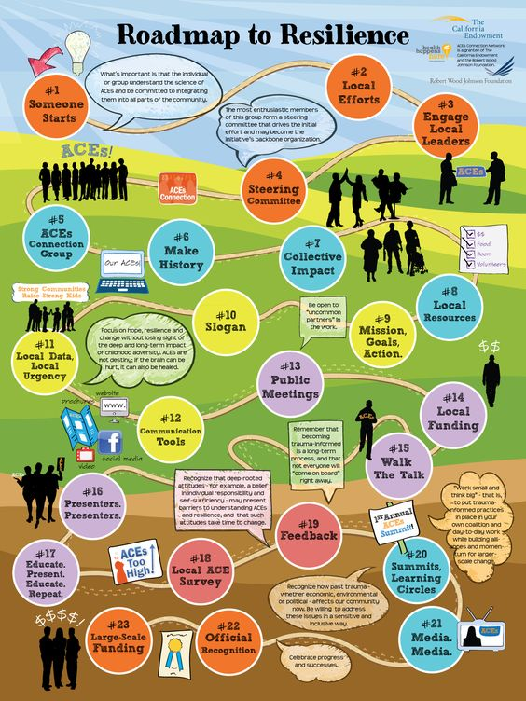

C. Risk/Vulnerability Pathway
The second image in this section will be a maze with longer, more twisted pathways. At each twist a different vulnerability/risk factor is to be inserted as an icon (italicized titles below). There are 17 risk factors listed below that I want captured across the maze. And a text box for each so I can elaborate on what they are. Therefore the icons and corresponding text boxes need to be close. There needs to be an entry and exit point in the maze, giving readers comfort that resilience can be reached but it will be a more convoluted pathway to get there when there is trauma or risk factors present. Icons be linked to the following topics.
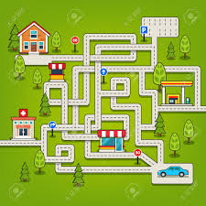

- Low self worth. Shame and inferiority complex at a lack of mastery of tasks.
- Poor attachment to primary caregiver in childhood
- Emotional regulation difficulties (withdrawn, sad, isolated and depressed).
- Sleep Disturbance
- Health Issues - chronic or acute
- Minimal leisure pursuits
- Career Instability
- Communication Barriers - difficulty with verbal and non-verbal communication, expressing opinions/emotions, problem solving and managing conflict.
- Perspective Taking / Empathy Difficulties
- Limited role models/mentors
- Inauthentic / Unstable Relationships
- Limited access to educational and health resources
- Risk taking - substance use, criminal behaviour
- Mental health concerns - complex trauma, depression, eating disorders, self harm, suicide ideation and attempts.
- Existing extended family conflict
- Family trauma and/or neglect
- Unstable living situation / homelessness

D. Values Activity - The Life Compass
Note to the designer. Please create an illustration around the following steps...

- Depict the following 9 domains of Identity:
- Health,
- Mental Health,
- Environment,
- Spirituality,
- Career,
- Family,
- Intimate relationship,
- Friendships,
- Leisure.
Readers are asked to consider these domains and write down what is important to them in each. Therefore, they will need room in each box/segment created to elaborate.

- They are then required to mark, for each of the 9 domains, on a scale of 0-10 how important these values are to them at this point in their life: 0= no importance, 10= extremely important.
- They then need to rank for each domain, on a scale of 0-10 how effectively they are living by these values right now. 0= not at all 10= living by them fully
- Finally they are asked what do they need to do to close the gaps?

