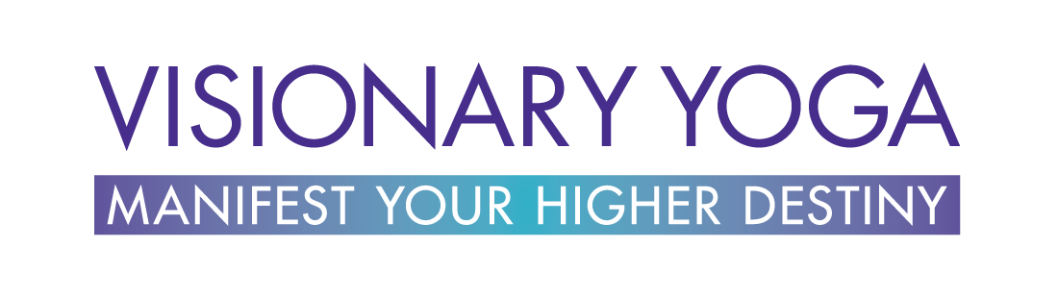

WATCH THE LATEST WEB TV EPISODE !
LOG IN TO
MEMBER’S PORTAL
SHOP
EVENTS
WEB TV
BOOK
BLOG
MEMBERSHIP
SPEAKING
PROGRAMS
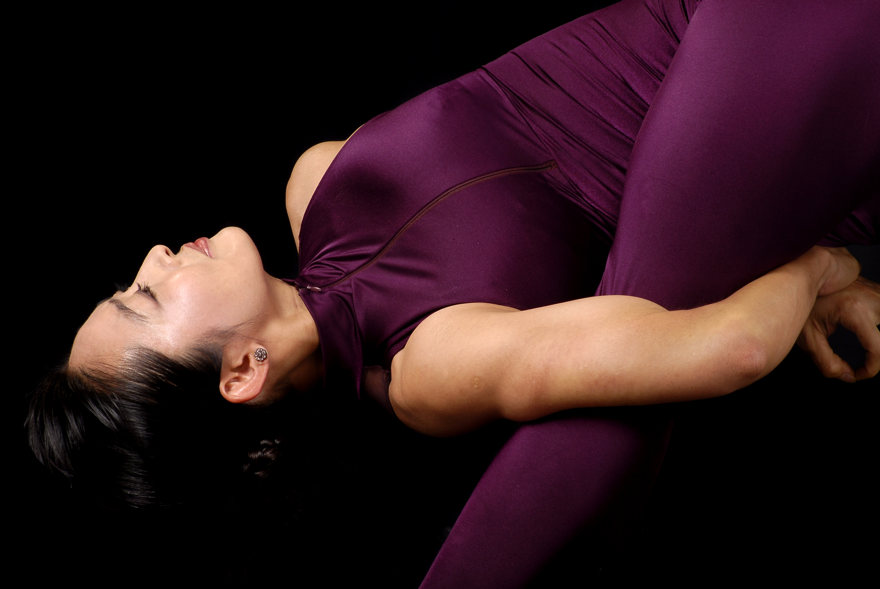
ABOUT
COURSES

RETREATS

CORPORATE
TRAININGS

CERTIFICATION
PROGRAMS

What’s Your Level of Mastery to Manifest Your Vision?

Where and How Can You Improve?

Find Out by Taking the Quiz!

Take the Quiz Now


I’m Mariko.

Yogi, ayurvedic healer, author, speaker, entrepreneur.

The role I am most proud to play is to be a PARTNER IN BELIEVING for my clients.

I hold the Vision for what your Soul longs to manifest in your life.

I hold the space for who you know you must to become to realize your Dreams.

This site is dedicated to that Visionary Being within you that knows you are meant to live a bigger life.

The good news is you don’t have be able to see the entire path to your dreams. No, thank God!

You just need to be able to see the NEXT STEP.

So no matter how many obstacles you’re facing,
no matter what the inner demons are, let’s face it:

You are here on this planet to manifest your higher destiny.

Begin your Journey NOW.



The real role of Yoga in the world is to open the doorways of your perception
to a higher reality. To awaken to the miracles present in
every moment of your day and night.

We are not here just to wake up, eat, work, seek pleasures and go to sleep!
We are here to co-create the miracle of life with Life itself.

The Notes from the Mystics are daily reminders to stay attuned to the Highest Vision for your life. These authentic quotes from the wisest beings in this universe – self-realized Yogis, Sages, Saints, and Visionaries , will inspire you to take daily action on your dreams.

Sign up and join the thousands of seekers who receive this daily injection of high –frequency thoughts from the greatest minds on this planet!

Receive Daily Inspiration!

Pre-order the Book and
get access to this
powerful course:

Yoga & the Art of Peak Performance
($297 value)!

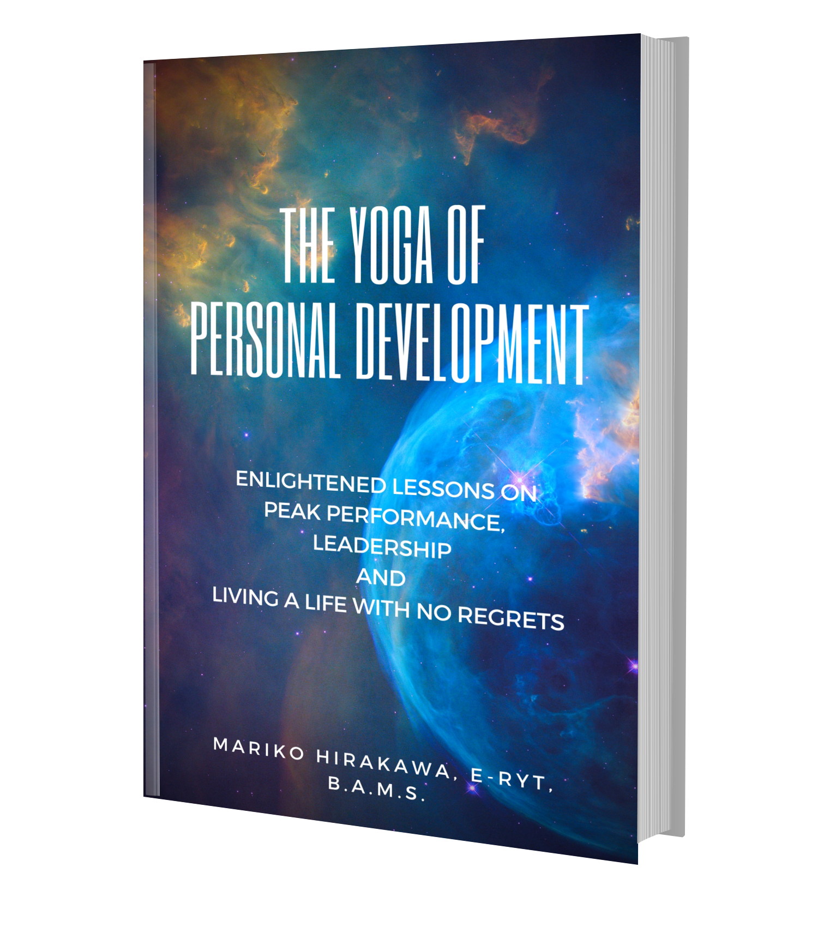

This is our premise at Visionary Yoga:

Whether you know it or not, you are already practicing the Yoga of Life, and we can always become more skillful at it.

It’s really time we graduate from thinking of ‘yoga’ as just a workout!

Even when Yoga has matured to become a $37 billion industry, we in the West have hardly scratched the surface of how deep this thing goes.

In this book I share with you how to become more skillful in the Yoga of life, business, and relationships, drawing on my ten years living in India, studying Yoga, Ayurveda, Sanskrit, and sitting at the feet of realized Masters. Whether you are beginning your journey or a seasoned practitioner, this book and revolutionize your life!


WPAT FM Radio
Nice Guys Business Podcast
Mindfulness Mode Podcast

Mariko Hirakawa has been featured on:

What is Visionary Yoga?

VIDEO (being created)

It’s time to take Yoga out of the
‘fitness box’…

From your practice on the mat to living your dreams, to achieving Peak Performance as a leader in your business, Visionary Yoga TV will inspire you to uplevel your life!

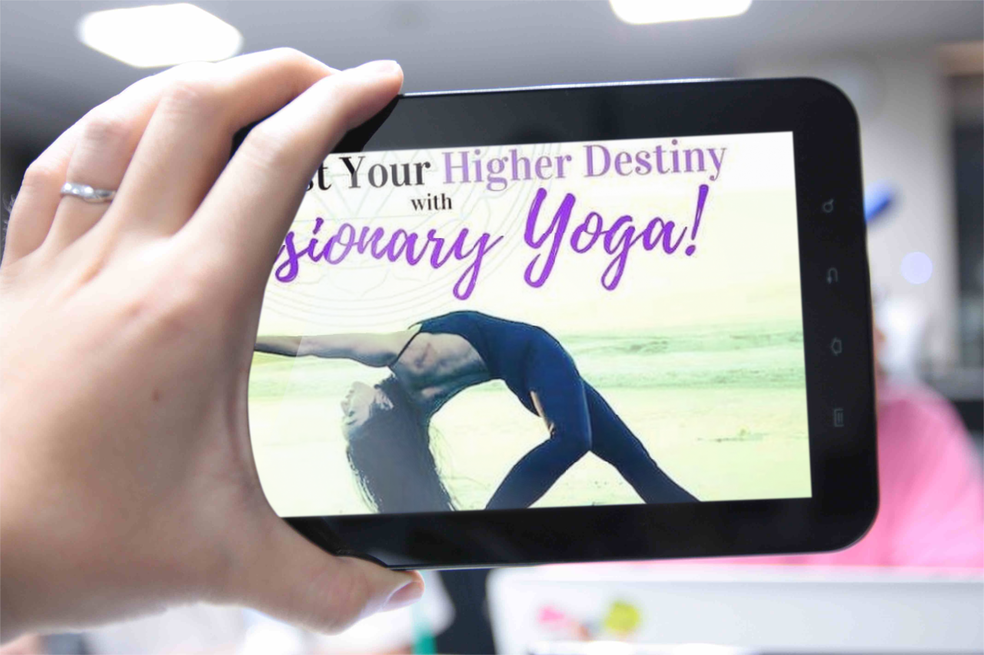



Watch Now


On your journey to living your Higher Purpose, it is important to know which stage you are in. Right support at the right time can get you unstuck and build momentum to realize your Vision!



You have a whole TEAM that needs to get ALIGNED WITH YOUR COMPANY’S VISION, UPLEVEL THEIR MINDSET and work as a harmonious whole…

FIND OUT MORE >>>



You want to GAIN CLARITY on your direction and Vision for a bigger life…

OR

You know what you want but need to STRENGTHEN YOUR BELIEF IN YOURSELF

GET STARTED >>>



You’ve been practicing Yoga for some time and are ready to take it to the Next Level… you’re even contemplating BECOMING A TEACHER…

EXPLORE THE POSSIBILITIES >>>


You’re a business leader or entrepreneur seeking BALANCE, QUALITY OF LIFE, and an effective way to OPTIMIZE YOURSELF FOR PEAK PERFORMANCE…

BEGIN YOUR JOURNEY >>>



“Mariko is a yoga instructor’s instructor. She’s the best one I’ve had. She’s passionate, precise, friendly, and very calming. Rarely do you walk out of a class feeling better than when you entered. In her class you feel energized and rejuvenated.

She seems to have dedicated much of her life to yoga having undergone advanced training in India. You can tell that yoga is a way of life for her. She exudes positive energy, attention to proper posture, and has an very calm music selection.

I wish I had known about her earlier. She’s a consummate professional with a sublime and uplifting spirit.”

Rate Your Burn Review

“Your help over the past year has been of immeasurable benefit to me…Your instruction, rooted in centuries of teaching and learning, and masterfully delivered, is exactly what I needed. Having had an Ayurvedic consultation with you enabled us to tap ever more of your plentiful resources.

Getting me moving, getting stronger and more flexible, paying more attention to how I breathe, meditation, learning pranayama techniques … I’m more thoughtful of what I eat. I can’t thank you enough. Sending appreciation and admiration,”

Harold Bott

“I’ve been taking Mariko’s class for years, and alter my weekend plans so that they don’t interfere with the one class she does downtown each week. She is a phenomenal instructor – a genuine yogi with a background in dance. Her instructions are nuanced but crystal clear, and it makes a huge difference.

The class is a serious workout – but you don’t muscle through it – everything is deliberate and controlled, focusing on form and breath.

She is also an incredible inspiration – she starts class with a story or anecdote which always hits home, and her class is a workout. It’s the only class I do that I feel that’s the total package. I leave feeling like I’ve worked every muscle in my body, got an amazing stretch, and strengthened my spirit. She is amazing and a joy to learn from.”

Review from Rate Your Burn

“Super guidance, she is incredibly good at instructions. I catch myself tuning into my muscles and poses in ways that I miss in the typical equinox class. She is wildly accomplished and has a really impressive background.

She is a holistic healer, focuses on mind body spirit and knows creates an incredible class. OUTSTANDING. Best yoga at equinox hands down. LOVE HER. (PS. she is absolutely stunning and lives by her practice. She radiates.)”

Review from Rate Your Burn

“She is most effective as a teacher and has helped me to identify the strengths and weaknesses in my body enabling me to perform the asanas with greater comfort and ease… Most importantly, she makes me feel that she cares; and, additionally, I feel a sense of improvement as a result of the way she encourages me and shows me how to work with my body.

Without Mariko knowing I have encouraged and invited others to join class with her – even if they are beginners. Mariko is attentive to and patient with each individual allowing the person to reach their potential.”

Margot Steinberg


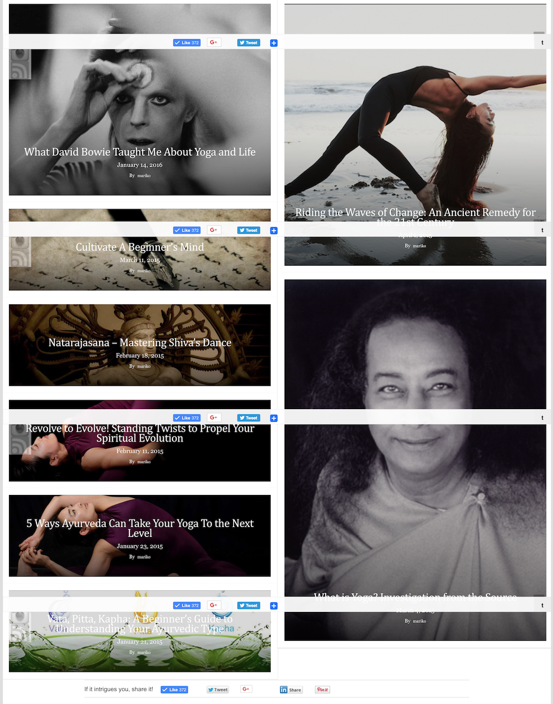

Watch Mariko’s Show:


Get Daily Inspiration:



Don’t leave without putting something in place to hold the Door of Possibility to your Dreams Open!

SIGN UP FOR
NOTES FROM THE MYSTICS

and be reminded every day of life’s incredible magic!



It all begins with YOUR Vision
for a bigger, better life.



SIGN UP FOR NOTES FROM THE MYSTICS!
Before you go, hold the Door of Possibility to your dreams open.
Learn More
When you invest in the realization of your Vision through us, you save and change lives.

Because with every product or service you purchase, you support children and mothers in need.

