Brochure Content
Front page

logo (above) with geometric modern design in logo colors (ideas below)


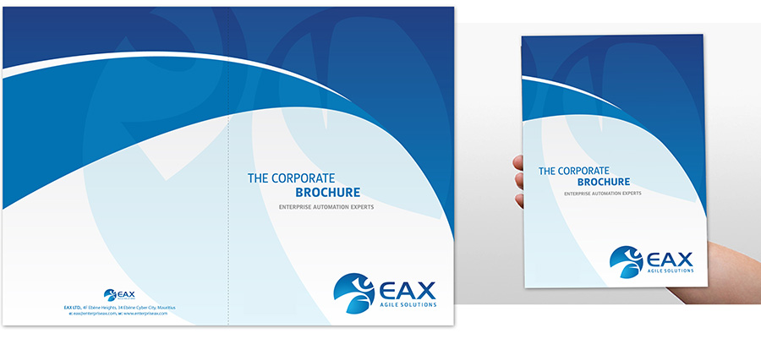

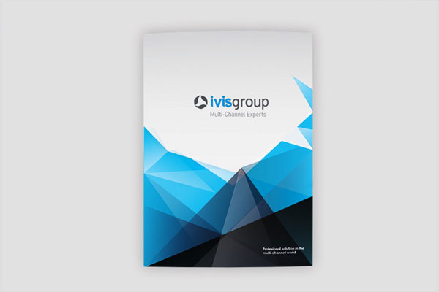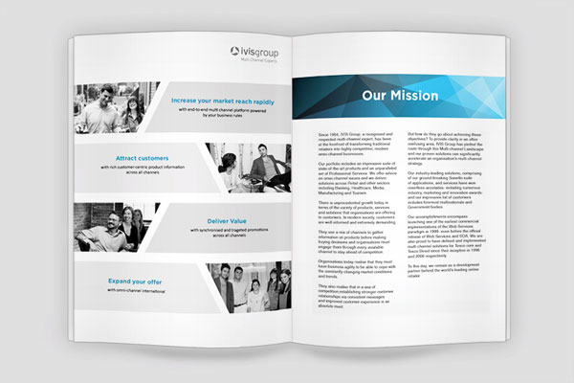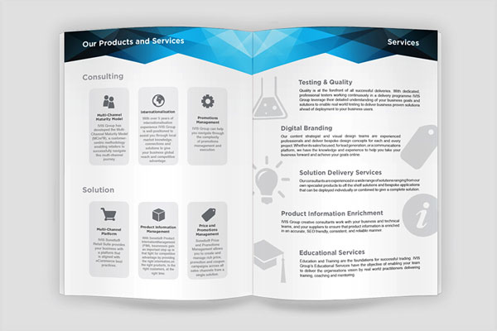

First page on the left hand side when open

Logo Icon with title below

NextPhase
Pharmaceutical Research
CRO


Our Services
- Comprehensive regulatory administration
- Quick and accurate data management
- Trial centered approval to project management
- Robust network of pre-qualified clinical research sites
- Over 200,000 research able patients throughout seven states
- Expert Trial Monitoring
- Cutting-edge, custom Clinical Trial Management Software
- Niche CRO specializing in emerging pharmaceutical and biotech companies
- Expedited FDA approval process
- Cost containment
- Quick Study Start Up

Page 2 on the side hand side when open

About Us
“Our mission is to ensure that we exceed industry standards, while delivering profitable growth through superior customer service, innovation, quality and commitment”
- Over 45 years of combined research experience
- Successful completion of multiple and diverse projects
- Projects completed on-time and under budget
- Co-created optimized Clinical Trial Management Software
- Impeccable reputation in research industry

NextPhase
Pharmaceutical Research
CRO

Contact Us
Web: www.npresearch.net
Telephone: 1-844-677-3732
E-mail: info@npresearch.net
Back Page

Follow design from cover can include logo and contact info

