Style Sheet – Ideas for logos
Keys: Talent and Tech

RF: I love this look for our three initials… GTA, if it works.

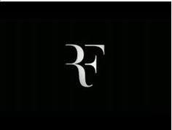

NCA: This one could be World Globes (looking tech and digital) and with the T in the middle space signifying Talent, could be perfect.



Girl Scouts: The “people” aspect of the image is applicable with “Talent”. Blue would be the predominant color. OK to mix in the yellow/gold and purple as well.



