Slingshot wishes to update the look of its business applications. Two representative forms are shown below. Please note, we are not considering changes in functionality or usability. Our goal is a cleaner, more contemporary design. New colors can be introduced provided the Slingshot logo colors remain the same (our corporate identity).
To be considered will include versions of the 11 toolbar icons shown below as well as the pagination icons and the additional icons on apply, search, new, delete and back buttons.
Main tool bar icons
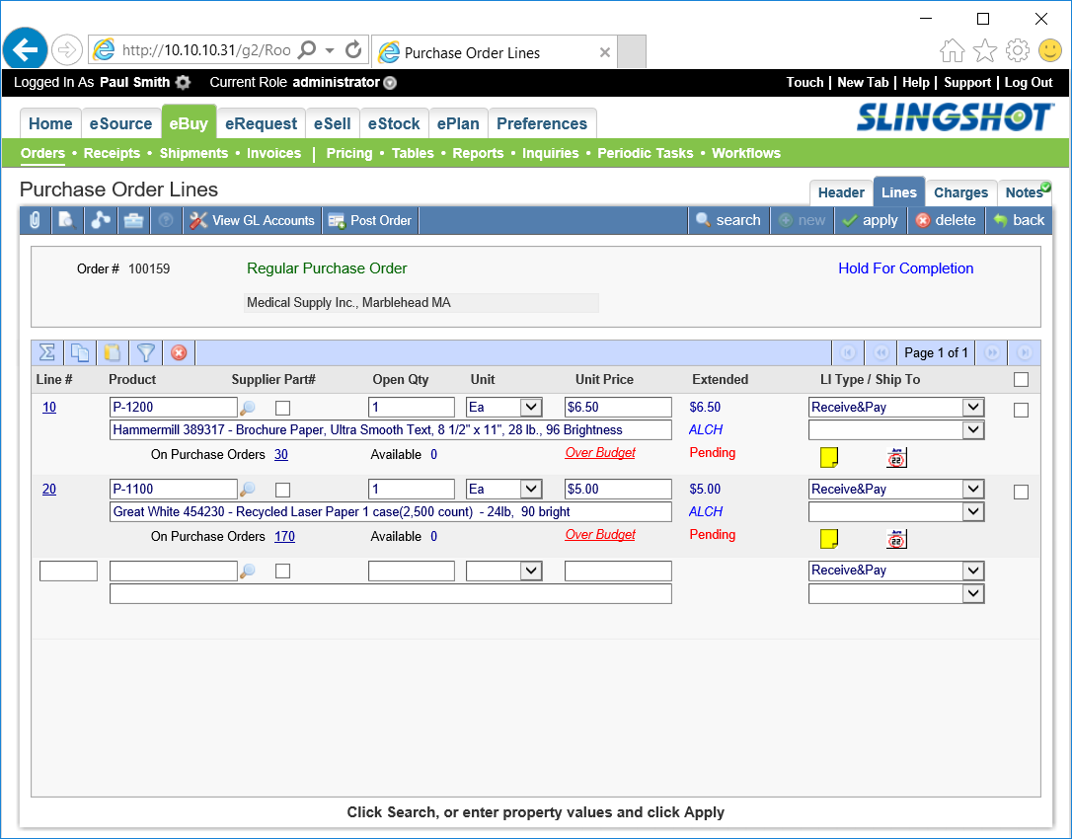
Attachments, Preview Document, Workflows, Toolbox, Help (disabled above), Tool (“View GL Accounts” above)
Details tool bar icons
Summation (adds totals on form), Copy to clipboard, Paste from clipboard, Select Filter, Delete
Please submit your version of the two forms shown below. The winning submission will provide a clean, contemporary and cohesive rendering of the seven form elements listed below.

Current Forms
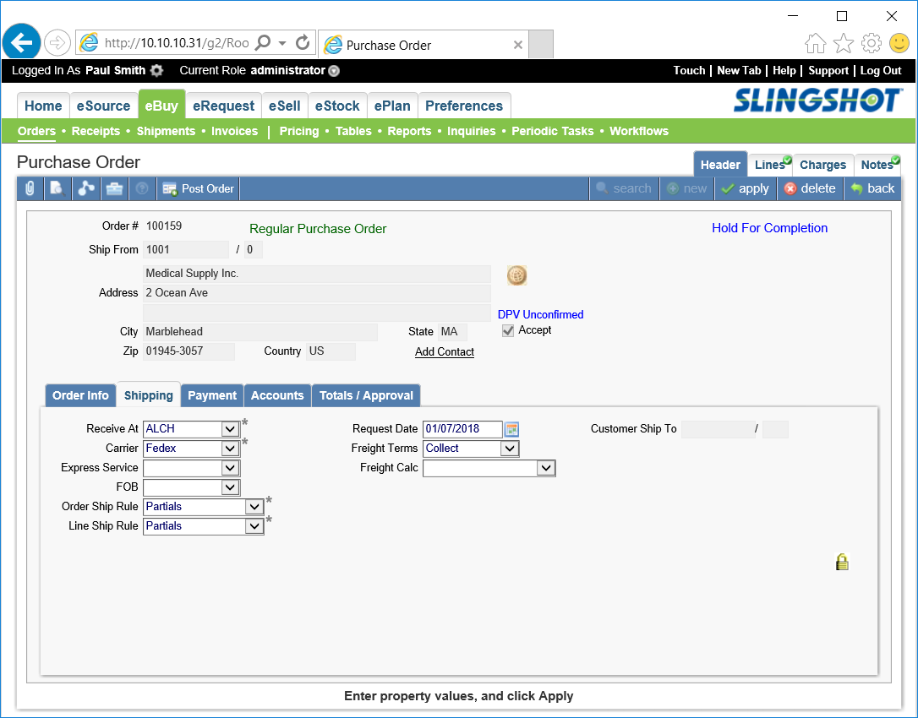
Message Window
Form tabs
Two menu bars
App Status bar
Folder tabs
Main Toolbar

Details Toolbar
There are seven form elements highlighted on the two forms above. The winning design must include each of these elements. The purpose of each element is described below.
The following elements are common to all forms.
- App Status Bar
This black bar is present on every form. It shows the currently signed in user and user role on the left. On the right is “Touch” reformats the form and all controls to a tablet friendly state; “New Tab” opens a new browser tab; “Help” displays the user’s guide; “Support” links to the Slingshot web site where the user can request support; “Log Out” exits the application.
- Two Menu Bars
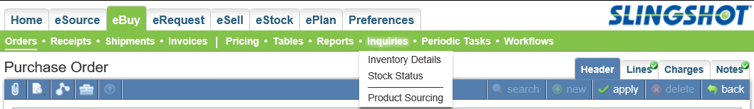
The user selects a menu item and a sub menu item to navigate to another area of the application.
- Main Toolbar
Left Side of Toolbar
The left side of the Main Tool bar show standard icons for attaching documents (paper clip); previewing printed documents (magnifier on sheet of paper); entering workflows (three white dots); toolbox (drops down links to optional functions used occasionally on the current form); to the right of these buttons are one or more frequently used tools (e.g. “View GL Accounts”, “Post Order”) .
Right Side of Toolbar
The right side of the toolbar contains “search”, “new”, “apply”, “delete” and “back” buttons. These buttons appear on every form but are “greyed out” in certain contexts.

- Form Tabs
Are used to group data. The data shown below the tab changes when a new tab is selected.
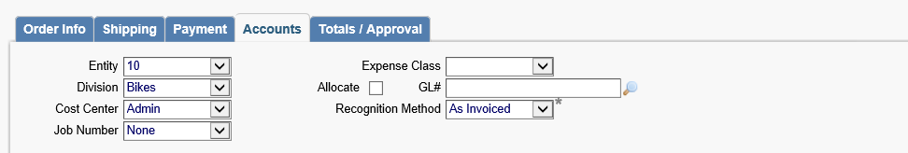
- Message Window
Errors and prompts appear at the bottom of each form in a message window.
- Folder Tabs
These tabs on the top/right side of the form link to another form showing a related list of records. Clicking the Lines folder tab causing the Purchase Order Lines form to appear. A green check mark on the tab indicates there are one or more items in the list. For example, the above order has lines and notes but no charges.
The following elements are common to forms with rows
- Details Toolbar
All forms with rows of data have a “details toolbar” above the rows.
Left Side of Toolbar
The summation icon causes totals for numeric row values to appear. The copy icon copies all rows into the clipboard. The paste icon transfers information from the clipboard to the form. The filter icon (funnel above) allows the user to list filters which can be applied to rows. The delete icon deletes selected rows. A row is selected by checking a box on the right side of each row. After the delete icon there can be one or more tools. These are invoked by selecting rows and pressing the toolbar button.
Right Side of Toolbar
The right side of the details toolbar is a pagination control.

