Title: Rise of the Small
Subtitle: Catalysing the blockchain evolution
by Raymond Ng

Back: Please see the attached photo for the layout of the back cover.
The text (summary is as follows) Please leave space for the website and the key take away.
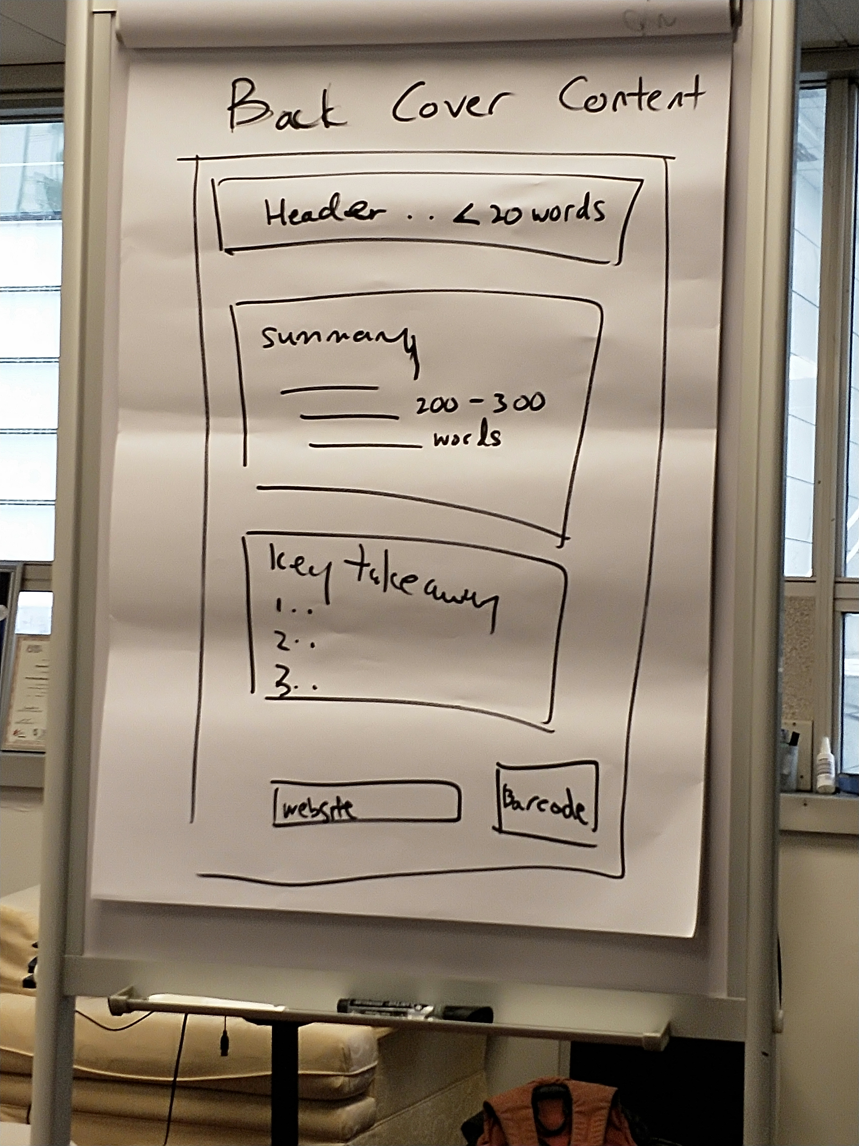

Summary:
Most people would have heard of Bitcoin and the underlying technology known as Blockchain. There have been two sides of the arguments.

On the side of the bankers and the regulators, their criticism of Bitcoin is that Bitcoin is unregulated and not backed by any asset. On the side of the Blockchain community, the regularly heard argument is that Bitcoin or CryptoAssets are limited and rare thus giving value to Bitcoin or CryptoAssets.

Both of these arguments are incomplete and do not explain the Blockchain evolution. The bankers and regulators are incomplete with their well intended advice because regulating an emerging historical trend caps the potential it can create in a society and that the backing of the dollar or other assets are still conditioned on various macroeconomic trend. The price of a real estate or even gold is still decided by market forces. Bitcoin or cryptoassets cannot be valuable just by virtue of its limitedness - there are a lot of things that are limited that may not be valuable.

Cryptoassets are valuable by virtue of how it overcomes the transactional friction that has been inherent in human history. Overcoming the transactional friction is the looking at the blockchain evolution via the eyes of an economist - that it would catalyse trading and create immense value for participating parties and create social utility for the world at large, and we are just at the beginning of the Blockchain Evolution.

