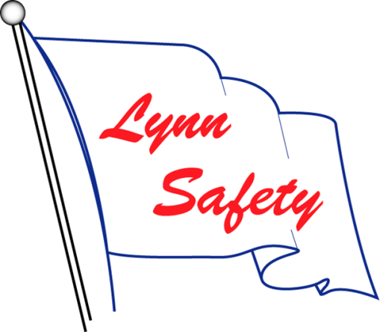

Davit Catalog Text

Standards in the suspended access industry require a building to provide certified anchorages capable of supporting the required loads before any suspended maintenance work is performed.
Davits are often used to provide access to areas of a building that are difficult to reach.
DESCRIPTION:
Davits provide an effective method for suspension of powered platforms (swing stage), single-man-baskets, or bosuns chairs (suspended equipment). A davit is defined by OSHA as “a device, used singly or in pairs, for suspending a powered platform from work, storage and rigging locations on a building being serviced. Unlike an outrigger, a davit reacts its operating load into a single roof socket or carriage attachment.”
Davits are regularly used on multi-level, mid-rise to high-rise buildings, due to the flexibility this equipment provides. Davits can be used to launch suspension equipment either from the ground or lower level (Ground Rigged), or from the roof or level above (Roof Rigged). The type of davit used depends not only on Ground vs. Roof Rigged, but also other factors such as obstructions, path of travel, and other variables that may be present on a building.

USE:
Davits are suitable for buildings that can sustain the required loads and that have complex rigging conditions. Davit bases can be mounted to the roof (or recessed under a deck), or the parapet wall depending upon the conditions on the building. Depending upon the building’s conditions, one application or installation type may be more cost effective and/or end user friendly than another. Davits are also used to access areas on the building that may be difficult to reach.

DAVIT TYPES & RIGGING METHODS:
Depending on the building’s features, Lynn Safety designs davits that fit the building’s needs. Every project is engineered to confirm the davit system is suitable for the building.

Portable Davits are dedicated to the building that can be moved along a level from one work location to the next in a designated area.
Fixed Davits are designed to remain at a fixed location as they may be either heavier than portable davits or have a longer reach that requires they be fixed in place.
Davit Carriages are davits that are mounted to either a manual or powered carriage that is stationed on a track. Davit Carriages are used to traverse on a roof or wall mounted track system. This system is utilized where portable davits do not have safe transportation or when a davit reach may be beyond 8’-6”.
Each of these categories of Davit arms can be designed to suit ground launching (ground rigging) or roof launching (roof rigging) based on the buildings conditions.
Ground Launched Davits are designed to rig the platform on the ground only or level below. Ground rig davit mast are typically short and easy to handle also known as low profile.
Roof Launched Davits are designed to launch the platform from the roof. Since the platform must be maneuvered over the parapet and outbound, roof launched davits must also be designed for ease of rotation under a load.
Top Rotating Davits are davits that have been designed with a davit mast, davit boom, and davit base where the davit boom (top portion of the davit) is rotatable.
All davits over 140 pounds are required to be raised in the position by mechanical means.
All davits over 80 pounds are required to be equipped with a means of transportation which shall keep the center of gravity of the davit at or below 36" above the safe surface during transport.
All Davit equipment is load tested by Lynn Safety field technicians to confirm that the equipment was installed and manufactured properly.
When designing for a Davit System, Lynn Safety takes multiple factors into account. First and foremost is whether the building’s structure can support a davit load. If a structural engineer is contracted for the building, our engineers will work hand in hand to determine whether a davit system is acceptable and what type of installation method is practical. We will provide all of the data necessary for your engineer to check the structure. If a structural engineer is not contracted for the building, our engineers will check the strength and capacity of the building’s structure to confirm that a davit system is appropriate for the building. Once deemed acceptable, our design team coordinates the davit design with you and your team to work together to design the best system for your building and to your satisfaction.
Lynn Safety provides Design services to work in conjunction with you to determine the most cost effective, safe, and end user friendly system for your building.
For categories of installation of Pedestals (davit bases), see Lynn Safety’s Pedestal Catalog.
For types of equipment that can be suspended from a Davit System, see Lynn Safety’s Suspended Equipment Catalog.

