Conference advertising brand design brief

Title
The 3DMedLab is hosting its 4th Annual medical conference on 13-14th October 2018 in Melbourne, Australia. The title of the conference is 3DMed Australia 2018.
Audience
The conference audience is aimed at people who have an interesting in 3D printing to benefit their work as well as printing for a hobby.
This year the conference will bring international and interstate speakers.

3DMedLab logo
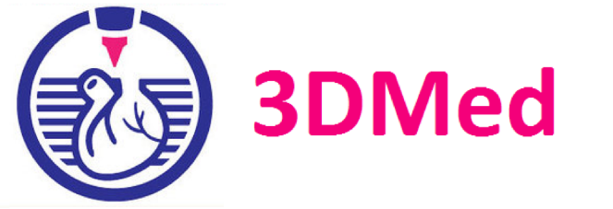

Colours
Pink and Blue are the main 3D Med Lab colours

Font
Arial

Picture
We are looking for a conference banner to display on our website and printed material. There needs to be a unique design related to 3D printing to distinguish our conference from others. The pictures cannot be copy and pasted from Google.

Examples of banner
