
MIRACLE WHITE

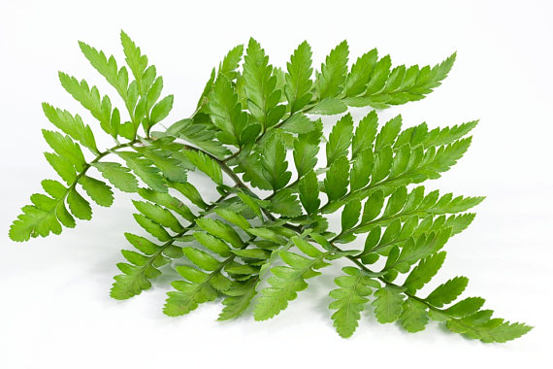

Skin Whitening & Sun Protection all in one
Oral supplements

SKIN WHITENING & SUN PROTECTION: THE SCIENTIFIC ANSWER

- PhytoflORAL : An award winning natural supplement using non-GMO tomato species rich in colourless carotenoids, phytoene and phytofluene. This patented combination provides superior whitening, UVA and UVB protection, anti-inflammatory and antioxidant properties.

- Polypodium leucotomos : Naturally extracted from a tropical natural fern found in the Americas, it has been used for centuries by the natives for its superior benefits. Now clinically proven to protect against UV radiation due to its antioxidant, anti-inflammatory and DNA repair abilities.

- L–Cysteine: A potent amino acid that has very high skin-whitening abilities. It prevents the production of pigment cells when the skin is exposed to UV rays and stimulates the production of Glutathione, another strong skin-whitening antioxidant.

Benefits of MIRACLE WHITE  - Skin Whitening  - Collagen Protection  - DNA Repair  - Prevents Against Premature Skin Aging  - Enhanced Antioxidant & Anti-inflammatory effects  - Natural UV Protection | 

CLINICAL STUDIES
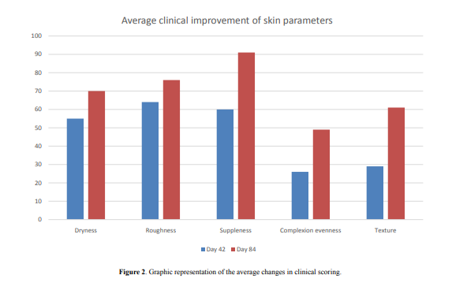
Skin improvement results of a clinical study conducted by dermatologists measuring skin quality after 12 weeks use of colourless carotenoids (Global Dermatology 2015: 2(4) Page178-182)

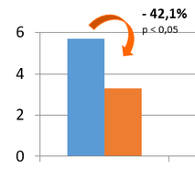

Reduction in intensity of melasma with usage of daily oral Polypodium Leucotomos for 12 weeks with sunscreen SPF 45 (American Journal of Dermatology 2012: 66(4) Page AB21).

One of the first Skin & Sun Protection ALL IN ONE

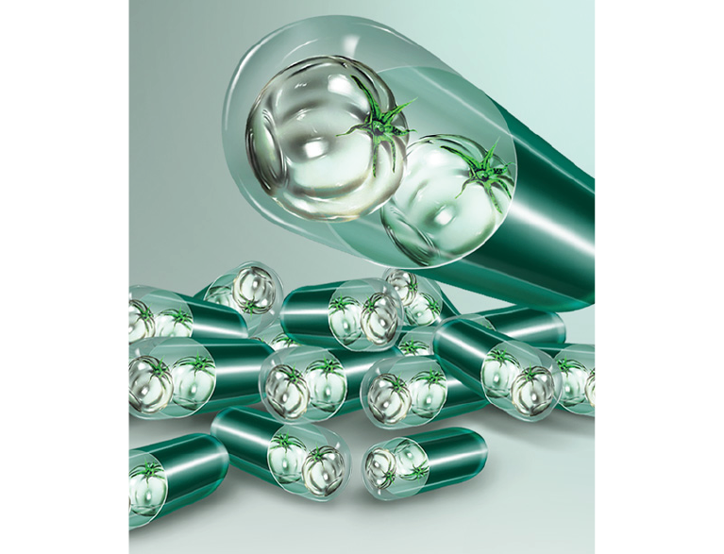

MIRACLE WHITE
Nature’s solution to skin whitening

Distributed by:

