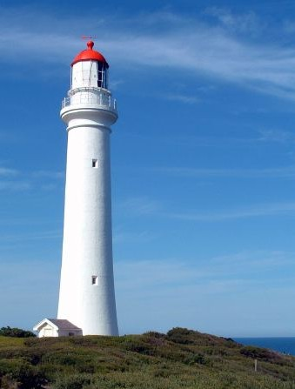

Image of the Split Point Lighthouse, Airey’s Inlet.

