


Davis Company
Multi-Plug
1 Plug ● 9 Different Configurations

14-30 14-50 14-60 15-30 15-50 15-60 18-30 18-50 18-60 0000000000
- Disconnect Electricity
- Loosen cord clamp
- Unscrew plug housing
- Change configuration
- Re-Assemble
Built for
30-60 Amperes 125/208/250 Volts

- HEAVY DUTY
- Transforming
- Patent Pending
MADE IN USA
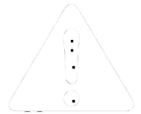WARNING: Read all instructions before use to avoid injury, shock or damage
z

