The
Wiggle chair

Made in our Brunswick factory, the “Wiggle Chair” has a rounded base to allow for moderate movement and multiple density foam core with a rip stop vinyl cover that is soft, but tough enough to withstand the classroom environment.
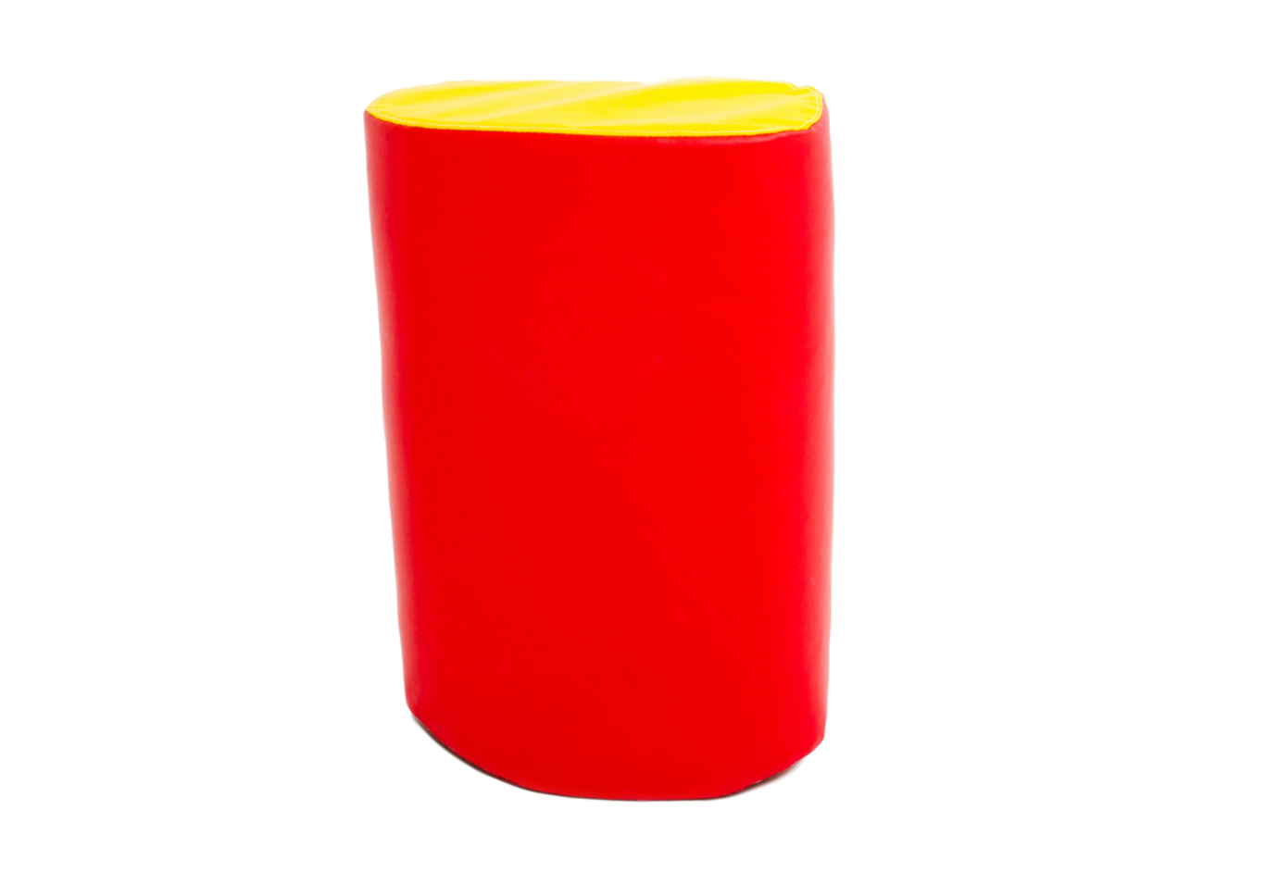



The National Autism Resource Blog article, “5 Strategies to Help Kids with ADD/ADHD and Autism focus in the Classroom,” says it’s all about core work. Children with Autism often have weak muscle tone. While researchers aren’t exactly sure why, we do have ways to help them strengthen those cores. The blog says that wiggle seats do two jobs by first, helping kids work their core muscles often, and two, lowering energy levels so they can focus more. It makes sense. If you’ve got energy zooming around your body all the time, you’re going to focus better if it’s got an outlet!

