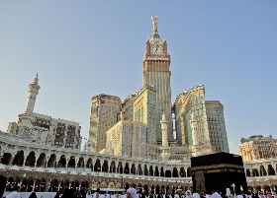
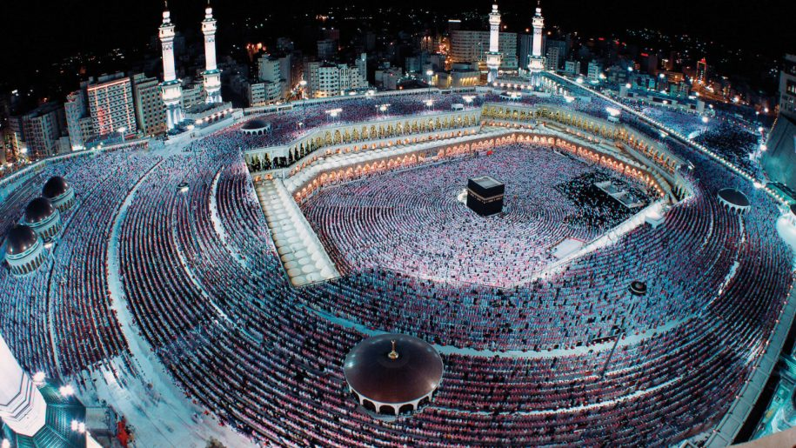
+
Package 2: Makkah First Class $7800
- Direct flight using Saudi Airlines (Aug 15 - Sep 6)
- 5 day stay at Durrat Minah Hotel in Makkah
- 5 star Hilton Convention hotel in Makkah in front of Haram Makki
- 5 star Dar Al-Iman Intercontinental Hotel in Madinah (On Haram Floor)

Hajj 2018
Maram Tours & Travel

Package 4: Madinah Deluxe $7800
- Direct flight using Saudi Airlines (Aug 12- Sep 2)
- 5 days in 5 star Rov Al-Madinah Hotel (20m of Haram)
- 2 day stay in Durrat Mina Hotel
- 5 star Hilton Convention hotel in Makkah in front of Haram Makki

Maram Tours & Travel Inc. Cell:(347)-575-7971, Office: (212)-376-4637 Address: 757 3rd Ave, New York, NY 10017 Website: Maramtravrl.com. All packages don’t include $300 hajj fee and Zabiha
Package 1: Makkah Econ. $6800
- Direct flight using Saudi Airlines (Aug 15 - Aug 31)
- 5 days stay at Durrat Minah Hotel in Makkah
- 5 days stay at 4 Star Al-Eiman Al-Manar Hotel in Madinah

Package 0: Makkah Express $10000
- Direct flight using Saudi Airlines (Aug 15 - Sep 1)
--10 days stay at 5 Star Hilton Convention Hotel in Makkah
- 7 days stay at 5 Star Leader Al-Mona Kareem Hotel in Madinah

Package 5: Madinah Express $10700
- Direct flight using Saudi Airlines (Aug 12- Aug 27)
- 5 days in 5 star Rov Al-Madinah Hotel (20m of Haram)
- 10 days in 5 star Hilton Convention Hotel in Makkah (in front of Haram)
- 1 Day in Jeddah Hotel

Package 3: Makkah Deluxe $8000
- Direct flight using Saudi Airlines (Aug 12- Aug 30)
- 5 days in 5 Star Hilton Convention hotel in Makkah
- 2 days in Durrat Minah Hotel
- 4 days in 5 star Rov Al-Madinah Hotel (20m of Haram)

