HOME GET TO KNOW US WHY BLU? HOST A POP-UP BECOME A STYLIST
BLU district logo here
Stylist Login
Pop-up your own BLU Boulevard for ONLY $99

Have a Slideshow on the Home Page
1st slideshow image: create a graphic based on the representation below

Design Notes: Please use my representations to make a professional design.

Main company color is Blue. The site should communicate: You should shop here if you want a FUN, Happy shopping experience.

Reference sites so you can see where I got inspiration from: www.lularoe.com and www.peekaboobeans.com

Shop Now
LIMITED INVENTORY that’s only available for ONE week!

2nd slide show image: USE IMAGE TITLED family of three

3rd slide show image: use image titled ladies shopping

4th slideshow image: use image titled older man bomber jacket

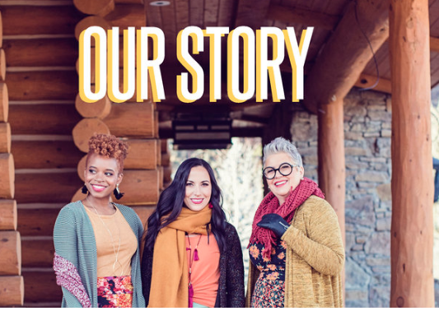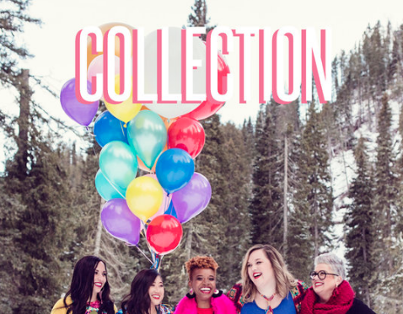
Design notes: Please use image titled retail therapy. Instead of collection, write SHOP
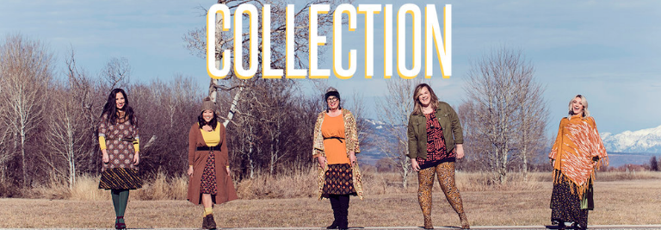
Design notes: Instead of collection, write Be Happier, Join the Movement

