MARCH Centre logo design brief
Task
A logo is required for the Centre for Maternal, Adolescent, Reproductive, and Child Health at the London School of Hygiene & Tropical Medicine.
Listing
https://www.designcrowd.co.uk/how-it-works
About us
The Centre for Maternal, Adolescent, Reproductive, and Child Health (MARCH) is the central hub for women’s, adolescent’s and children’s health within The London School of Hygiene & Tropical Medicine (LSHTM).
The MARCH Centre brings together over 200 researchers from across LSHTM. It aims to strengthen and promotes innovation, evaluation and evidence-based policy making by fostering communication and collaboration inside and outside the School and between researchers and policy makers, across a range of settings in over 100 countries and multiple disciplines.
The March Centre has a lifecycle approach which focuses on three priority themes:
- Adolescents (A)
- Births (B)
- Children (C)

Vision: To improve women’s, children’s and adolescent’s health worldwide.

Values: Research excellence, Relevance to policy and programmes, especially in the highest burden settings and raising the next generation of research leaders to improve the health of women, children and adolescents

Website: http://march.lshtm.ac.uk/

Current logo


Issues with the current logo
- Not very descriptive of what we do
- Doesn’t give any insight into our work
- Not visually appealing
- Looks dated and historical

Restrictions/ elements that must be incorporated into the new logo
- Our new logo needs to include the acronym ‘MARCH’ and ‘Centre for Maternal, Adolescent, Reproductive, and Child Health’

Ideas/considerations
- The logo would ideally include all stages of the lifecycle (women, children, babies and adolescents) rather than just focusing on one stage
- Our logo is often placed next to the LSHTM school logo on materials which is below:


- Our audience is very global and a mix of academics, students, NGOs and policymakers- it would be helpful to have a logo symbol that is easy to understand and interpret and relevant to our work.

Lifecycle emblem
This emblem is separate to our logo, but is a visual representation of the themes of the MARCH Centre. It gives you an idea of the stages of the lifecycle the MARCH Centre conducts research on.
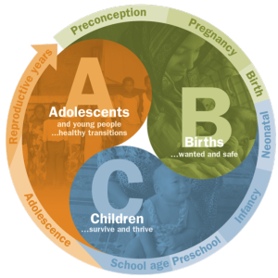

Example logos from other centres at the school



